WEC/DET Security Technology Discovery Approach

Hi Erick,

I found a new document this morning that I’ve sent you by email. It is a 2018 review of all the platforms in use by DET.

Your forensics expert will create a discovery process “map” for you I imagine - listing what information you’ll ask for from DET and WEC about the systems involved in the Wisconsin election - but I thought I would take a crack at putting one together for you so you can go inito that conversation with your forensics person with a “point of view” about how to do this, and then you can see what he comes up.

First, I think WEC/DET will take this more seriously if you approach it in a way where you try to get to the people responsible for the technologies in their key technology “categories” that they have defined internally.

They will likely have a person who who has been trained to respond to legal inquiries, and trained to provide only specifically what is asked for based on a narrow interpretation of what you asked for.

You want to talk to the lower level person who actually runs/adminiisters the system(s) in each technology area, and meet them ideally in person - don’t let people hide behind zoom or a phone call. These people are not going to think about what info they should give you or not - they will just comply, and will frankly be nervous about ever being accused about being anything less than truthful.

This document I found today will help with this. It is a 2018 description of all the technologies used by DET for all purposes, and gives us insight into the language and “vocabulary” they use to talk about their technology infrastructure. Here’s a screen grab of the cover and TOC:

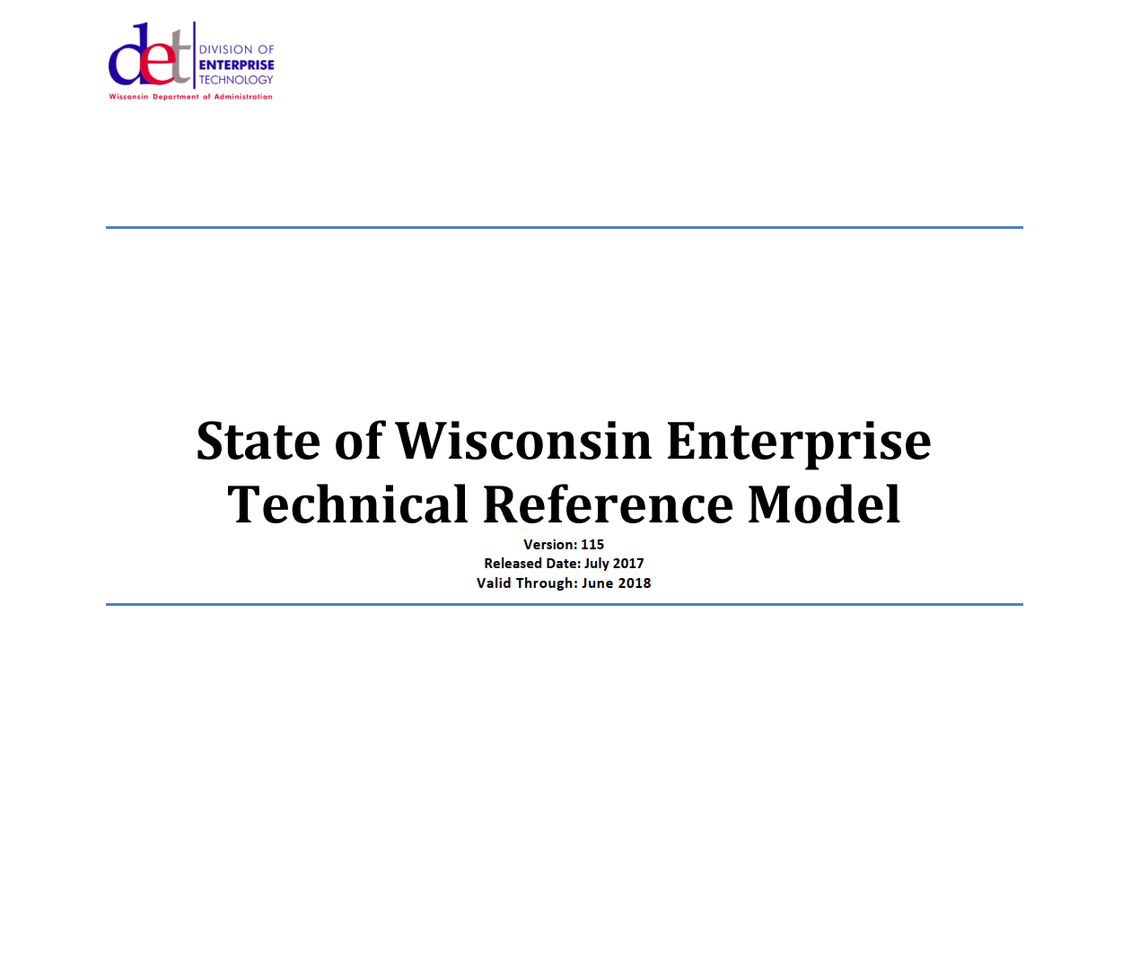

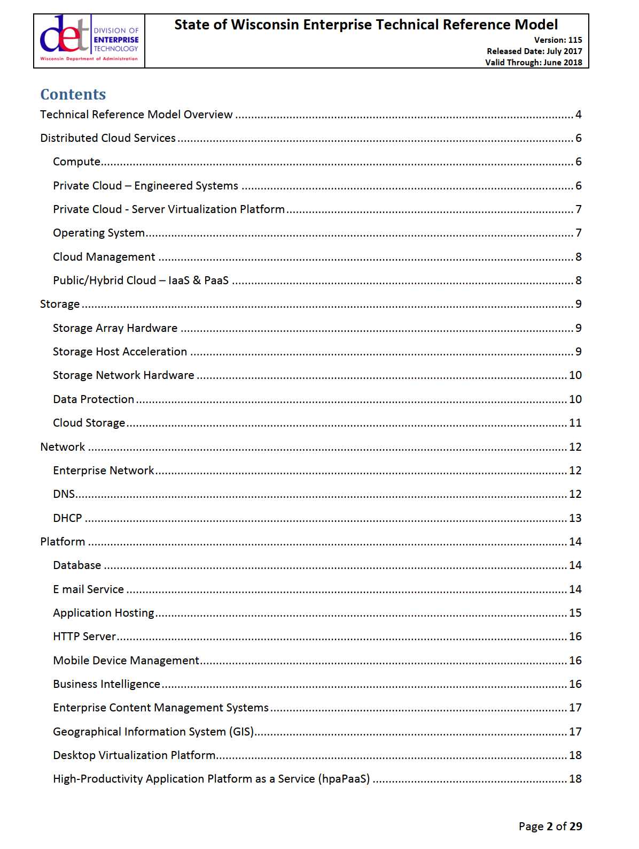

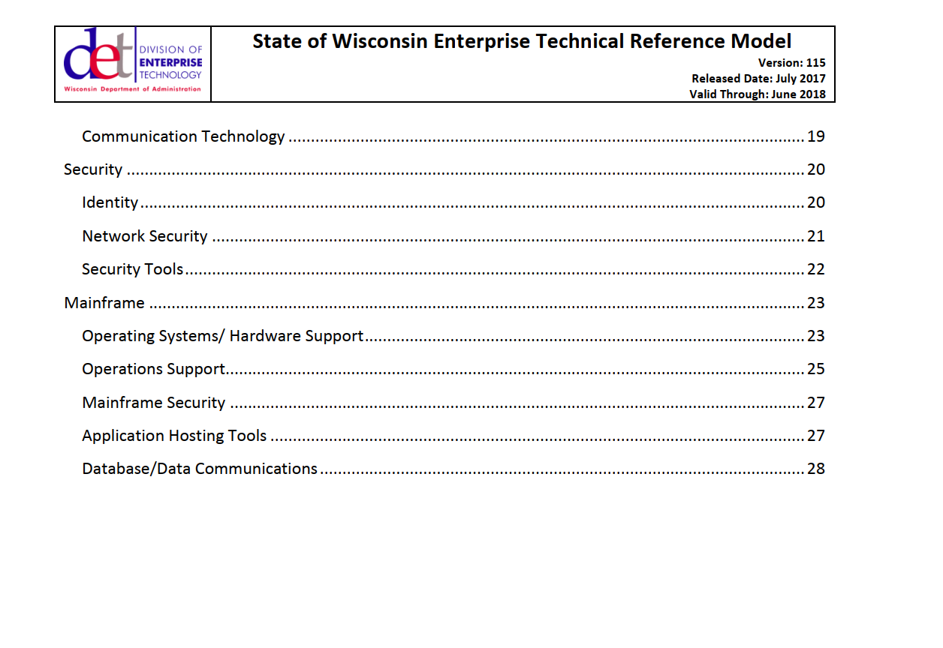

Using their language (“lingo”) will establish your team’s credibility, and make them think “hmmm, these guys have done some homework, I wonder how much they know, who they know on the inside here?”.

Here is what I would ask for in terms of the categories outlined in the TOC in this document - note that these are just some items that I found interesting, your forensics person may come up with a better / more informed list.

- Security - Identity

  - This is perhaps the most important category of systems and related information, as it goes to the heart of which users have access to WISVOTE, how they do multi-factor authentication with the hardware USB devices (i believe they call them fido keys).

  - Below is the list of products used to manage identity and access control for all systems in DET (not just WISVOTE or WEC systems).
  - 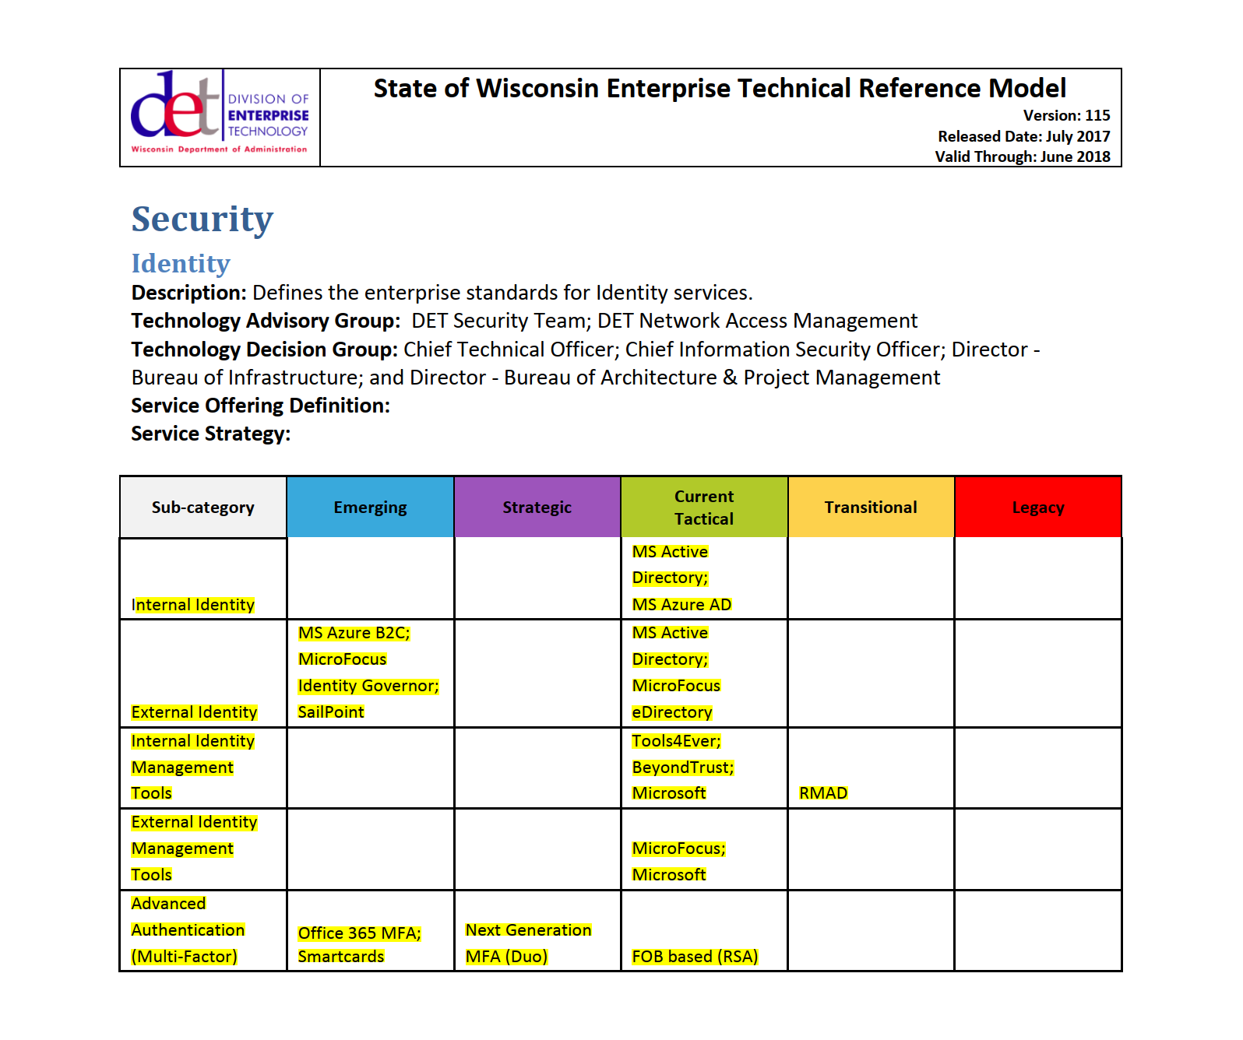
  - These are the Microsoft Active Directory products, which are very likely the products that include the authentication credentials for the 3000 users of WISVote.

  - Recall that one of the key issues to investigate, is the statement from this document, the June 14th 2018report to the municipalities:
    - 
    - It includes this statement about implementing multi-factor authentication:
    - 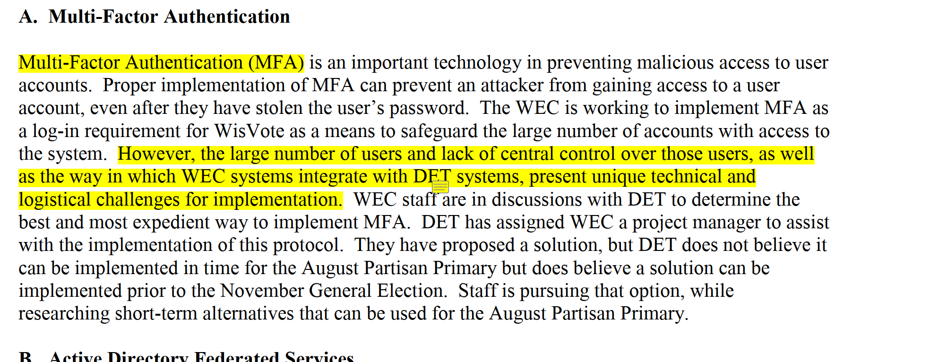
    - Determining how the “lack of central control over those users” was addressed is a key issue, especially since it seems you have heard that the FIDO/MFA hardware devices were freely copied and distributed.

  - Recall that another key issue raised in this document was the statement that WEC was looking to setup its own “Active Directory Federated Services” server, as explained in the June 14, 2018 document:
    - 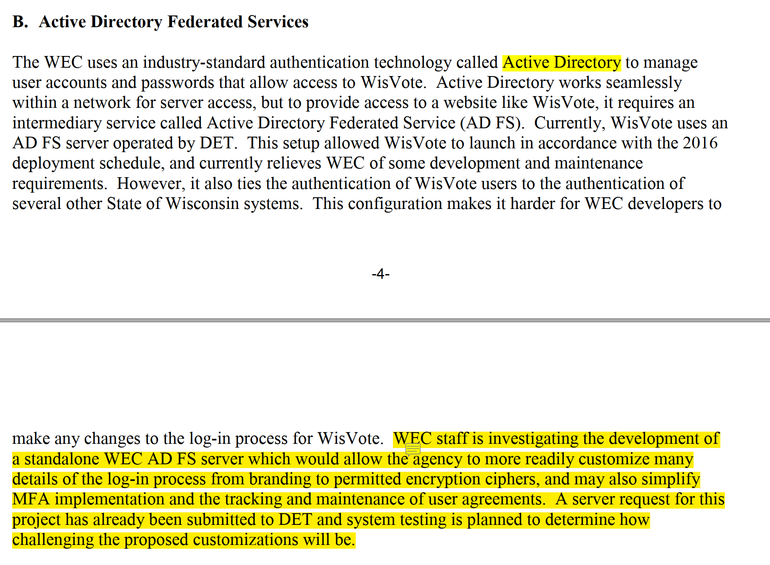
    - Need to investigate if this was ever done, and why. And of course, reviewing relevant log information from these servers would be important. If WEC administered which users had access to WISvote, this is where you will find all the users who were added, deleted, etc.

- Security Tools
  - 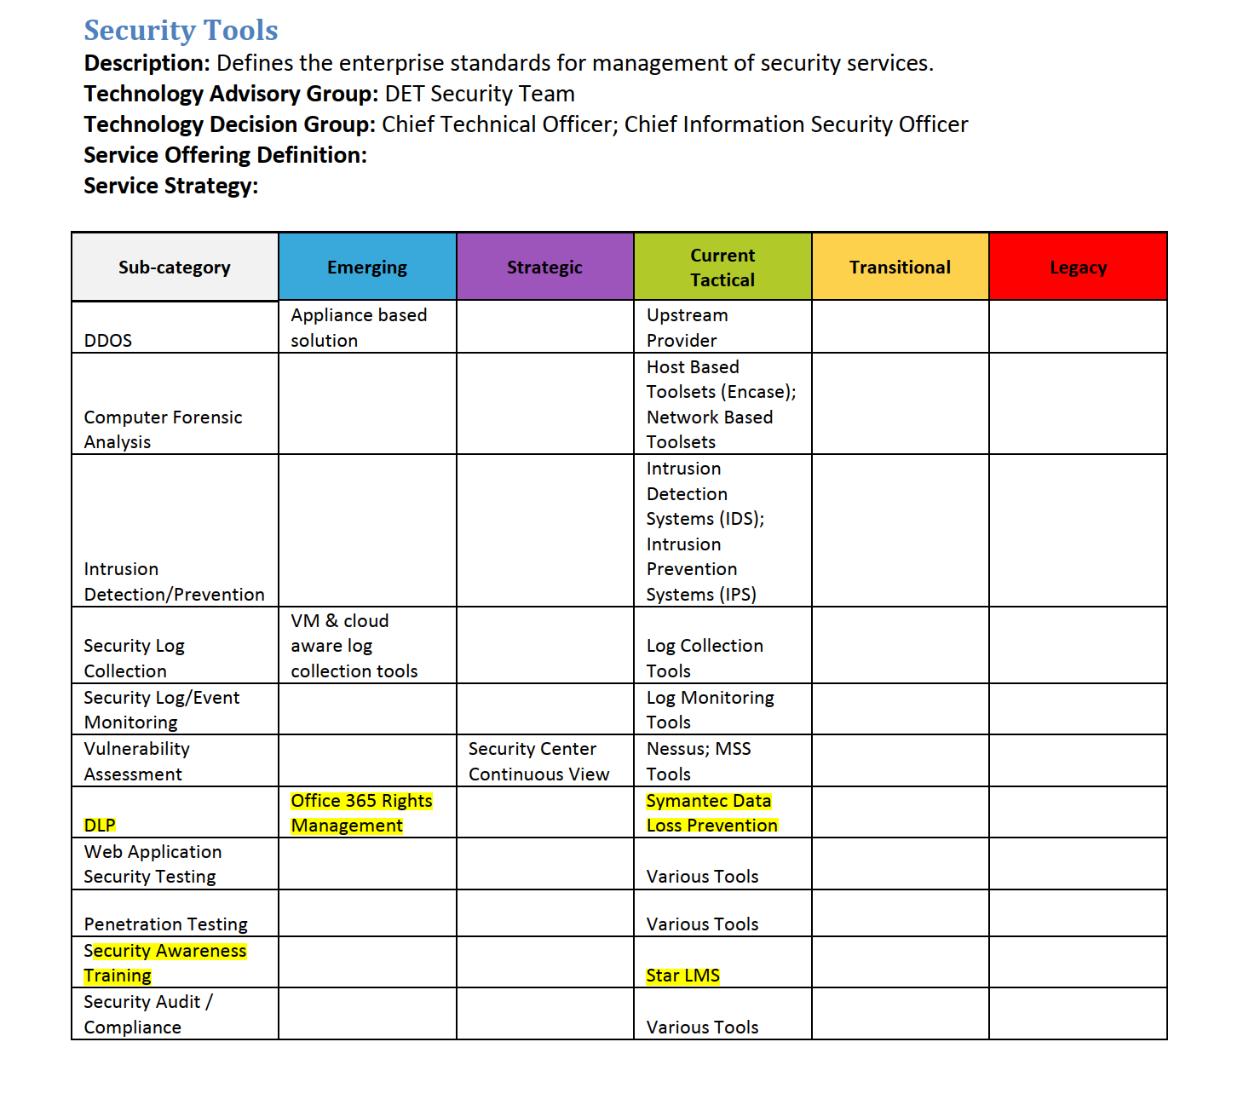
  - DLP stands for “data loss prevention”.
    - This is a VERY important to tool to get its logs and reports from whenever the network of not for profits was active, as this tool is the type of tool that may create a record/log entry when someone sends data out to one of the domains (like ctcl.com, natvoteathome.org, etc.).
    - Products are Symantec Data Loss Prevention and Office 365 Rights Management.
  - Remember that in a memo from Lori O’Bright, Outagamie County Clerk, she mentioned that WEC was looking at deploying behavioral analysis software - we want to find out from her if that was deployed / if she knows anything more about it - might have been this DLP software, but worth asking her / WEC:
    - 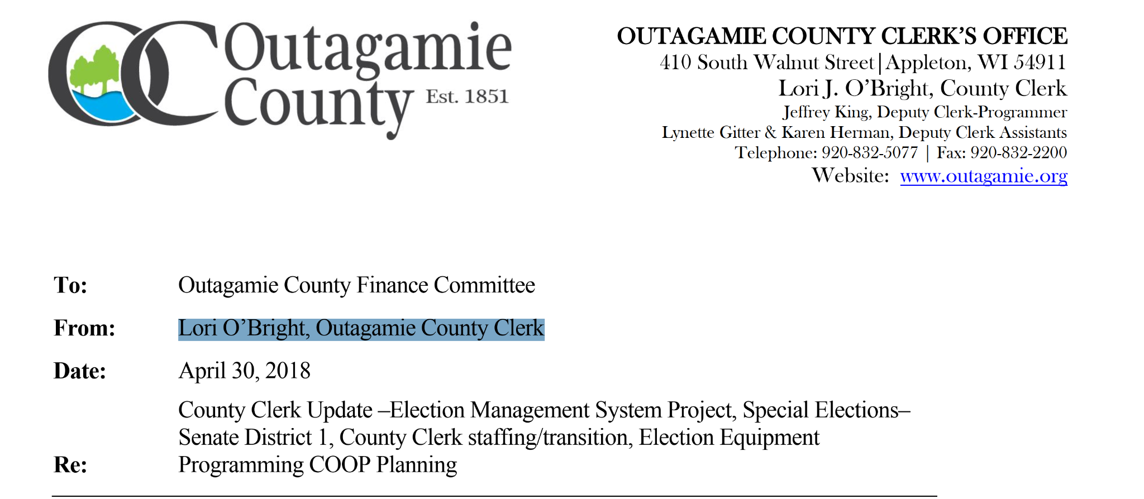
    - 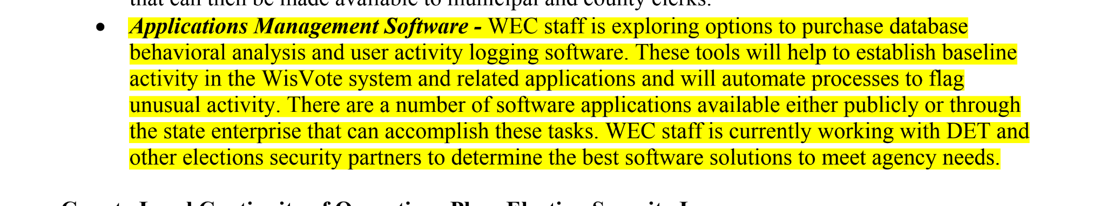
  - Security Awareness Training
    - This “Star” LMS (Learning Management System) may be a source of interesting information about their information security policies.

- Data Protection
  - 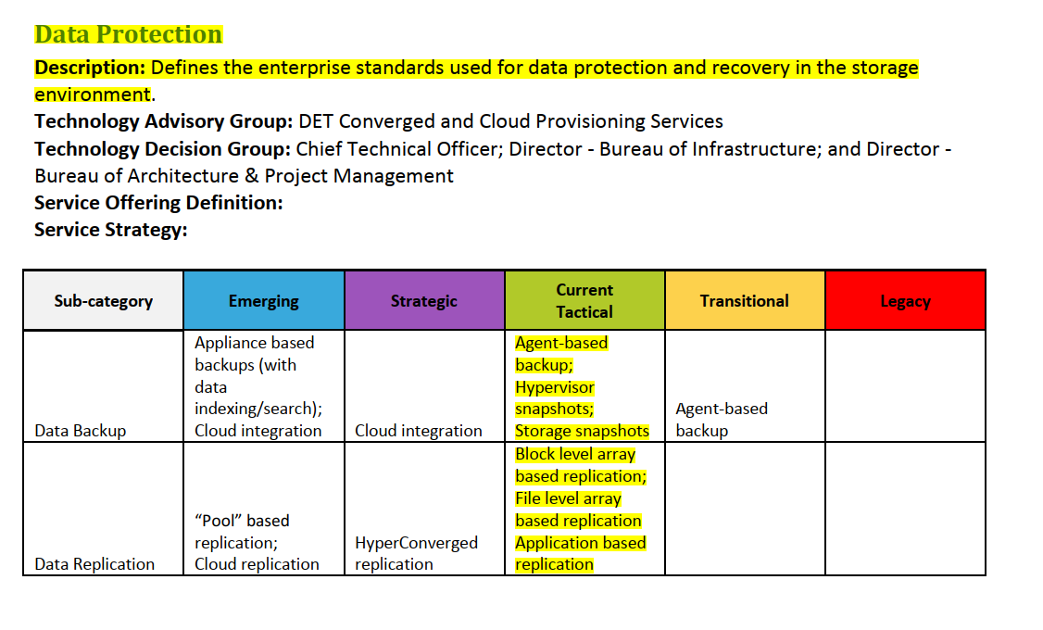

  - Background: For security reasons, they probably have a policy not to talk about which products they use (why advertise this to the bad guys - a good policy)
    - Make them provide you with a list of all technology products related to data protection that they have in use, including version numbers

  - Requests:You need to ask/find out the following:
    - Get a copy of their internal Data Protection policies and procedures documents
      - Why? This will help you understand what their standard policies are and if anyone has deviated from them, or if they say “oh, you know we backup everything daily except for the microsoft active directory federated services server”

    - What products and what versions of those products were used at the time of the election and which are used now
      - Why: for security reasons, they are not revealing what products they use for data security, you need a list so you know what products you need to ask about - log files to request from those products showing
        - Who logged in to do anything to the system’s configuration
        - What did they do?
- Network
  - 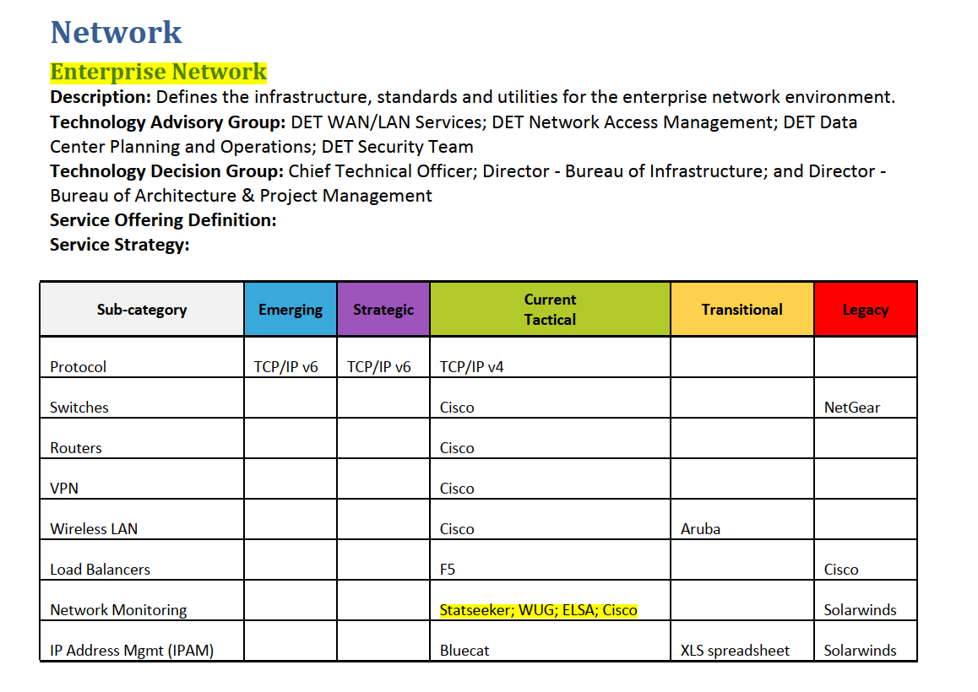
  - Background: these network products may be able to tell you the identity of every device - including the FIDO/RSA key devices used for multi-factor authentication I believe - that ever attach to the network, and potentially the IP address of device they were connecting from. Perhaps important if you really want to dig into when those FIDO keys are attaching to the network.

  - Statseeker
    - Notice what they say this product does - it tracks devices - like those FIDO/RSA security devices
    - 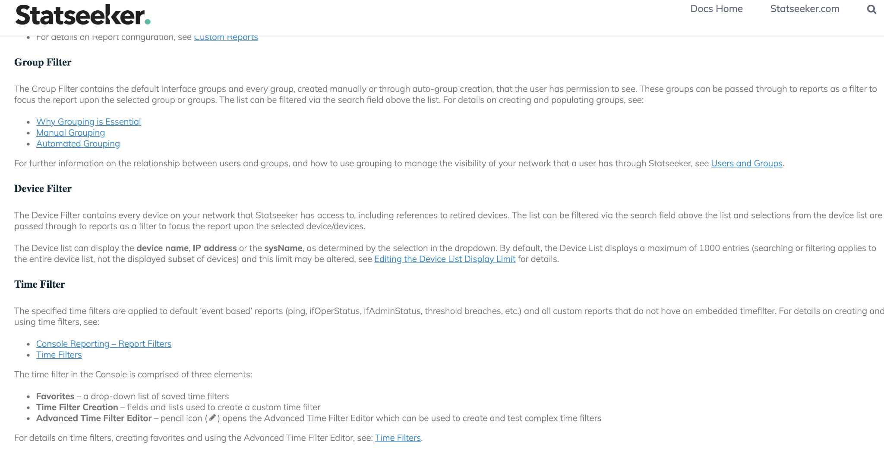

  - WUG (think that stands for “What’s Up Gold”:
    - 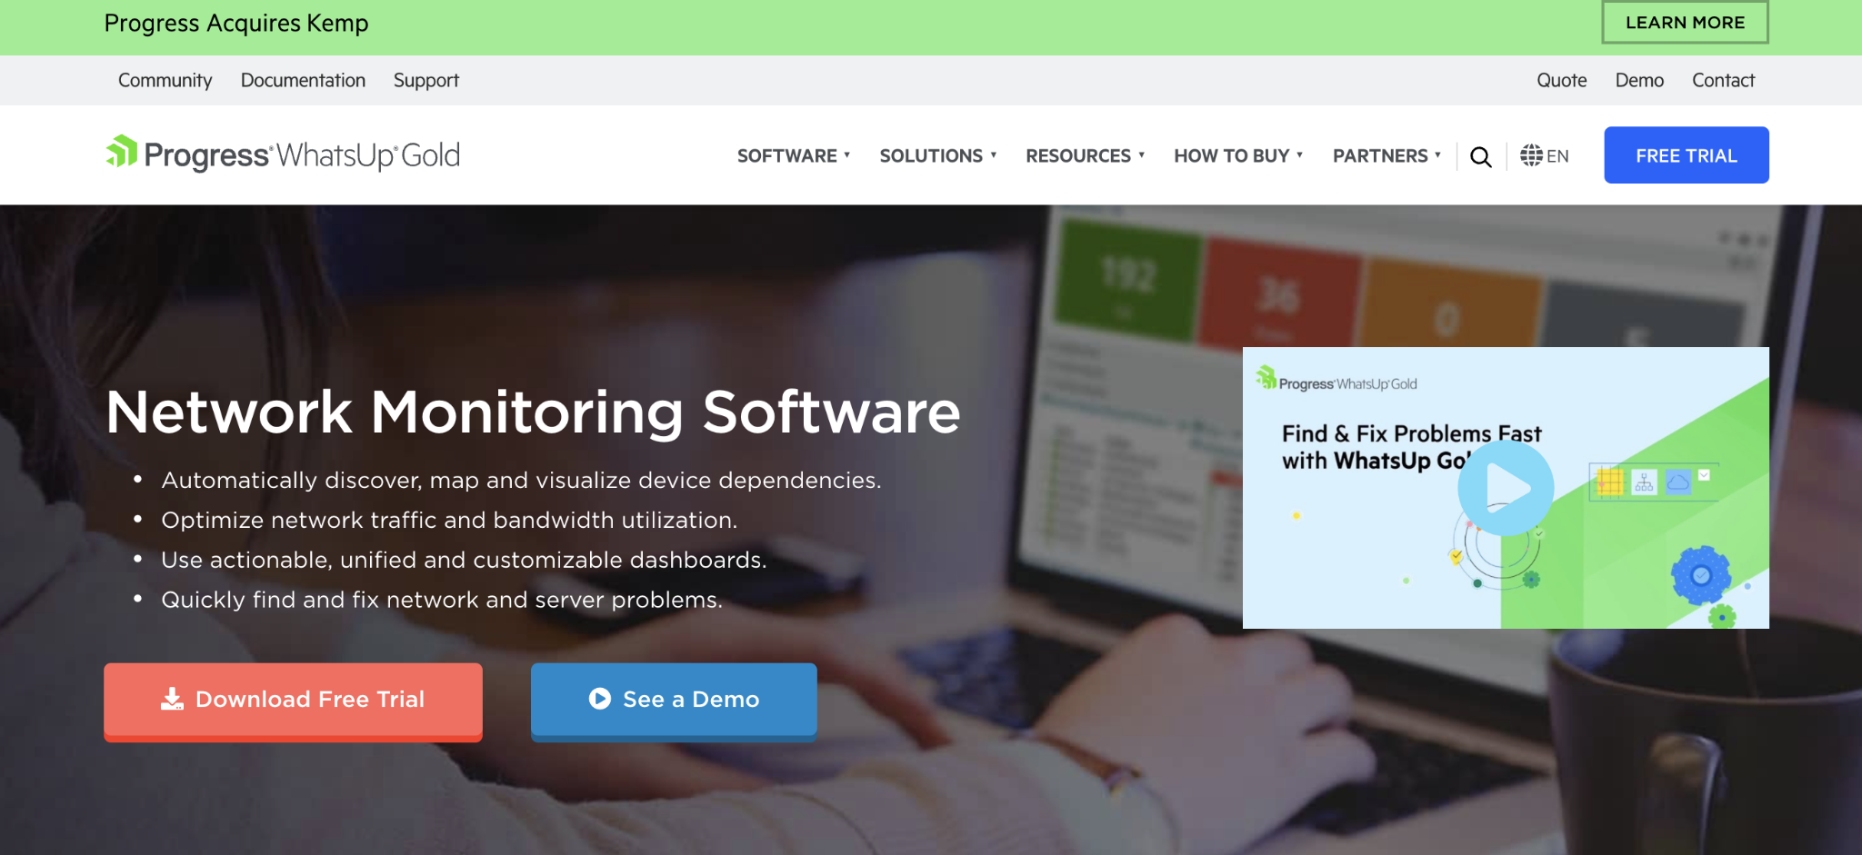
    - Background: network monitoring software
      - Your infosec guy will need to evaluate whether this network monitoring software could have anything of value for you in terms of logs, etc.
  - ELSA
    - Background: this one is probably quite important.
    - 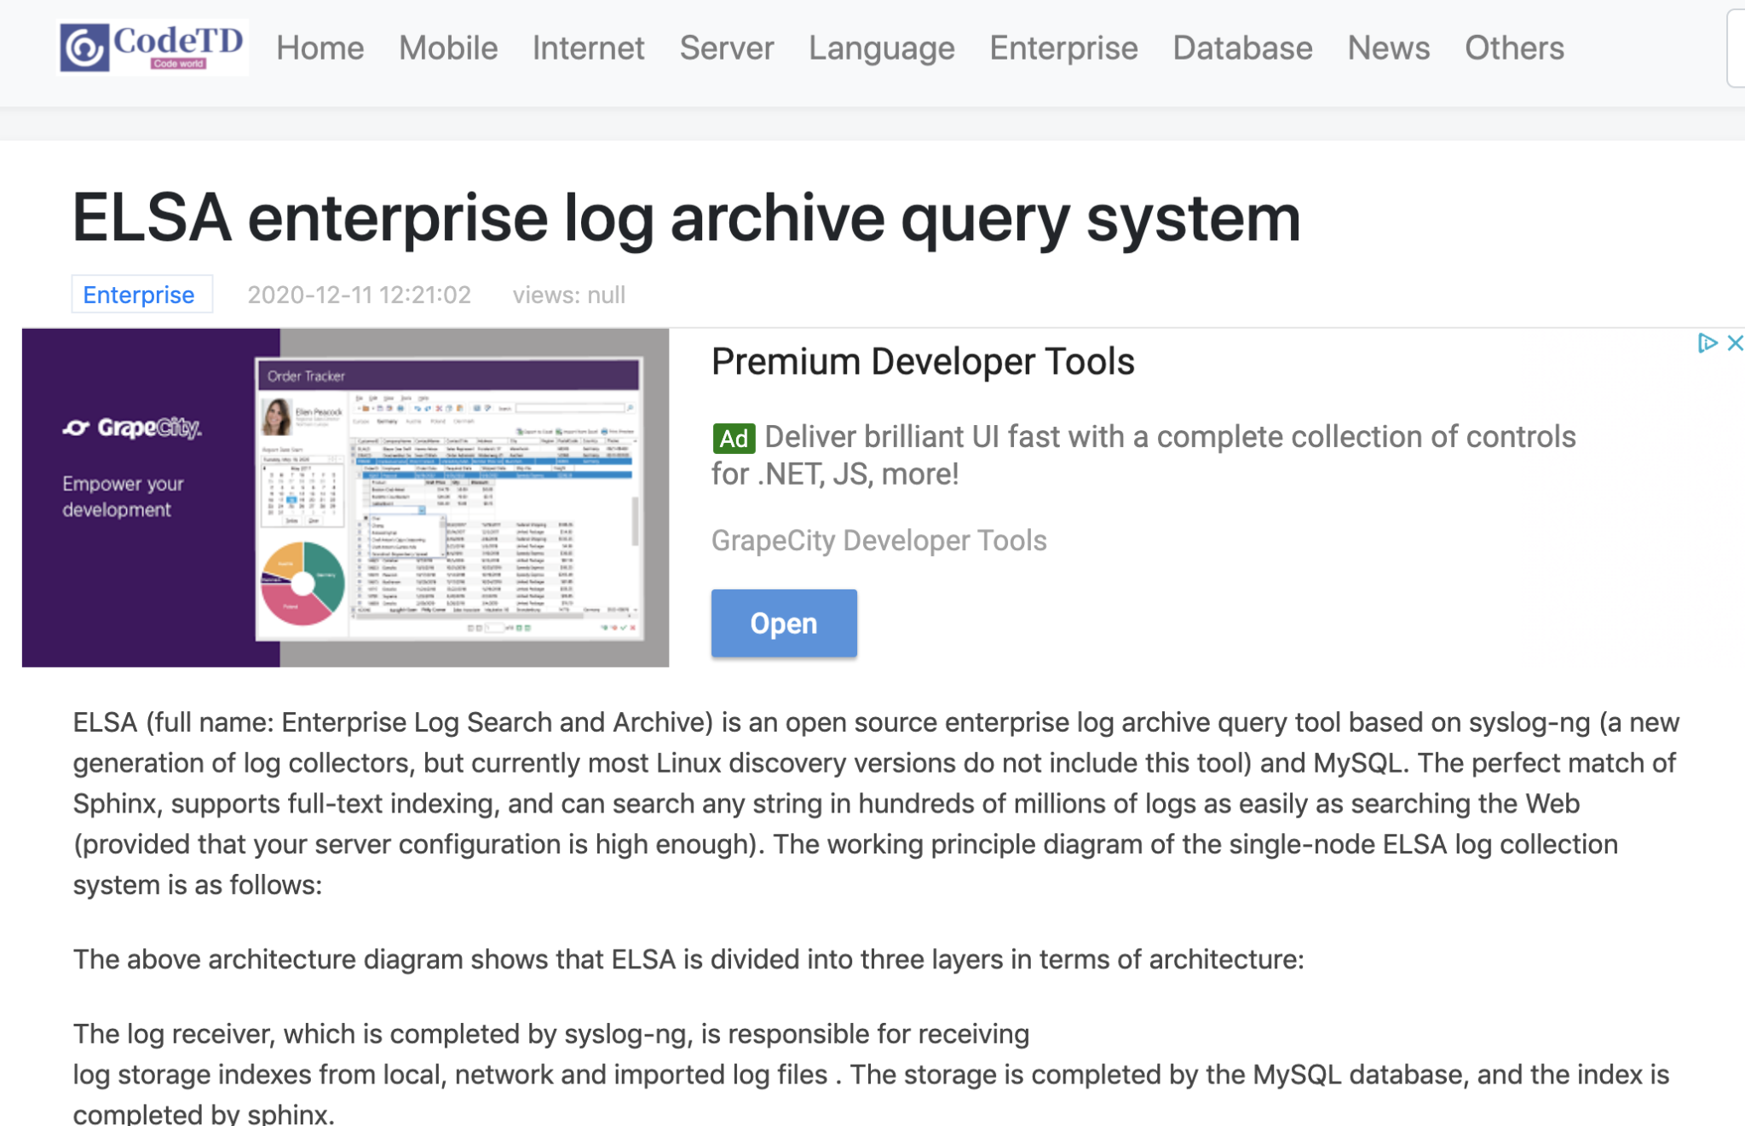
    - Enterprise Log Search and Archive
      - This is a tool they probably use to make it search through all of their system logs from multiple systems.
      - Definitely useful for your guy doing the forensics work!
  - Bluecat IP Address Management
    - This tool may contain useful information, since it logs IP address info
    - 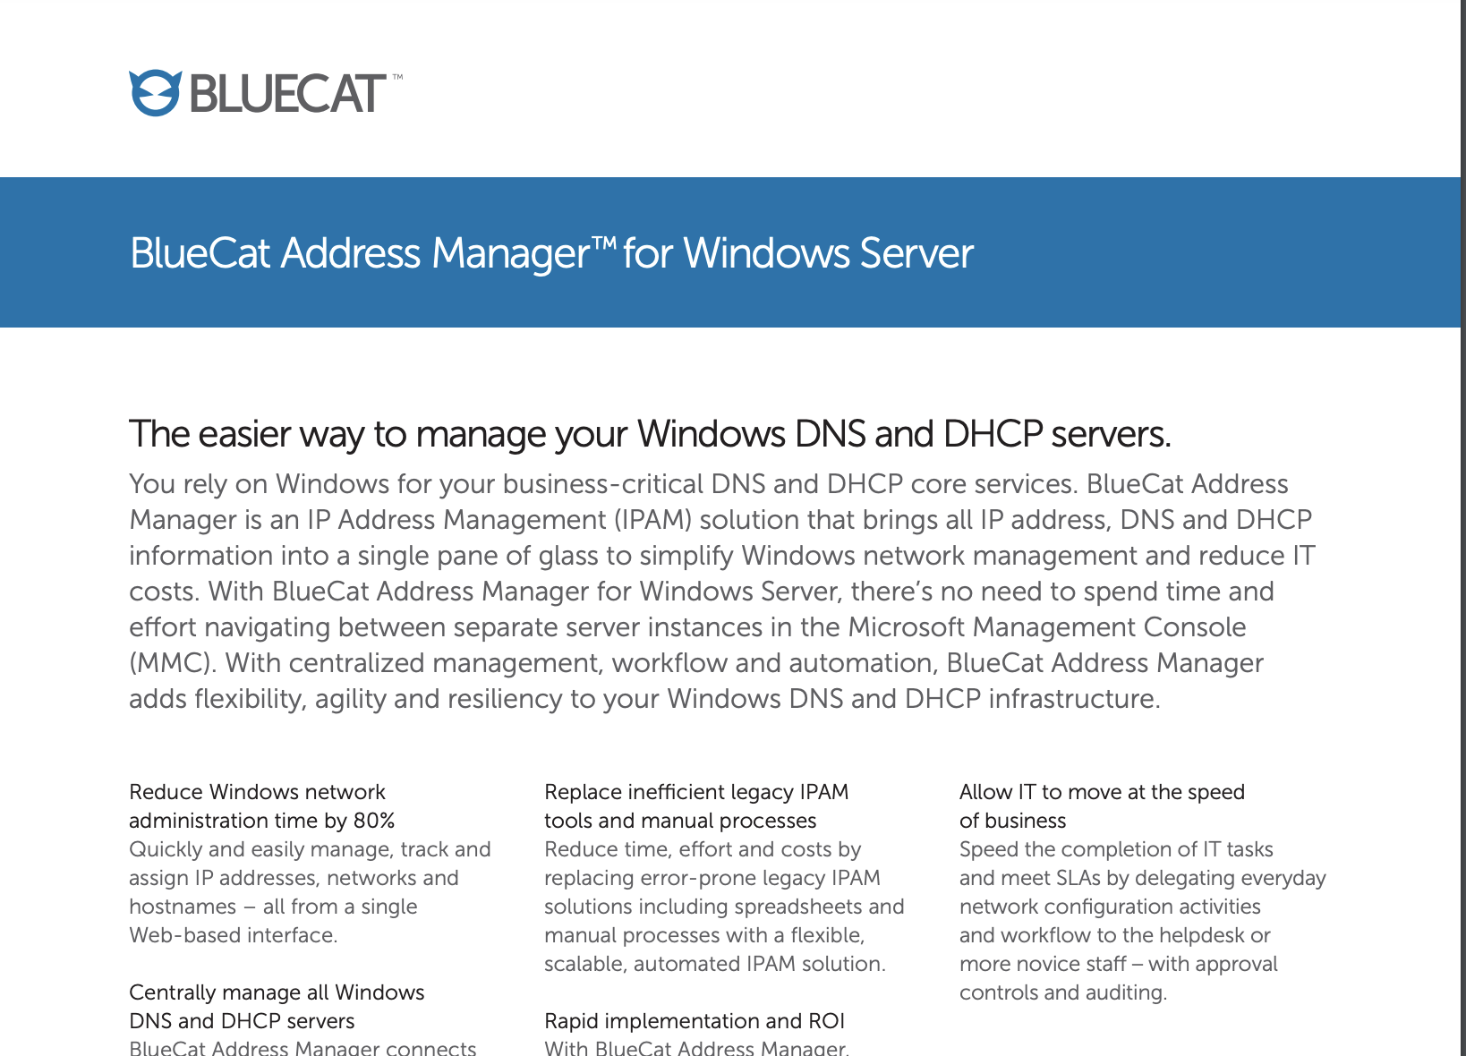
- Email
    - 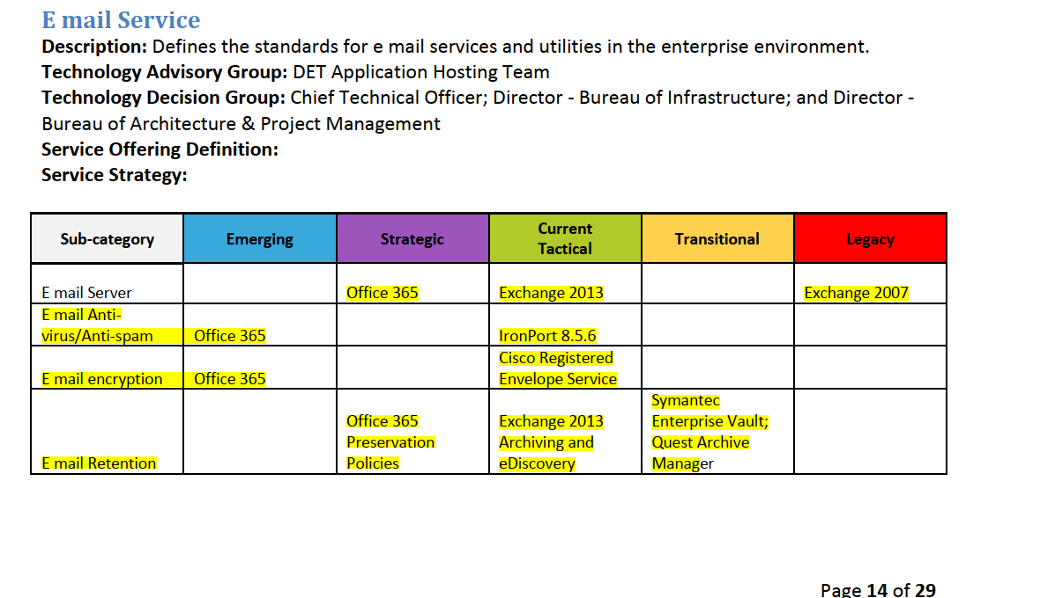
    - These products are all important to your email review.
      - The email system is Exchange 2013 (that’s an on premise, DET managed email service) and Office365 is a hosted solution - hosted meaning the servers are hosted at a microsoft facility.

    - Notice these products in list above that are for backing up / storing emails, so they will be of great interest to your team
      - Symantec Enterprise Vault
      - Quest Archive Manager
      - Exchange 2013 Archiving and eDiiscovery
      - Office 365 Preservation Policies
        - Some users of email in Wisconsin may be on Office365 (newer technology) and others may be on Exchange 2013 (older technology).

- Application Hosting
  - 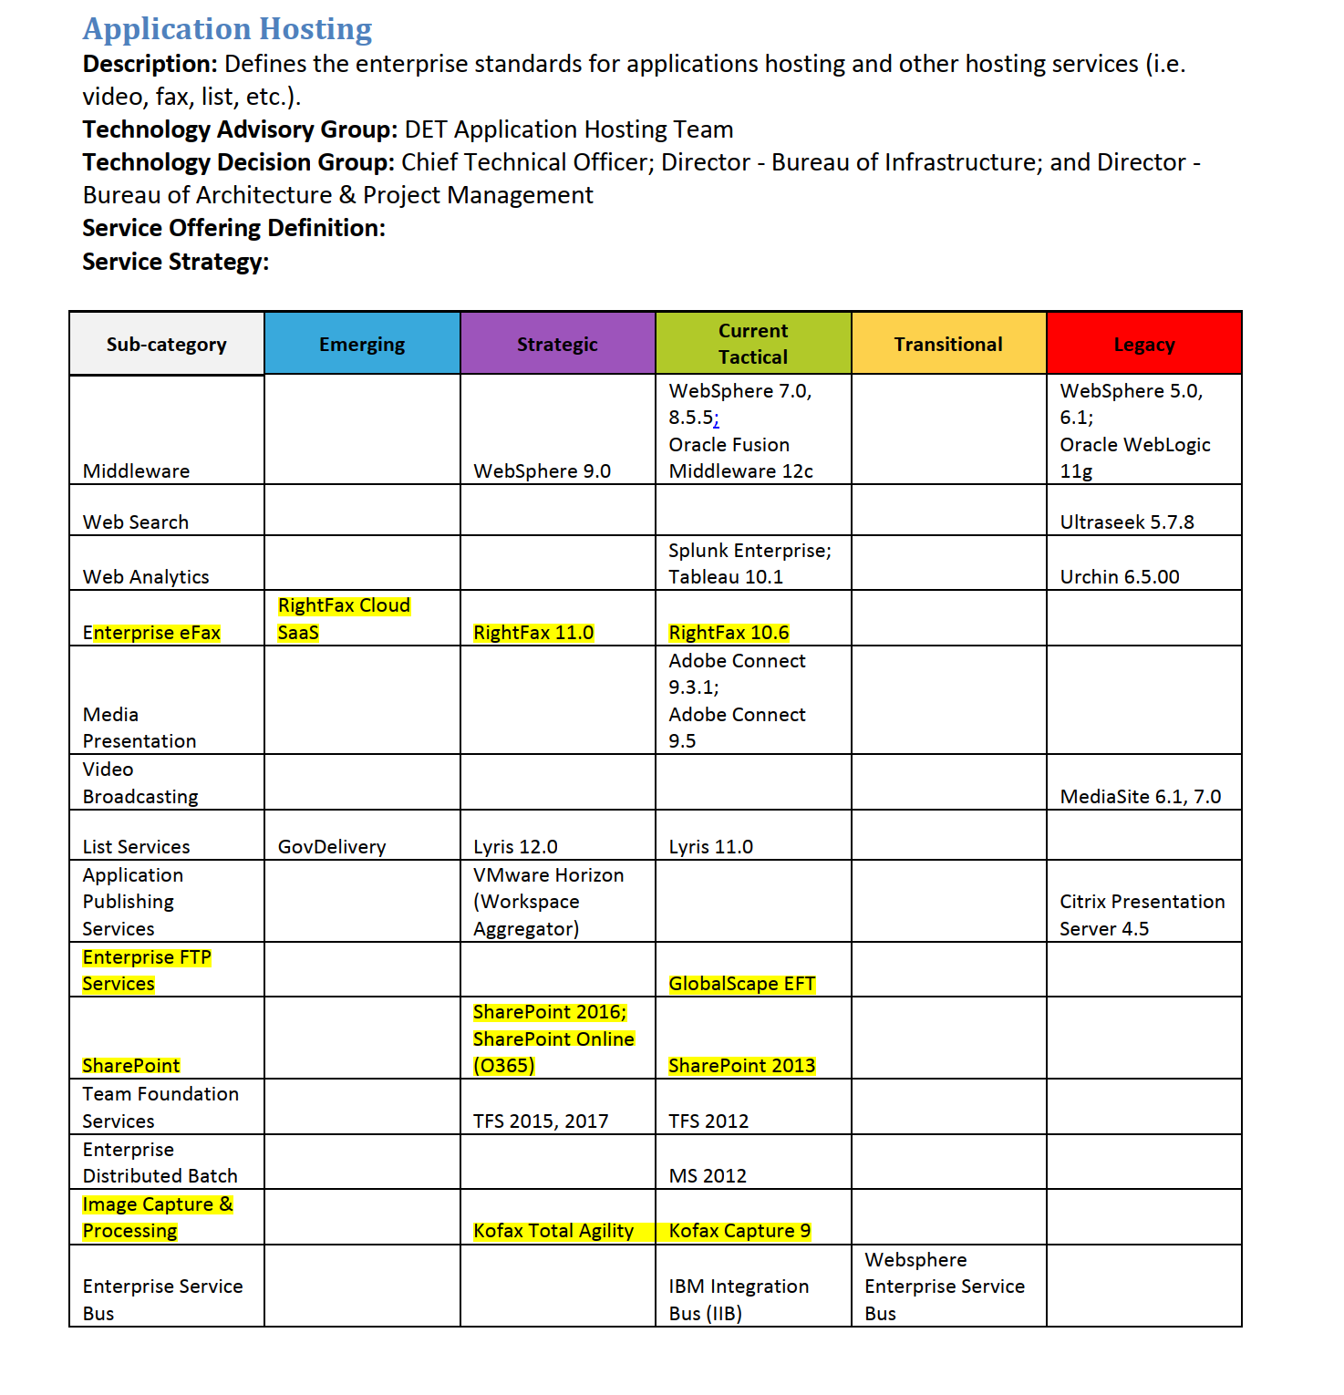
  - The products listed above are all products that could have been used to send information out of a clerk’s office:
    - Enterprise efax - RightFax - this is software on a computer that lets you send faxes from a computer
    - Enterprise FTP Services - Globalscape EFT
      - This is a “file transfer protocol” product where files can be placed so they can be downloaded
    - Sharepoint
      - A microsoft file sharing product
    - Image Capture and Processing
      - Kofax is another electronic scanning and faxing product

- Network Security
  - Your forensics person will find all of these products interesting - some of them may have logs showing people who visited ctcl’s site, etc.
  - 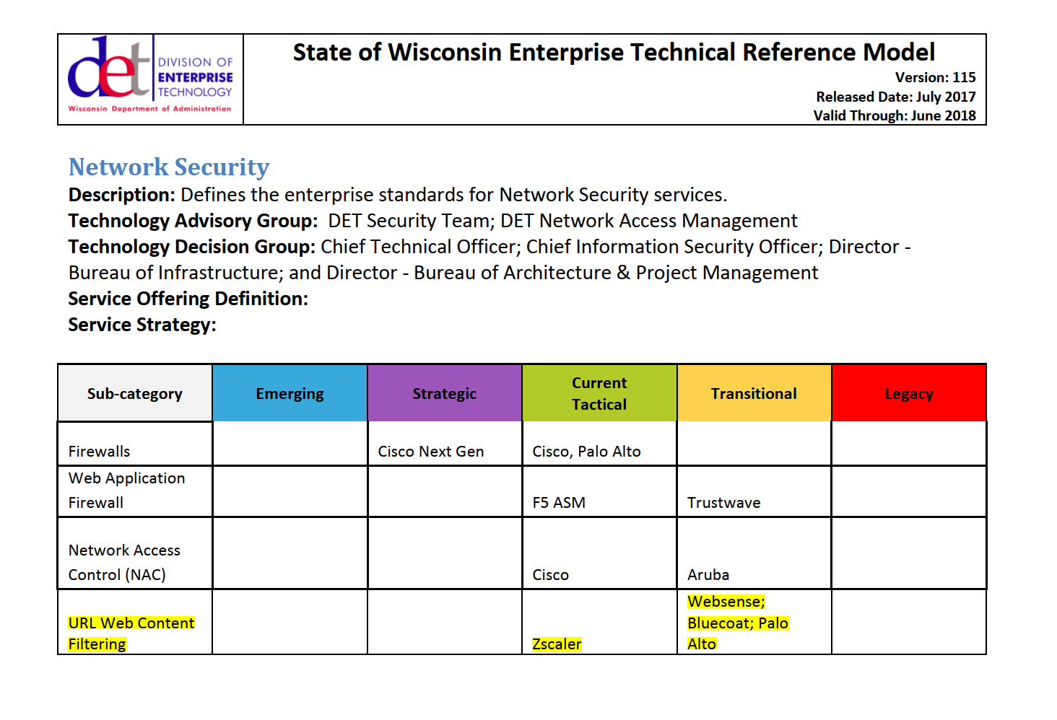
  - The zscaler product has some data loss protection (detects when data leaving the network) features, so it may yield some clues.

