  sc election system vulnerabilities whitepaper  [Document subtitle] | Abstract  A brief SC election machine vulnerabilities study identifying potential issues and risk reduction solutions to improve voter confidence and system security. scsafeelections.org

Overview: Much of the content for this whitepaper is built upon resources and insight from previously documented Election Assistance Commission reports and nationally trusted resources (see reference section for full listing & credits).
Part I of this whitepaper has been edited to specifically address South Carolina Election systems (ES&S 6.0.2.0) utilized in the 2020 Presidential election and specific analysis to address associated vulnerabilities.
Part 2 will address specific vulnerabilities that can be relevant in the South Carolina 2022 mid-term election utilizing ES&S version 6.1.1.0 as certified under the outdated VVSG 1.0 federal voting system standards.
Part I: Whitepaper on South Carolina Election System vulnerability 6.0.2.0.
Background:
Resent South Carolina Canvassing efforts were initiated by scsafeelections.org to review the outcome of the 2020 Presidential Election. What was identified in that effort was the potential for foreign actor interference within that election. This whitepaper was born out of concern from registered South Carolina voters as to the integrity of our states election process and the investment in the election machines used in that process. Many affidavits were signed by South Carolina registered voters to errors identified in the counting of those votes to state certification. Below are some results identified within this review:
- 22,016 votes that were counted outside the legal dates
- 2,598 or 30% of registrants that were evaluated were not eligible to vote due to a move more than 30 days prior to the election, death, or voting from a non-domicile (commercial property).
- Lost votes (people who state that they voted but there was no record of that vote in the rolls) in each county exceeded the allowable machine error rate
- There was a high number of deceased registrants on the rolls some of whom voted post death and many who had passed away more than 3 years ago.
- We found concerning data integrity issues such as 1,353 people whose date of registration is well before their date of birth
- There were also suspiciously high spikes in registration activity 6 months prior to the election.
- There were over 70 possible multiple state voters (voted in 2 states for the 2020 election)

“Forty-three percent of American voters use voting machines that researchers have found have serious security flaws including backdoors. These companies are accountable to no one. They won’t answer basic questions about their cyber security practices and the biggest companies won’t answer any questions at all. Five states have no paper trail and that means there is no way to prove the numbers the voting machines put out are legitimate. So much for cyber-security 101… The biggest seller of voting machines is doing something that violates cyber-security 101, directing that you install remote-access software which would make a machine like that a magnet for fraudsters and hackers.”, Senator Ron Wyden, D-Ore., during a March 21, 2018, U.S. Senate Intelligence Committee hearing, one of the numerous hearings that Congress convened to discuss election security following the 2016 election.
Computerized voting in South Carolina is largely complex and privately-run system conducted out of the public eye using complex encryption with very little oversight. Counting of ballots has been outsourced and audits are not transparent end to end reviews. Much of the SCVotes.org web page has code provided by a foreign owned company, Scytl, who according to Wikipedia was bankrupt May 11th, 2020 just before the 2020 US Presidential election and was in control of the Spanish government with government direction to sell assets in 2020. This means the trade secrets for electoral processing of an American Presidential election were in corporate transition weeks before the election. As the writing of this whitepaper, Scytl is still a foreign owned corporation. In summary, the citizens of SC as well as the state securities commission do not have access to the machines or source codes for the ES&S Election Management System machines or SCTYL reporting.
The figures below are a Scytl redirect website to the official SCvotes.org webpage.
Figure A. Scytl splash redirect insignia when opening enr-SCvotes.org
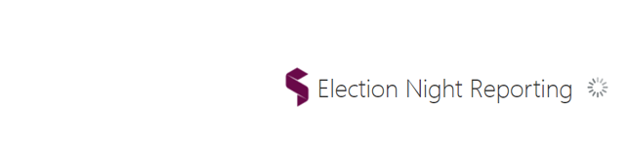

Figure B. SCvotes Election Night Reporting Front page
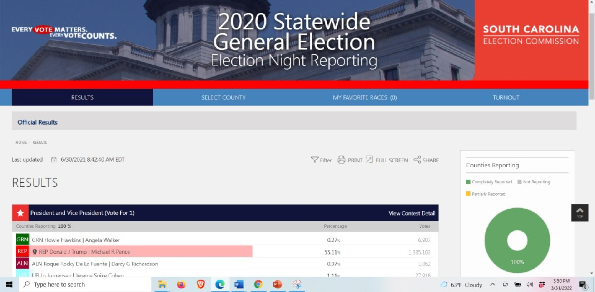

ES&S overview: The software source code and hardware design of the SC election system components are kept as trade secrets and therefore difficult to study or investigate. Yet if you do your research, you will find internet resources that provide data on the South Carolina ES&S election system 6.0.2.0 configuration used in the 2020 Presidential election. With detailed review of the same you can then identify specific election system vulnerabilities due to build type susceptibility. This whitepaper is authored to identify some of those vulnerabilities and the required counter-measures in order to scan for a more secure system.
- USB Vulnerability on completely isolated Election Machines:
Election systems do not need to be on the internet to be vulnerable. The US Department of Defense secure intranet is completely air-gapped, yet was vulnerable. Contrary to popular belief, all electronic voting equipment can be hacked because all such equipment must receive programming before each election from memory cards or USB drives prepared on election management systems which are often computers not only connected to a network (fully hackable) but also running out-of-date versions of Windows operating systems such as South Carolina’s ES&S 6.0.2.0.
If any county election management system is infected with malware, the malware can spread from that system to the USB drives, which then would transfer it to all the voting machines, scanners, and ballot-marking devices in the county or state depending on source.
In 2008, a serious breach in Pentagon information systems came from a single USB infected with a virus that spread through the Defense Department’s Secret Internet Protocol Router Network – the classified SIPRNet. This system is “Air Gapped”. After that hack, the Department of Defense restricted the use of USB drives, established programs to control and track personnel authorized to use them, and largely barred users by setting up computers without USB ports or restricting certain computer users to not recognize flash drives. Securing election systems should be as critical as securing America’s defense. SIPRNet is not connected to the internet, yet vulnerable.
In contrast, the election system programmed by local county election officials or third-party vendors, who could be plugging infected USB drives into computers connected to the internet, before plugging those same USB drives into the optical scanners, tabulators, and voting machines that collect, count, and determine election results. This is a major vulnerability as there is no method to validate the USB drives used in the election are “Virus-Free”. VIRUS SCANS OF FLASHDRIVES USED SHOULD BE SCANNED FOR VIRUS OR MALWARE BEFORE & AFTER ELECTION DAY USE.

- South Carolina used Out of date operating systems Windows 7 and Windows Server 2008
In 2019, the Associated Press reported that most election jurisdictions nationwide, including numerous swing states, were still using Windows 7 or older operating systems to create ballots, program voting machines, tally votes, and report counts. South Carolina is one of those states. The figure below is a representation of the Test Plan used to certify the South Carolina election system. No cybersecurity penetration testing is identified within this test plan. The SEC knew the operating systems was out of date.
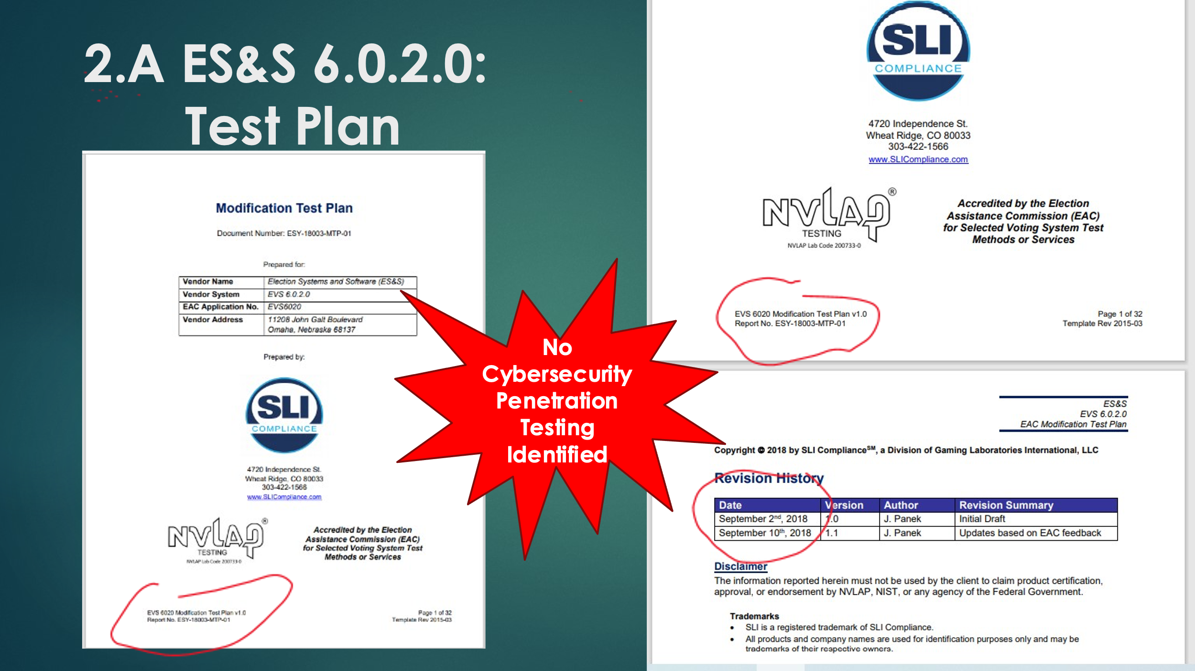
Windows 7 reached its “end of life” on Jan. 14, 2020, meaning Microsoft stopped providing technical support and producing “patches” to fix software vulnerabilities. A review of the certification test plan and report reveal the utilized software configuration. In the review of 2.B below, we must be able to answer the question was extended vulnerability protection procured and applied to the software package identified in the configuration details?
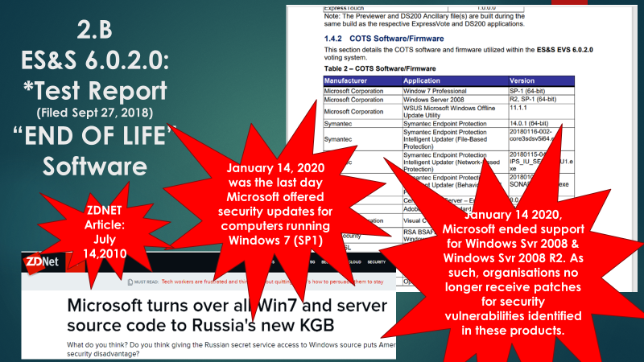

- Remote Access vulnerability
NBC News reported ten months before the 2020 election that ES&S, the largest U.S. election machine vendor, had installed at least 14,000 modems to connect their voting machines to the internet even though many election security experts had previously warned that voting machines with modems were vulnerable to hackers:
In Wisconsin, the Office of Special Counsel (OSC), headed by retired state Supreme Court Justice Michael Gableman, also found that ES&S voting machines were online and connected to the internet.
In Michigan, attorney and Secretary of State candidate discovered a Telit LE910-SV1 modem chip embedded in the motherboard of an ES&S DS200 voting machine, the same system used in South Carolina.
In South Carolina we have found wireless SSID location at polling places noting that remote access is available. The figure below is a screenshot from a voter outside of the voting location.
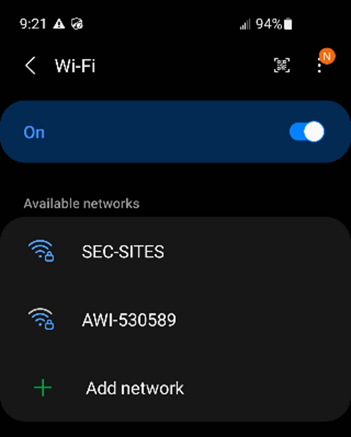
Through these modems, hackers could theoretically intercept results as they’re transmitted on election night or, worse, use the modem connections to reach back into voting machines or the election management systems to install malware, change software, or alter official results. Electronic Polling Books themselves may not only be vulnerable to attack, but also may allow bad-actor access into the rest of the system for manipulation of results.

- Vulnerabilities by the numbers, troubles by the score
The Cybersecurity and Infrastructure Security Agency (CISA) leads the national effort to understand, manage, and reduce risk to our cyber and physical infrastructure. In review of CISA available data we find that there are well over 100 vulnerabilities associated with any system utilizing the same configuration as the South Carolina voting system. The figure below represents just a small fraction:

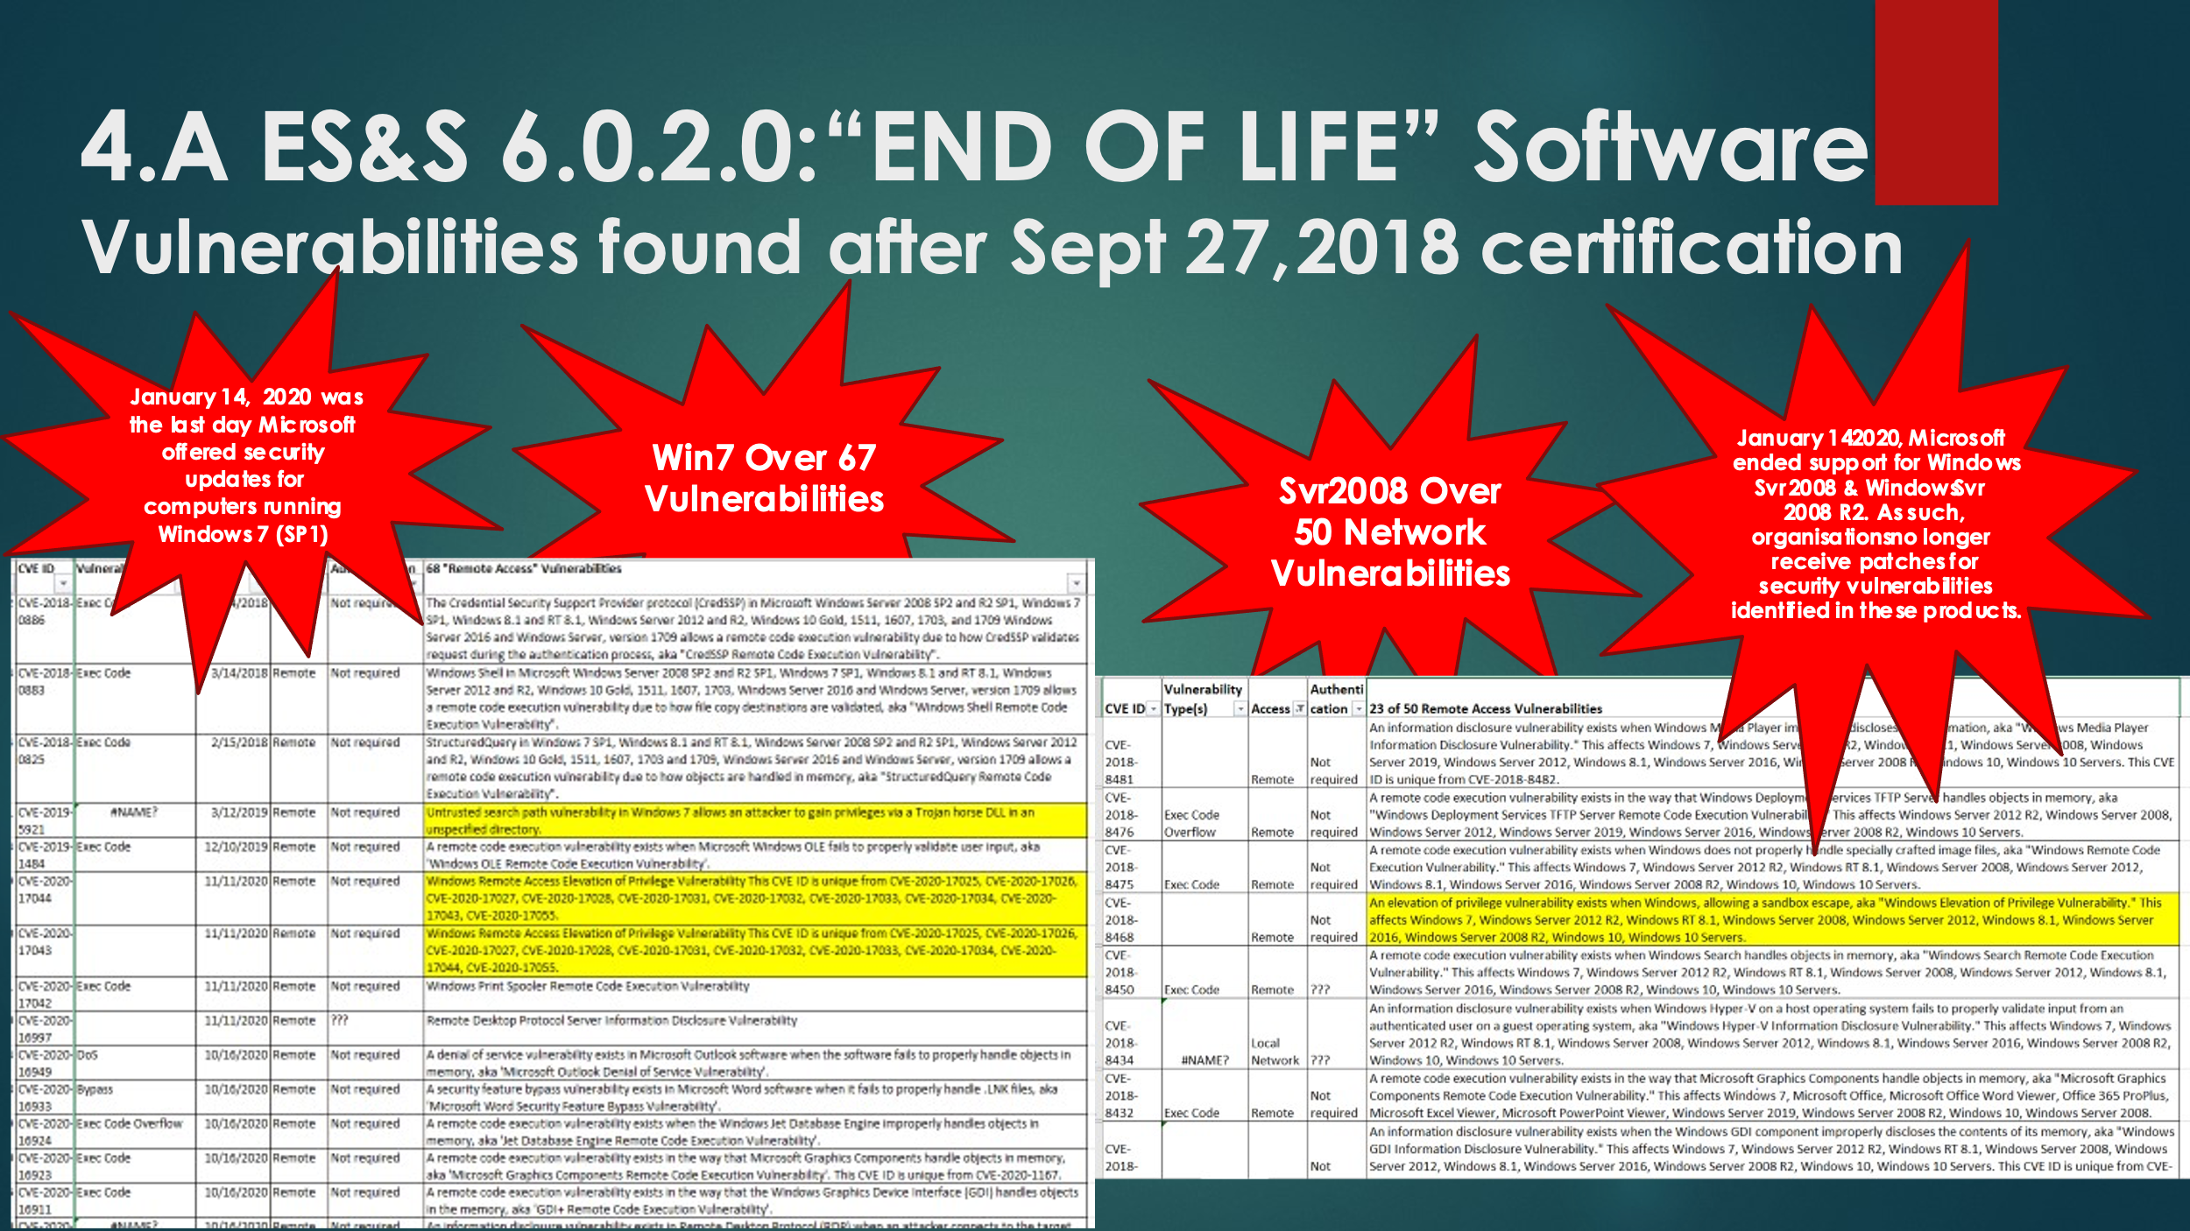
Any of the vulnerabilities could have been exploited in 2020. The issue here is, even if all the cybersecurity steps and scans were performed correctly to eradicate the possibility of any of these being exploited, we still have a problem. There were vulnerabilities that existed but were not discovered until after the Presidential election. A few of these are Log4J, Log4shell, & Daxin as seen on the next figure:
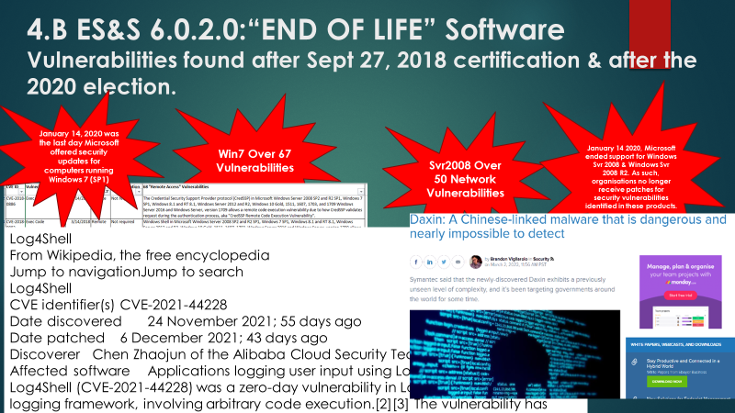
Log4Shell & Log4J was unnoticed from 2013 to 24NOV21. Here we recognize critical zero-day vulnerabilities identified that could not have been patched. With source code available, network vulnerabilities of plenty, and a cryptographic interface no one can trace (controlled by a foreign government). This system is primed for attack. Reference: The Common Vulnerabilities and Exposures (CVE) system provides a reference-method for publicly known information-security vulnerabilities and exposures. The United States' National Cybersecurity Federally Funded Research & Development Center, operated by The Mitre Corporation, maintains the system, with funding from the US National Cyber Security Division of the US Department of Homeland Security. The system was officially launched for the public in September 1999.
See the South Carolina election system cybersecurity operating system vulnerability data here:
- Conclusion
We have shown multiple vulnerabilities. We have not even considered the number of procedural issues and other weak links in voter rolls, phantom voters, out of state, or many other illegal opportunities to manipulate the electronic voting systems. Therefore, not only are hackers able to penetrate elections through vulnerable USB cards and election management systems, but also through the very voting machines themselves.
This isn’t a problem exclusive to elections, all computers are hackable and that is why election security experts have recommended hand-marked (water-marked) paper ballots and E2E (end to end) post-election audits.
This isn’t a partisan issue, both Democrats and Republicans are well aware of the secrecy, privatization, and hackable hardware and software that runs South Carolina elections.

Part II: Whitepaper on South Carolina Election System vulnerability 6.1.1.0.
Overview: ES&S 6.1.1.0 upgrade certification overview: Again, software source code and hardware design of the SC election system components are kept as trade secrets and therefore difficult to study or investigate. This segment of the whitepaper is authored to identify some potential vulnerabilities and the required counter-measures in order to help secure the 2022 SC Mid-Term elections. Please note the testing occurred in 2020 and associated vulnerabilities were discovered NOV/DEC 2021. Therefore, this system maintains some of the same vulnerabilities identified in Part I unless professionally scanned & patched. This EAC certification reference contains all test data associated with this review: https://www.eac.gov/voting-equipment/evs-6110.
The EVS 6.1.1.0 successfully completed conformance testing to the outdated Voluntary Voting System Guidelines version 1.0, not on the current Voluntary Voting System Guidelines (VVSG) version 2.0.
This embedded spreadsheet contains the VVSG 2.0 requirements.
According to SC LAW the election system must meet the minimum EAC requirement. The current minimum requirement is VVSG 2.0. In addition, as provided in §5.9 of the EAC’s Voting System Testing and Certification Program Manual (Certification Manual), for an Initial Decision of certification to become final and to issue a certification number and a Certificate of Conformance, a manufacturer must provide documentation to the Program Director verifying that the trusted build has been performed, software has been deposited in an approved repository, and system identification tools are available to election officials. A manufacturer must submit a letter, signed by both its management representative and a Pro V&V official, stating (under penalty of law) that it has: 1. Performed a trusted build consistent with the requirements of §5.6 of the EAC’s Certification Manual; 2. Deposited software consistent with §5.7 of the EAC’s Certification Manual; 3. Created and made available system identification tools consistent with §5.8 of the EAC’s Certification Manual (a copy and description of the system identification tool developed must be provided with the letter); and 4. Upon a final decision to grant certification, the manufacturer accepts the certification and all conditions placed on the certification. It is imperative that SC SEC ensure these minimum requirements are met.
New legislation has recently been signed that will impact the use of such election systems in South Carolina. However, this does NOT remove the responsibility of the State Election Commission to ensure the security of such election machines used throughout the state. Cybersecurity and applicable process vulnerabilities must be addressed upon discloser of such, and if not reasonably circumvented, paper ballots must be utilized to secure the election integrity. The figure below shows the applicable statute updates associated with S108.
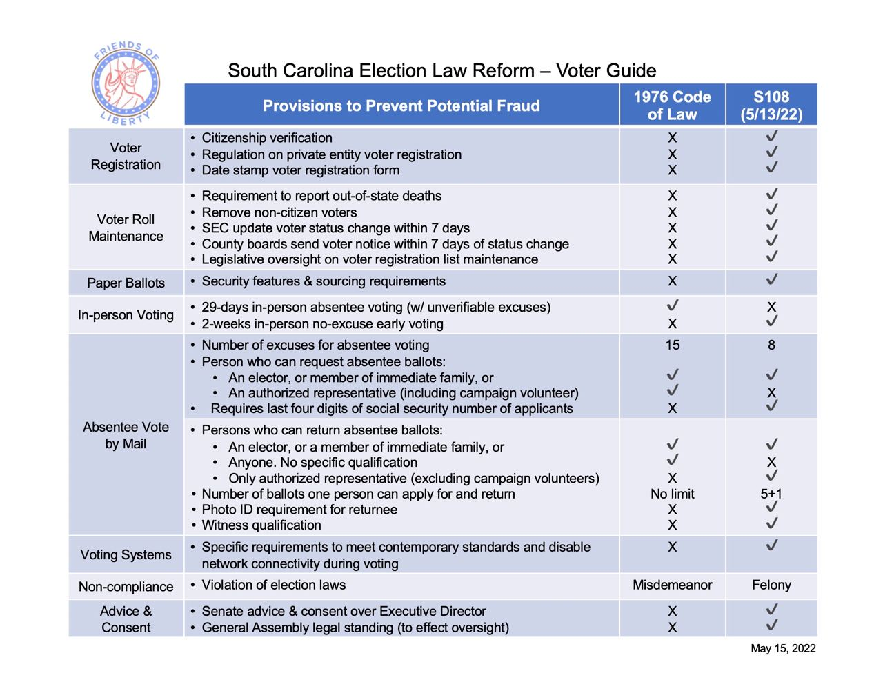

- South Carolina used Out of date Security Patch Windows 10 and Windows Server 2016
The figures below represent the 6.1.1.0 election system components Test Plan which is to document the procedures that the certified independent laboratory will follow to perform certification testing during a system modification campaign for the Election Systems and Software (ES&S) Voting System (EVS) 6.1.1.0 (EVS 6.1.1.0) to the requirements set forth for voting systems in the U.S. Election Assistance Commission (EAC) 2005 Voluntary Voting System Guidelines (VVSG), Version 1.0. The current test plan does not address the VVSG 2.0 requirements. This would mean the current system as tested does not meet the minimum requirements as outlined in South Carolina Law. The figure below is a representation of the Test Plan used to certify the South Carolina election system. In addition, No cybersecurity penetration testing is identified within this test plan. The SEC should take immediate action to address this issue. As addressed in Part I of this whitepaper, there are known cybersecurity vulnerabilities that have been identified since the certification of version 6.1.1.0.

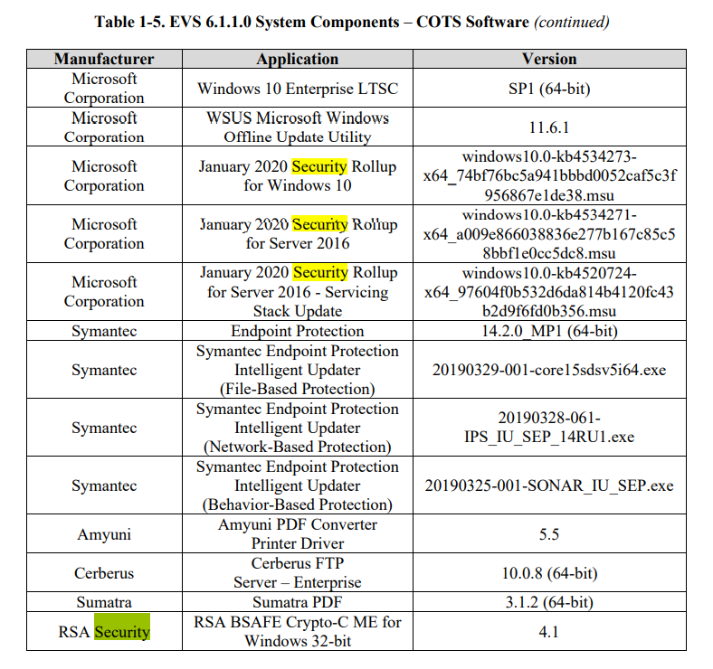
- Remote Access vulnerability
As noted in Part I, NBC News reported ten months before the 2020 election that ES&S, the largest U.S. election machine vendor, had installed at least 14,000 modems to connect their voting machines to the internet even though many election security experts had previously warned that voting machines with modems were vulnerable to hackers:
- Wireless Network Connection Vulnerability on “Air-Gapped” Election Machines:
Election systems do not need to be on the internet to be vulnerable. Wireless vulnerability exists as identified by EAC. February 2021, the U.S. Election Assistance Commission, the federal board that sets guidance on how Americans vote, adopted a comprehensive, and long-awaited update to its security standards on election technology. But while the election security community largely embraced the Voluntary Voting System Guidelines 2.0, the EAC stopped short of banning wireless connectivity in ballot scanners and electronic tablets, a decision that led to a group of technologists and former election officials saying that even switched off, wireless capabilities pose a security risk. Access can be through these wireless cards or printers, even if used for ancillary poll registration validation.
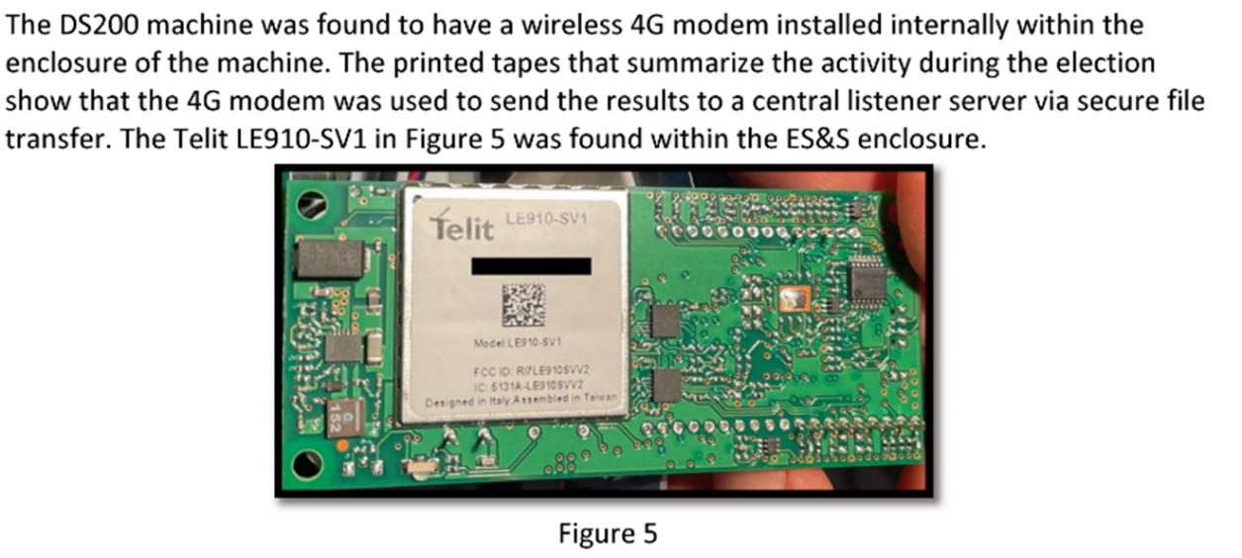

Smartphones and wireless network access cards, such as those found in the ES&S DS200, give users mobile access to email, the internet, GPS navigation, and many other applications. However, smartphone security has not kept pace with traditional computer security. Technical security measures, such as firewalls,
antivirus, and encryption, are uncommon on mobile phones, and mobile phone operating systems
are not updated as frequently as those on personal computers. Mobile social networking
applications sometimes lack the detailed privacy controls of their PC counterparts. Unfortunately, many smartphone network users do not recognize these security shortcomings. Many users fail to enable the security software or update the associated security patches that comes with their networks, and they believe that network connectivity on their “Air-Gapped” systems is as safe as or safer than surfing on their computers. Meanwhile, mobile phone networks are becoming more and more valuable as targets for foreign-actor attack.
In South Carolina we have found wireless SSID location at polling places noting that remote access is available. The figure from the manual below shows Electronic Poll Book capability within the system.
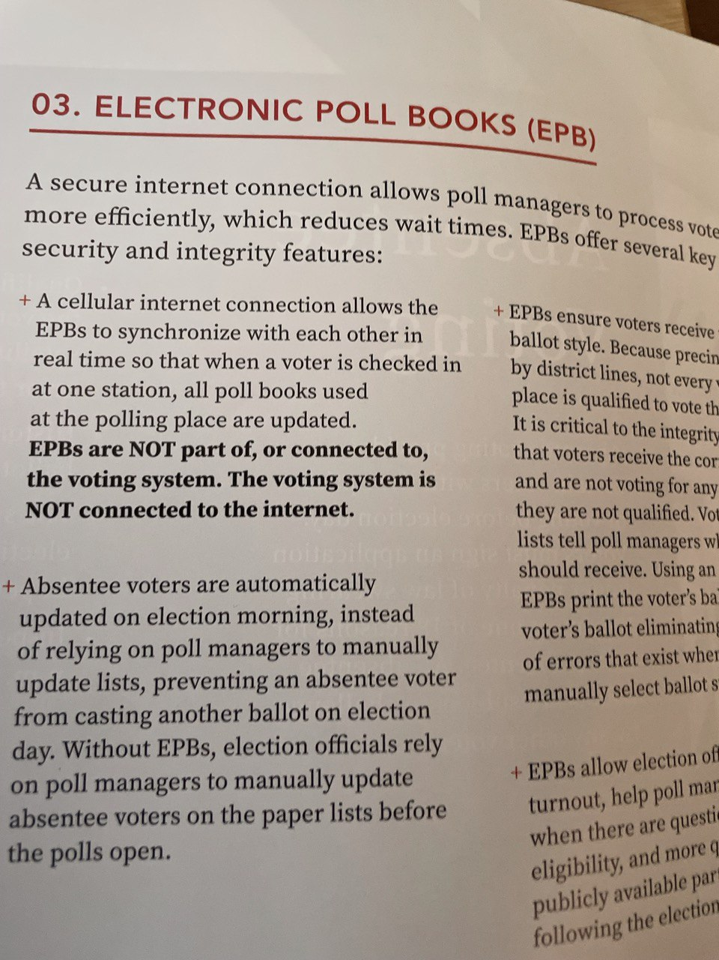
Through these modems, hackers could theoretically intercept results as they’re transmitted on election night or, worse, use the modem connections to reach back into voting machines or the election management systems to install malware, change software, or alter official results.
This team has been made aware of the potential for cell phone interference from localized cell phones in the vicinity of polling places. In fact, there is policy in place that request cell phones not be used by those who are voting. Yet page 5 of the South Carolina Poll Managers Handbook states that cell phones are to be on and charged at all times. Are these cellular networks monitored for validation of security protocols?
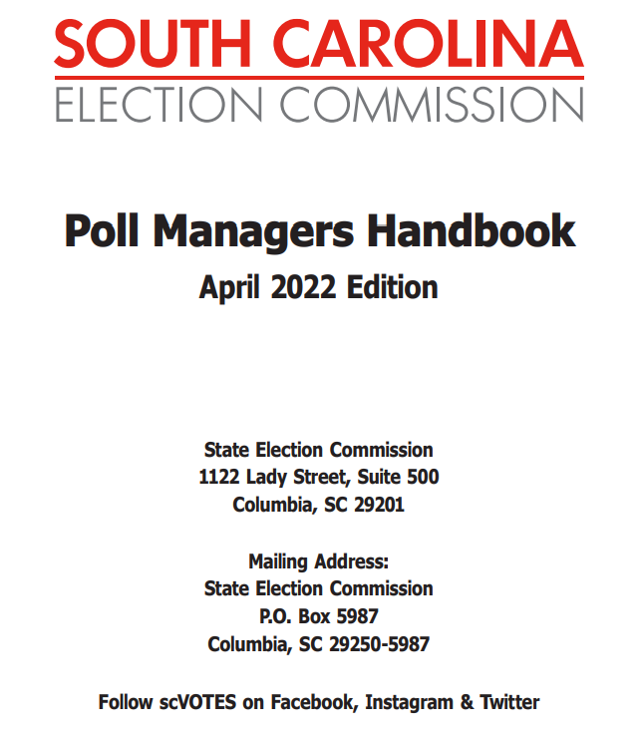
- ES&S 6.1.1.0 Continued Vulnerabilities by the numbers, troubles by the score
The Cybersecurity and Infrastructure Security Agency (CISA) leads the national effort to understand, manage, and reduce risk to our cyber and physical infrastructure. In review of CISA available data we find that there are well again well over 100 vulnerabilities associated with the updated WIN10/SVR2016 election systems now setup as the South Carolina voting system.
Many of the vulnerabilities that could have been exploited in 2020, could still be available for exploitation in the new system. The issue here is, the cybersecurity patches, steps, and scans need to be performed correctly to eradicate the possibility of any of these being exploited. There are vulnerabilities that exist, but they are not integrated into the ES&S 6.1.1.0 build. A few of these continue to be Log4J, Log4shell, & Daxin as seen in Part I.
Log4Shell & Log4J is still unpatched & unnoticed from 2013 to 24NOV21. Here we recognize critical zero-day vulnerabilities identified that could not have been patched. This system is again primed for attack. Reference: The Common Vulnerabilities and Exposures (CVE) system provides a reference-method for publicly known information-security vulnerabilities and exposures. The United States' National Cybersecurity Federally Funded Research & Development Center, operated by The Mitre Corporation, maintains the system, with funding from the US National Cyber Security Division of the US Department of Homeland Security. The system was officially launched for the public in September 1999. See the South Carolina election system 6.1.1.0 cybersecurity operating system vulnerability data here:
- Conclusion
Noting the applicable resources outlined by the SEC, there is security partnership of state, federal and private cybersecurity professionals as well as state and federal law enforcement and intelligence agencies to assist in securing the 2022 election. However, we must recognize that these partnerships must be more than just available, they must be engaged in securing the system. As certified, the ES&S 6.1.1.0 still has shown multiple vulnerabilities. We have not even considered the number of procedural issues and other weak links in voter rolls, phantom voters, out of state, or many other illegal opportunities to manipulate the electronic voting systems. In addition, we would like to see an audit process that is able to validate vote selection from poll to state certification including the SCYTL election night reporting. As we look into the system configuration of 6.1.1.0 below, we recognize the voting process used within the configuration shown must be compliant.
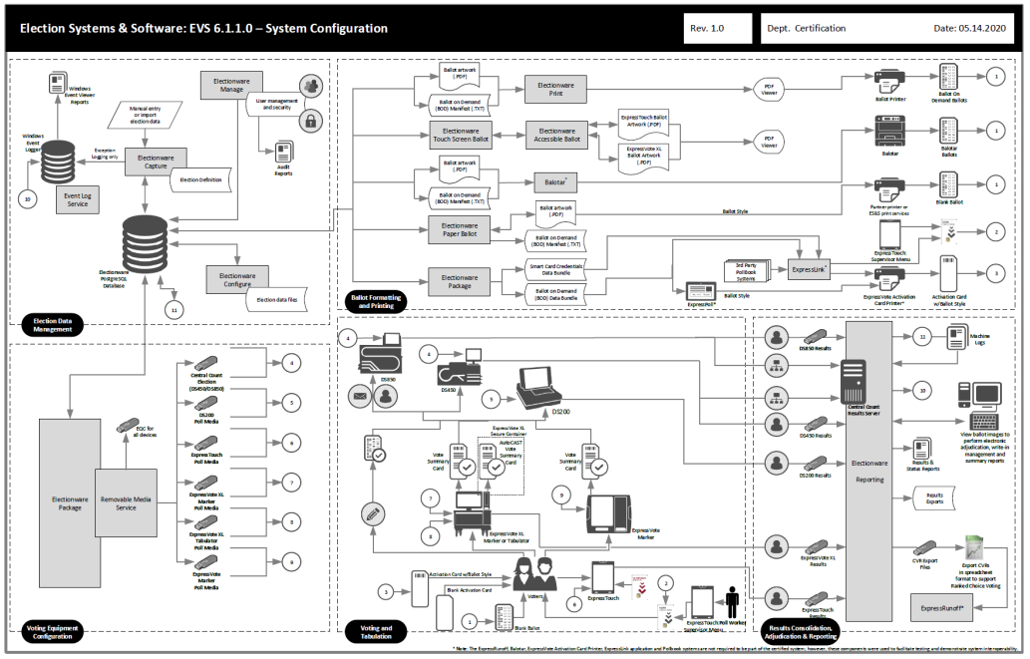
To maintain certification this process must be strictly adhered to and any deviation of system configuration or how the system is used can make the accreditation null & void. Network vulnerabilities isn’t a problem exclusive to elections all computers are hackable and that is why election security experts have always recommended hand-marked paper ballots and rigorous post-election audits. Therefore, not only are hackers able to penetrate elections through vulnerable USB cards, wireless cards, and election management systems, but also through the very voting machines and or associated process themselves.

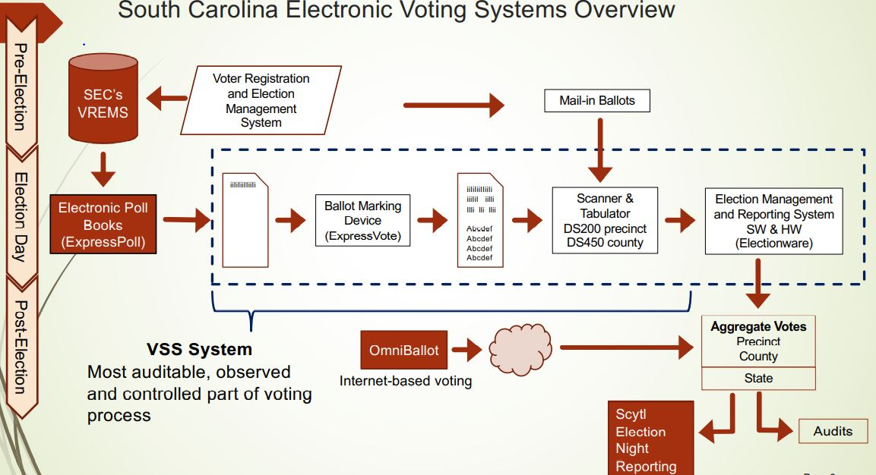
Provided by friendsofliberty.co

This isn’t a partisan issue, both Democrats and Republicans are aware of the secrecy, privatization, and hackable hardware and software that runs South Carolina elections. South Carolina registered voters should be able to trust our voting systems and know that their vote counted and that only legal votes are being counted. We want our officials to be elected not selected.

- Follow the Science
Regardless of politics, these vulnerabilities are very real, they still exist today, and they are best explained by the computer scientists who have spent the last two decades researching them.
Professor Matt Blaze, Georgetown University, Computer Science:
“I come here today as a computer scientist who spent the better part of the last quarter century studying election system security… To be blunt, it’s a widely recognized really indisputable fact that every piece of computerized voting equipment in use at polling places today can be easily compromised in ways that have the potential to disrupt election operations, compromise firmware and software, and potentially alter vote tallies in the absence of other safeguards. This is partly a consequence of historically poor design and implementation by equipment vendors but it’s ultimately a reflection of the nature of complex software. It’s simply beyond the state of the art to build software systems that can reliably withstand targeted attacks by a determined adversary in this kind of an environment…Just as we don't expect the local sheriff to singlehandedly defend against military ground invasions, we shouldn't expect county election IT managers to defend against cyber attacks by foreign intelligence services.”
Professor J. Alex Halderman, University of Michigan, Computer Science:
“I’m a professor of computer science and have spent the last ten years studying the electronic voting systems that our nation relies on. My conclusion from that work is that our highly computerized election infrastructure is vulnerable to sabotage and even to cyber attacks that could change votes... I know America’s voting machines are vulnerable because my colleagues and I have hacked them repeatedly as part of a decade of research studying the technology that operates elections and learning how to make it stronger. We’ve created attacks that can spread from machine to machine like a computer virus and silently change election outcomes. We’ve studied touch screen and optical scan systems and in every single case we’ve found ways for attackers to sabotage machine and to steal votes…In close elections, an attacker can probe the most important swing states or swing counties, find areas with the weakest protection, and strike there. In a close election year, changing a few votes in key localities could be enough to tip national results.”
Professor Andrew Appel, Princeton University, Computer Science:
“Installing new software is how you hack a voting machine to cheat. In 2009, in a courtroom of the superior court of New Jersey, I demonstrated how to hack a voting machine. I wrote a vote-stealing computer program that shifted votes from one candidate to another. Installing that vote stealing program in a voting machine takes seven minutes per machine with a screwdriver. But really the software I built was not rocket science. Any computer programmer could write the same code. Once it’s installed, it could steal elections without detection for years to come… Other computer scientists have demonstrated similar hacks on many models of machine. This is not just one glitch from one manufacturer of machine, it’s the very nature of computers. So how can we trust our elections when it is so easy to make the computers cheat?”

The foundation of our Constitutional Republic is free, fair, and open elections!

- References:
(provided by Kanekoa https://kanekoa.substack.com/)
- Politico: More than 20 states have faced major election hacking attempts, DHS says (Sept. 30, 2016)
- Wired: America’s Electronic Voting Machines Are Scarily Easy Targets (Aug. 2, 2016)
- Politico: How to Hack an Election in 7 Minutes (Aug. 5, 2016)
- LawfareBlog: Secure the Vote Today (Aug. 8, 2016)
- CNN: Just How Secure Are Electronic Voting Machines? (Aug. 9, 2016)
- CBS: Hacker demonstrates how voting machines can be compromised (Aug. 10, 2016)
- ABC: Yes, It's Possible to Hack the Election (Aug. 19, 2016)
- Atlantic: How Electronic Voting Could Undermine the Election (Aug. 29, 2016)
- FOX: Princeton Professor demonstrates how to hack a voting machine (Sept. 18, 2016)
- Fortune: Watch This Security Researcher Hack a Voting Machine (Nov. 4, 2016)
- Vox: Here’s how hackers can wreak havoc on Election Day (Nov. 7, 2016)
- PBS: Here’s how hackers might mess with electronic voting on Election Day (Nov. 8, 2016)
- Slate: Now Is the Time to Replace Our Decrepit Voting Machines (Nov. 17, 2016)
- PBS: Recounts or no, U.S. elections are still vulnerable to hacking (Dec. 26, 2016)
- Politico: U.S. elections are more vulnerable than ever to hacking (Dec. 29, 2016)
- ScientificAmerican: Our Voting System Is Hackable by Foreign Powers (March 1, 2017)
- Politico: Will the Georgia Special Election Get Hacked? (June 14, 2017)
- NPR: If Voting Machines Were Hacked, Would Anyone Know? (June 14, 2017)
- HuffPost: Good News For Russia: 15 States Use Easily Hackable Voting Machines (July 17, 2017)
- Forbes: These Hackers Reveal How Easy It Is To Hack US Voting Machines (July 29, 2017)
- CNET: Defcon hackers find it’s very easy to break voting machines (July 30, 2017)
- CNN: We watched hackers break into voting machines (Aug. 11, 2017)
- Intercept: The U.S. Election System Remains Deeply Vulnerable (Oct. 3, 2017)
- NYT: The Myth of the Hacker-Proof Voting Machine (Feb. 2, 2018)
- Slate: America's Voting Systems Are Highly Vulnerable to Hackers (Feb. 22, 2018)
- NYT: I Hacked an Election. So Can the Russians. (April 5, 2018)
- NewYorker: America Continues To Ignore Risks of Election Hacking (April 18, 2018)
- Reuters: Old voting machines stir concerns among U.S. officials (May 31, 2018)
- Axios: There's more than one way to hack an election (July 3, 2018)
- Newsweek: Election Hacking: Voting-Machine Supplier Admits It Used Hackable Software Despite Past Denials (July 17, 2018)
- Salon: Remote-access allowed: Voting machine company admits installing vulnerable software (July 20, 2018)
- BBC: Hacking the US midterms? It's child's play (Aug. 11, 2018)
- PBS: An 11-year-old changed election results on a replica Florida state website in under 10 minutes (Aug. 12, 2018)
- Guardian: Why US elections remain 'dangerously vulnerable' to cyber-attacks (Aug. 13, 2018)
- Guardian: Kids at hacking conference show how easily US elections could be sabotaged (Aug. 22, 2018)
- National Academies of Sciences, Engineering, Medicine: Securing The Vote (Sept. 6, 2018)
- CBS: Why voting machines in the U.S. are easy targets for hackers (Sept. 19, 2018)
- NYT: The Crisis of Election Security (Sept. 26, 2018)
- Politico: Attack on commonly used voting machine could tip an election (Sept. 27, 2018)
- WSJ: Voting Machine Used in Half of U.S. Is Vulnerable to Attack (Sept. 27, 2018)
- CNN: Hackers Bring Stark Warning About Election Security (Sept. 27, 2018)
- Wired: Voting Machines Are Still Absurdly Vulnerable to Attacks (Sept. 28, 2018)
- JenniferCohn: The genesis of America’s corrupted computerized election system (Oct. 10, 2018)
- Slate: Can Paper Ballots Save Our Democracy? (Oct. 10, 2018)
- NYT: America's Elections Could Be Hacked. Go Vote Anyway (Oct. 19, 2018)
- Vox: The hacking threat to the midterms is huge. (Oct. 25, 2018)
- Forbes: Threats Obvious, But Electronic Voter Systems Remain Insecure (Nov. 1, 2018)
- SciAmerican: The Vulnerabilities of Our Voting Machines (Nov. 1, 2018)
- NYT: The Election Has Already Been Hacked (Nov. 3, 2018)
- NYBooks: Voting Machines: What Could Possibly Go Wrong? (Nov. 5, 2018)
- GQ: How to Hack an Election (Nov. 5, 2018)
- Salon: Philly ignores cybersecurity and disability access in voting system selection (Feb. 16, 2019)
- Politico: State election officials opt for 2020 voting machines vulnerable to hacking (March 1, 2019)
- TechCrunch: Senators demand to know why election vendors still sell voting machines with ‘known vulnerabilities’ (March 27, 2019)
- Salon: New "hybrid" voting system can change paper ballot after it's been cast (March 28, 2019)
- AP: Exclusive: New Election systems use vulnerable software (July 13, 2019)
- Vice: Critical US Election Systems Have Been Left Exposed Online (Aug. 8, 2019)
- CNN: Watch this hacker break into a voting machine (Aug. 10, 2019)
- NBC: How Hackers Can Target Voting Machines (Aug. 12, 2019)
- WaPo: Hackers were told to break into U.S. voting machines. They didn't have much trouble. (Aug. 12, 2019)
- MITTech: 16 million Americans will vote on hackable paperless machines (Aug. 13, 2019)
- Salon: Hackers can easily break into voting machines used across the US (Aug. 14, 2019)
- FOX: Election machine keys are on the Internet, hackers say (Aug. 22, 2019)
- Hill: Voting machines pose a greater threat to our elections than foreign agents (Oct. 2, 2019)
- NPR: Cyber Experts Warn Of Vulnerabilities Facing 2020 Election Machines (Sept. 4, 2019)
- JenniferCohn: America’s Electronic Voting System is Corrupted to the Core (Sept. 7, 2019)
- Wired: Some Voting Machines Still Have Decade-Old Vulnerabilities (Sept. 26, 2019)
- Hill: Hacker conference report details persistent vulnerabilities to US voting systems (Sept. 26, 2019)
- MotherJones: Researchers Assembled over 100 Voting Machines. Hackers Broke Into Every Single One. (Sept. 27, 2019)
- WaPo: The Cybersecurity 202: U.S. voting machines vulnerable to hacks in 2020, researchers find (Sept. 27, 2019)
- RollingStone: John Oliver Breaks Down Faulty Election Machine Security on 'Last Week Tonight' (Nov. 4, 2019)
- Bloomberg: Expensive, Glitchy Voting Machines Expose 2020 Hacking Risks (Nov. 8, 2019)
- NYBooks: How New Voting Machines Could Hack Our Democracy (Dec. 17, 2019)
- WaPo: Voting machines touted as secure option are actually vulnerable to hacking, study finds (Jan. 8, 2020)
- NBC: 'Online and vulnerable': Experts find nearly three dozens U.S. voting systems connected to internet (Jan. 10, 2020)
- ElectionLawJournal: Ballot-Marking Devices (BMDs) Cannot Assure the Will of the Voters (Feb. 14, 2020)
- AP: Reliability of pricey new voting machines questioned (Feb. 23, 2020)
- Guardian: Hack the vote: terrifying film shows how vulnerable US elections are (March 26, 2020)
- HBO: Kill Chain: The Cyber War on America’s Elections (March 26, 2020)
- WSJ: Why a Data-Security Expert Fears U.S. Voting Will Be Hacked (April 24, 2020)
- WhoWhatWhy: Touchscreen Voting Machines And The Vanishing Black Votes (May 27, 2020)
- KimZetter: The Election Security Crisis and Solutions for Mending It (Sept.1, 2020)
- DotLA: LA County is Tabulating Votes with QR Codes. Security Experts Think It's a Bad Idea (Oct. 22, 2020)
- AJC: In high-stakes election, Georgia’s voting system vulnerable to cyberattack (Oct. 23, 2020)
- NYBooks: How Safe Is the US Election From Hacking? (Oct. 31, 2020)
- USA Today: Will your ballot be safe? Computer experts sound warnings on America's voting machines (Nov. 2, 2020)
- Politico: One big flaw in how Americans run elections (Nov. 2, 2020)
- HeritageFoundation: Iranian Hackers Indictment Shows Vulnerability of Online Voter Registration (Nov. 30, 2021)
- GovernmentTechnology: Report: Hackers Can Flip Votes in Georgia's Voting System (Jan. 27, 2022)

