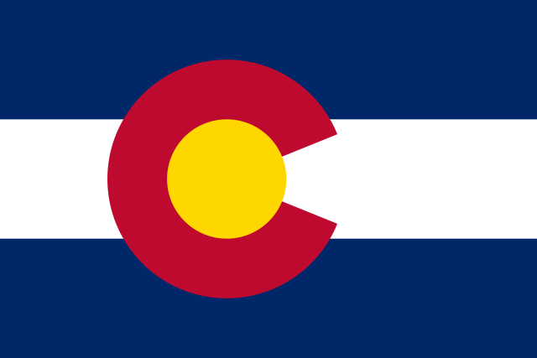

COLORADO CANVASSING REPORT quick hits
Results from Four Colorado Counties, Comprising 1.1M+ Voters
Implications for Colorado
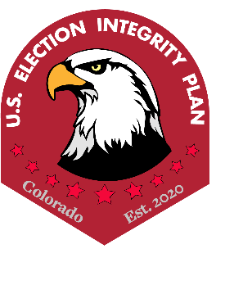
April 13, 2022
- The results of voter canvassing in four Colorado counties (Douglas, El Paso, Pueblo, and Weld) showed significant discrepancies and irregularities in the Colorado election records, indicating failure of safeguards to achieve the Colorado Constitution’s mandate that the general assembly secure the purity of elections and guard against abuses of the elective franchise
- 9,472 voters were canvassed and 4,601 confirmed across 4 counties (El Paso, Weld, Pueblo, and Douglas) using statistical sampling
- Sampling results suggest that anywhere between 5% – 11% of voters experienced an election irregularity/discrepancy (which translates to a range of 56,152 to 123,852 voters across four counties)
- If this same range is extrapolated to the entire state, then the number of voters impacted is anywhere between 210,091 and 462,201
  - The most common irregularities were election law violations as explained below:
    - Voter did not cast a ballot, but records indicate a ballot was cast in their name.
Violation of CRS 1-13-705: "Any person who falsely personates any elector and votes at any election provided by law under the name of such elector shall be punished by a fine of not more than five thousand dollars or by imprisonment in the county jail for not more than eighteen months, or by both such fine and imprisonment."
    - The voter did cast a ballot, but records do not indicate a ballot was cast.
Violation of CRS 1-13-723: "Every officer upon whom any duty is imposed by any election law who violates his duty or who neglects or omits to perform the same is guilty of a misdemeanor and, upon conviction thereof, shall be punished as provided in section 1-13-111."
    - The voter did not live at the address at the time of the 2020 election.
Violation of CRS 1-2-228: "Any person who votes by knowingly giving false information regarding the elector's place of present residence commits a class 6 felony and shall be punished as provided in section 18-1.3-401, CRS."
    - Voter's party affiliation changed without their authorization.
Violation of CRS 1-2-218.5: "The declaration of affiliation of each registered elector shall remain as recorded in the registration record until the elector changes or withdraws his or her affiliation."
  - The second most common irregularity was that a voter did not reside at an address that is officially documented in the registration database during canvassing, but the registration database still reflected that the voter was living at the address as of December 2021
    - This is concerning because these voters potentially received incorrect precinct ballots and impacted races and measures that they shouldn’t have.
- El Paso County had the highest irregularity/discrepancy rate that ranged from 7.5% to 13.5% (which translates to a range of 54,359 to 69,829 voters).
- Using the results of the canvassing-discovered irregularities as a proxy for the entire state indicates that 7-12% of all election races and measures on Colorado's November 2020 ballots may be questionable.

This is based on extrapolation from the December 2020 registration file which includes 4,201,827 registered voters
https://codes.findlaw.com/co/title-1-elections/co-rev-st-sect-1-13-705.html
https://codes.findlaw.com/co/title-1-elections/co-rev-st-sect-1-13-723.html
https://codes.findlaw.com/co/title-1-elections/co-rev-st-sect-1-2-228.html
https://codes.findlaw.com/co/title-1-elections/co-rev-st-sect-1-2-218-5.html
This is based on all ballot measures and races where only a single candidate could win. The races and measures in question are those with margins of failure or pass that were less than the estimated ballot irregularity rates. Calculations of these numbers available upon request. Data retrieved from: https://results.enr.clarityelections.com//CO//105975/276916/reports/summary.zip

