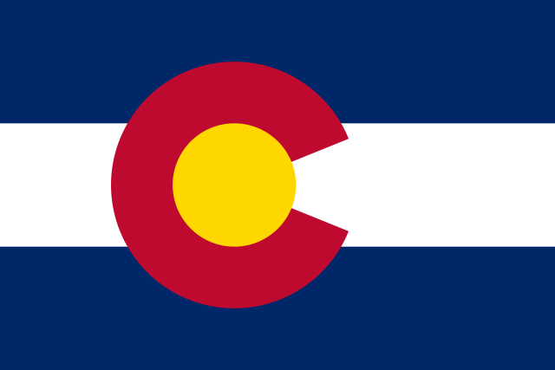

COLORADO CANVASSING REPORT

Results from Four Colorado Counties, Comprising 1.1M+ Voters
Implications for Colorado

April 13, 2022
Contents
Bottom-Line Up Front 2
Introduction 3
Purpose 4
Part 1: Methodology 5
Methodology for Canvassing 5
Methodology for Statistical Analysis and Precinct Selection 5
Part 2: Findings 6
Discrepancy Rate Calculation 8
Total (All Four Counties Combined) 8
El Paso County 10
Weld County 11
Pueblo County 13
Douglas County 14
Conclusions 16
Appendix 17
Reviewers' Credentials 17
Statistical Methodology 18

Bottom-Line Up Front
In order to verify the accuracy of the Colorado Secretary of State's voter rolls and voting history records concerning the November 2020 General Election, Colorado citizens took on the arduous task of canvassing residences that were listed on the aforementioned rolls. More specifically, canvassing took place in 2021, in four Colorado counties (Douglas, El Paso, Pueblo, and Weld), and successfully reached 4,601 of the 9,472 visited residences. Statistical analysis was performed on both the data and affidavits collected from this randomized canvassed sample. Results indicate that between 5% and 11%, or conservatively 8% (123,852 out of 1.1M), of voters in those four counties were affected by unexplained irregularities in Colorado's voter rolls and voting records. This irregularity rate is a conservative estimate that does not account for other, uncanvassed indicators of irregularity and inaccuracy. For Example, over 120,000 statewide ballots were undeliverable, which are likely due to inaccuracies in the Statewide Colorado Voter Registration and Election (SCORE) system. Using the results of the canvassing-discovered irregularities as a proxy for the entire state indicates that 7-12% of all election races and measures on Colorado's November 2020 ballots may be questionable.
Colorado elections belong to Colorado citizens. The Citizens of Colorado conducted this canvassing and analysis; this is their report. The intent of this report is to exhibit what was found and inform the public; especially public officials. For it is the sworn obligation and statutory duty of every Colorado election official to investigate all Colorado election irregularities, determine any impacts, and resolve said issues. Those officials who fail to look for, discover, report, investigate, and remedy these irregularities are potentially negligent, and/or in complete denial of any issues. Additionally, inaction on known issues constitutes a failure of duty to satisfy Article VII, Section 11 of the Colorado Constitution's requirement to "secure the purity of elections and guard against abuses of the elective franchise."
No public official bears more responsibility than the CO Secretary of State, whose powers under Colorado statute are explicitly enacted so that she may "secure the purity of elections and to guard against the abuses of the elective franchise," and who has control over SCORE, the certification of voting systems, and the Code of Colorado Regulations pertaining to elections. Despite multiple reports from concerned citizens pertaining to election irregularities, vulnerabilities, and potential dilution of Colorado citizens' elective franchise, the Secretary has yet to investigate (or remedy) said issues. Instead, the Secretary continues to emphatically report that Colorado's election system accuracy and safeguards are not only adequate but exemplary. The citizens' evidence-based report suggests otherwise.
The irregularities and issues identified in this report directly impact (and call into question) statewide, county, and local elections. To fully determine the magnitude, impact, and root causes of these issues, a statewide investigation (encompassing canvassing and a full forensic audit of all election-related systems and processes) must be performed by independent auditors, selected by and reported to the citizens of Colorado. The vote of each Colorado citizen is sacred and must be secured. If crimes have been committed against any Colorado citizen’s vote, it must be investigated and, where appropriate, prosecuted. Such action must be accomplished to ensure the integrity and security of all Colorado elections.

Introduction
"All political power is vested in and derived from the people; all government, of right, originates from the people, is founded upon their will only, and is instituted solely for the good of the whole." – Constitution of the State of Colorado, Article II (Bill of Rights), Section 1
"HAVA resulted from a national consensus that the nation's electoral system needs improvements to ensure that every eligible voter has the opportunity to vote, that every vote that should be counted will be counted, and that no legal vote will be canceled by a fraudulent vote." (Emphasis added) – Colorado Revised Statute CRS 1-1.5-101
The Colorado Secretary of State asserts that elections in Colorado are "… the gold standard, but not only that, we are a beacon of hope for rest of nation." However, Judicial Watch concludes that Colorado's elections are in the bottom tier, ranking 34th out of 50 states, of free and fair elections when judged on security and integrity. These perspectives cannot be reconciled; either one perspective is true, but not the other, or neither is true.
A logical approach and the standard wherever fiduciary duties are involved would be to subject Colorado's election system and elections to independent audit, free from conflict of interest. The Secretary of State's fiduciary duty is clarified in CRS 24-18-103. Being that the citizens of Colorado are sovereign, such that all Colorado state authority and power is vested in and derived from the people, founded upon their will, and instituted solely for the good of the whole, no public official can reasonably or legally claim any authority to limit their access or ability to demand and conduct that independent audit.
In December 2020, several hundred Colorado citizens requested that an independent audit be conducted on Colorado's 2020 election through a petition of Colorado's General Assembly. The Legislative Audit Committee denied the audit and, further, voted not to study whether an audit should be conducted. That denial betrays their Constitutional obligation. Six months later (June 17, 2021), the Colorado Secretary of State created and enacted new "emergency" election rules, including prohibiting third-party (independent) audits. Over 1,900 citizens submitted written comments objecting to the Secretary's new rules, with none supporting the new rules. Hundreds of citizens took the time to state their objections at an August 3, 2021 hearing required before permanent adoption of the "emergency" rules. Those written comments and stated objections of citizens reflect their will, and their lack of consent for the Secretary’s rules. Colorado citizens never voted on this new rule to abridge citizens' authority. It was enacted by the sole authority of the Secretary of State, with the blessing of the Colorado Attorney General.
With no independent audit of Colorado's elections or election system, and a new rule prohibiting independent audits, Colorado's "gold standard" election system is merely an unsubstantiated, unverifiable claim. Nor are Colorado citizens' concerns unique; an October 2021 Rasmussen Reports survey showed that 56% of the US population question the integrity of the November 3, 2020 election. Any claim about the standards of Colorado's election practices, whether purporting the strengths or weaknesses therein, should be backed by evidence. Voters must have confidence in the election system, and it can be restored with transparency and unbiased investigations.
It is the People who have full and unrestricted Constitutional rights to transparency and integrity in their elections and it is not subject to arbitrary abridgment by the Secretary of State. Many of the Colorado citizens who had petitioned the General Assembly and objected to the Secretary of State's rules, joined efforts and launched an independent canvass of Colorado's November 2020 election. Their coalition of several hundred citizens, from all backgrounds, expertise, and political affiliations, was met with unfair and inaccurate disparagement by the Secretary of State. Despite this opposition, the citizens took on the responsibilities that the public officials refused to do, and they completed the canvass and summarized their findings. This report is the citizens' report.
This report details the methodology used in canvassing, precinct selection (i.e., “population”), statistical analysis, and the overall findings pertaining to the Colorado elections. This report is not affiliated with any political party. All efforts and results of this report are the product of citizen volunteers seeking to understand the Colorado election system by asking: What was the anomaly rate, if any, within the Secretary of State’s record of Colorado's November 3, 2020 election? Canvassing was accomplished entirely by volunteers and encompassed over 7,850 people-hours. This report is a testament to the caliber and character of the citizens who volunteered: everyday citizens who stepped up to civic duty to preserve and protect our sacred elections.

Purpose
The purpose of this report is to expose issues that were identified from canvassing, comprehensively assess the extent and severity of these issues, summarize these findings, and to provide recommendations for a full, independent forensic audit on the entire election system (to include records, technology, processes, etc.). Part 1 details the methodology used for data collection and statistical analysis. Part 2 details the findings from the data collected and highlights multiple categories of irregularities and election laws violated during the 2020 election.

Part 1: Methodology

Methodology for Canvassing
Canvassing involves going door-to-door in selected communities and speaking face-to-face with the residents of those dwellings. The volunteers who performed the canvassing received standardized training on how to professionally and objectively interact with the resident, collect data (about the resident's November 3, 2020 voting experience), and complete affidavits. Volunteers were issued a standardized script, a walk-list to fill out (i.e., collect data), blank affidavit forms (to document irregularities), and they canvassed in teams of two or more, to ensure their safety and eyewitness accounts for all interactions.
Each volunteer team's script was designed to prevent biased discussions with the resident while giving the resident ample opportunity to speak without interference from the volunteer. Volunteers did not ask anyone what their voting selections or choices were; they simply verified the information in Secretary of State public records. The script also helped ensure the standardization of data collection. The script was as follows:
1. Did you vote in the November 3, 2020 election?
2. If so, by what means did you return your ballot (mail-in, drop box, or in-person)?
3. Did you receive any extra ballots at this address?
4. Is your voter information accurate (i.e., name, address, party affiliation, etc.)?
5. Are there any other experiences you would like to share?

Methodology for Statistical Analysis and Precinct Selection
A statistical sampling approach was used to make valid assertions about entire counties. Statistical sampling has been deemed credible in legal settings, as data collected in this manner can illustrate underlying features of a whole population while also maintaining randomness in the sample. Following this methodology, the required sample size was determined based on the standard deviation of a precinct's aggregate propensity to vote, a predetermined confidence level, and a desired margin of error limit. A 99% confidence level was selected, with a desired margin of error of 3%.
The propensity to vote was determined using a metric called the "Voter Opportunity Score" (VOS). The VOS is derived from voting history, which is contained in the Secretary of State's public data. This VOS metric is calculated by taking the number of Colorado elections a registered voter actually participated in and dividing it by the total number of Colorado elections that a voter had the opportunity to participate in (based on their age/date of registration). The VOS is noted in the following equation:
$$VOS=\frac{number of CO elections that an individual voter actually participated in}{number of CO elections that an individual voter had an opportunity to vote }$$
The VOS indicates the likelihood that an individual will participate in any given election and is represented as a number ranging from 0 to 1 (where 0 indicates the voter has not participated in any elections, and 1 indicates the voter participated in every possible election). A VOS was calculated for every voter within a selected county. Similarly, a Precinct VOS was computed using a weighted-average formula for each precinct.
$$Precinct VOS=\frac{total number of CO elections that all voters in a precinct participated in}{total number of CO elections that all voters had an opportunity to vote }$$
Given that the VOS indicates the voting likelihood of an individual, and that social scientists assume human behavior can theoretically be modeled on a bell curve, extreme outliers of the behavior can be identified (on either side of the curve), and inferences made regarding the most frequent behaviors (i.e., the middle point or region of the curve). Applying this theory to voting propensity, the VOS identifies (and selects) the "extreme" precincts to be canvassed. Specifically, precincts with the highest and lowest weighted-average VOS are chosen to be canvassed since they represent the extreme behaviors, as noted above. Lastly, equal sampling from both the high and low VOS precincts is made to identify any behavioral changes around a specific election.
Canvassing occurred in Weld, Douglas, El Paso, and Pueblo counties. The results for these counties are included in Part 2: Findings.

Part 2: Findings
Affidavits generated from canvassing were notarized, scrutinized, verified, and organized into four categories:
- Election Law Violation
- Multiple Ballot(s) Received
- Voter Moved but Registration Database Never Updated
- Probable Election Law Violation

Election Law Violation
  - Voter did not cast a ballot, but records indicate a ballot was cast in their name.
Violation of CRS 1-13-705: "Any person who falsely personates any elector and votes at any election provided by law under the name of such elector shall be punished by a fine of not more than five thousand dollars or by imprisonment in the county jail for not more than eighteen months, or by both such fine and imprisonment."
  - The voter did cast a ballot, but records do not indicate a ballot was cast.
Violation of CRS 1-13-723: "Every officer upon whom any duty is imposed by any election law who violates his duty or who neglects or omits to perform the same is guilty of a misdemeanor and, upon conviction thereof, shall be punished as provided in section 1-13-111."
  - The voter did not live at the address at the time of the 2020 election.
Violation of CRS 1-2-228: "Any person who votes by knowingly giving false information regarding the elector's place of present residence commits a class 6 felony and shall be punished as provided in section 18-1.3-401, CRS."
  - Voter's party affiliation changed without their authorization.
Violation of CRS 1-2-218.5: "The declaration of affiliation of each registered elector shall remain as recorded in the registration record until the elector changes or withdraws his or her affiliation."
Multiple Ballot(s) Received
  - Multiple ballots were sent to voters (with correct address), and/or residents received multiple ballots for a voter who did not live there.
Voter Moved but Registration Database Never Updated
  - The voter does not reside at an address that is officially documented in the registration database. Thus, the registration database is outdated and inaccurate (as of December 2021).
Probable Election Law Violation
  - The voter's address or other information contained errors (intentionality unknown).
  - The voter did not receive a ballot and had to vote in person.
Information from each affidavit category was processed into data spreadsheets and utilized as a function in the statistical analysis portion of this report. Findings from the statistical analysis are detailed in the next section. Note: to protect an individual's identity, all personal information (i.e., names, addresses, etc.) are removed from this report. That being said, affidavits and accompanying data will be provided to officials.

Discrepancy Rate Calculation
After all affidavits were collected for El Paso, Weld, Pueblo, and Douglas counties, they were peer-reviewed by multiple volunteers to ensure proper inclusion in the final results presented. The total number of affidavits collected was divided by the number of confirmed residences to determine the discrepancy rate percentages. Confirmed residences denote the successful ability to collect data about the resident (actual “face-to-face” discussion with resident), and/or information about the address (i.e., address was a vacant or commercial lot).
$$Discrepancy Rate=\frac{total number of affidavits}{confirmed residences}$$

Total (All Four Counties Combined)
After the peer-review process was completed, it was determined that 367 affidavits met the criteria for inclusion in the report. Using the discrepancy rate formula from above, it was calculated that 367 affidavits equate to approximately an 8% affidavit rate.
$$Discrepancy Rate=\frac{367}{4,601}=0.797 \sim 8\%$$
In statistics, this above discrepancy rate can be described as a "best estimate" rate when applying a designated sampling error to the value. For this study, a 3% margin of error was used to calculate the needed sample size for each county. Subtracting the 3% margin of error from the best estimate discrepancy rate obtains a low estimated discrepancy rate (or lower bound). Conversely, adding the 3% margin of error to the best estimate discrepancy rate obtains a high estimated discrepancy rate (or higher bound). Additionally, a 99% confidence level was used. The combination of the 99% confidence level and 3% margin of error confirms that if this methodology was used in canvassing repeatedly, 9.9 out of 10 times, the discrepancy rate would fall between 5% and 11%.
Note: many affidavits were not included because of the uncertainty of what the affiants (the person that signed the affidavit) meant. Thus, it is highly probable that this report's number of affidavits (i.e., election discrepancies) is underrepresented versus the actual count. The table below shows the final canvassing results, including the range of estimated voters affected by irregularities in voter registration and voting history records in Colorado.

Below is a breakdown of all 367 affidavits, from all four counties, by category:
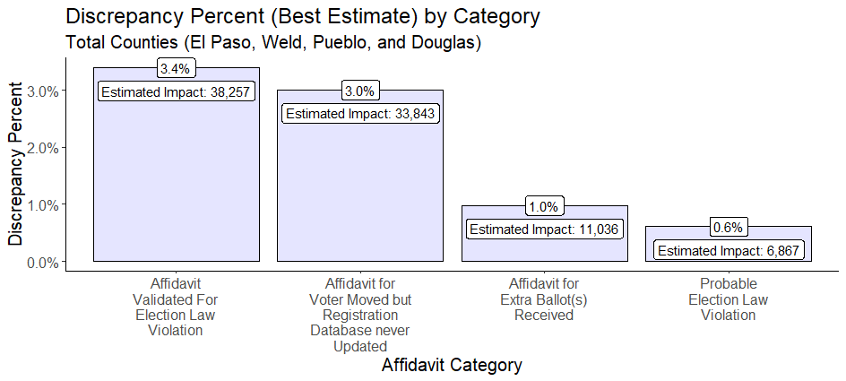
As the above figure illustrates, 3.4% of the affidavits reflected election law violations, 3.0% reflected inaccuracies in the registration database, 1.0% were from multiple ballots being received, and 0.6% reflected probable election law violations.
Below is a breakdown of all four counties' election law violation categories:
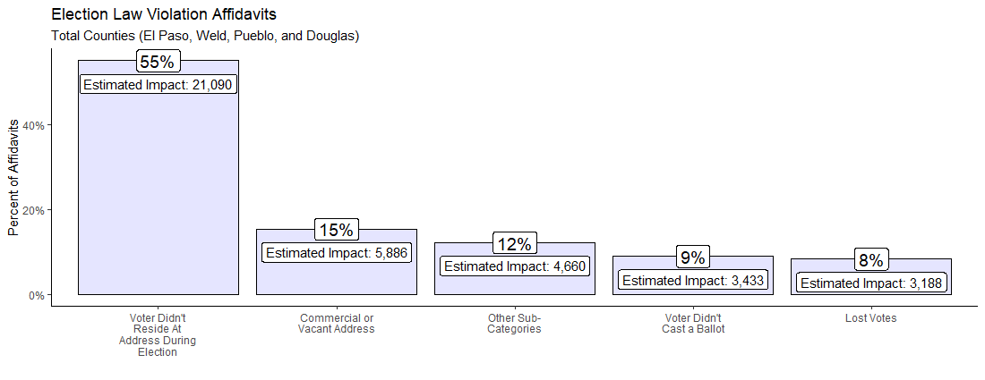
Regarding voters who had moved, if the affiant confirmed that the voter did not live at the address at the time of the 2020 General Election, then these affidavits were considered election law violations. If the affiant did not confirm whether the voter lived at the address at the time of the election, but the registration database reflected that the voter still resided at that residential address (as of December 2021), then these affidavits were put into a separate category called "Affidavit for Voter Moved but Registration Database never Updated." If ballots for "moved" voters are cast, but they do not live in the precinct (let alone the county or state), these votes are illegal and can illegally affect election results at any level of government (e.g., from Federal to school board elections).
The following four sections investigate the discrepancy rates within each county (listed in descending order of total discrepancy rates).

El Paso County
Of the four counties canvassed, El Paso had the highest discrepancy rate of 10.5% (best estimate). This reflects that discovered irregularities affected over 54,000 voters in El Paso County in Colorado. The table below shows the range of possible discrepancy rates for El Paso County.
The most significant portion of issues noted above was attributable to election law violations. Issues in this category included but were not limited to, voters listed as having voted from commercial addresses and vacant lots, voters who did not live at the address at the time of the 2020 general election, and unauthorized party affiliation changes.
Below is a breakdown of El Paso County's discrepancy percentages by category:
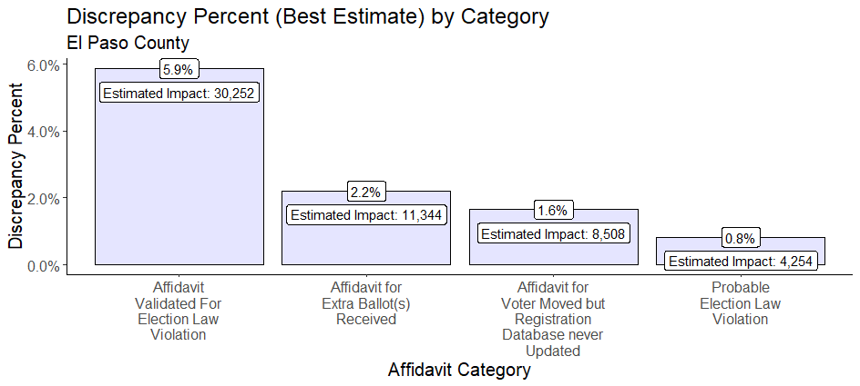

Below is the breakdown of El Paso County's election law violation affidavits category:
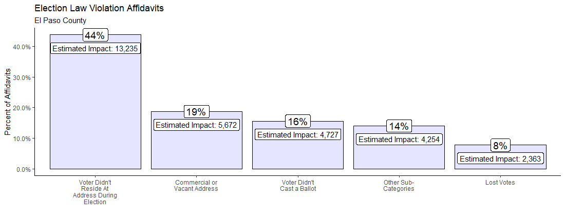
Given the results discussed above, any race won, or ballot measure that passed/failed with a margin less than or equal to 10.5% in El Paso County should be questioned.

Weld County
Weld County had the next highest discrepancy rate of the canvassed counties. The majority of issues were attributed to election law violations. Other issues included commercial addresses, vacant lots, voters who did not live at the address at the time of the 2020 general election, and unauthorized party affiliation changes.

Below is a breakdown of Weld County's discrepancy percentages by category:
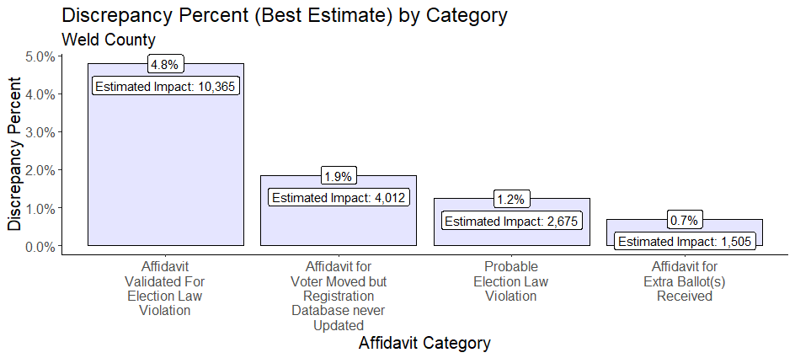
Below is the breakdown of Weld County's election law violation affidavits category:
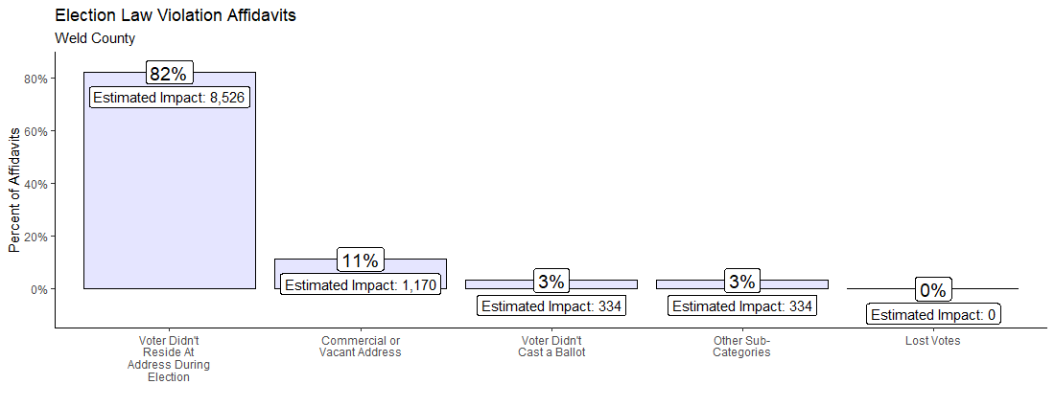
Most election law violations were related to voters who didn't live at the stated registration address during the 2020 election. The second-largest category of election law violations was for voters who were registered and/or voted from a commercial address or vacant lot. An interesting finding from this second category is that multiple people were registered to the Weld County Clerk and Recorder's office.
Given the results discussed above, any race won or ballot measure that passed/failed with a margin less than or equal to 8.6% in Weld County should be questioned and audited.

Pueblo County
Pueblo County had significant issues with the registration database not being updated to reflect voters corrected residential addresses. This means that many precinct-level ballot measures voted on may have been influenced by those who did not reside in those precincts. Additionally, Pueblo County had the most significant portion of voters in the four canvassed counties who were affected by "lost votes." Lost votes are when the voter confirmed via affidavit that they had either mailed in a ballot or voted in person, but the Secretary of State reporting has no record of the vote.
Below is a breakdown of Pueblo County's discrepancy percentages by category:
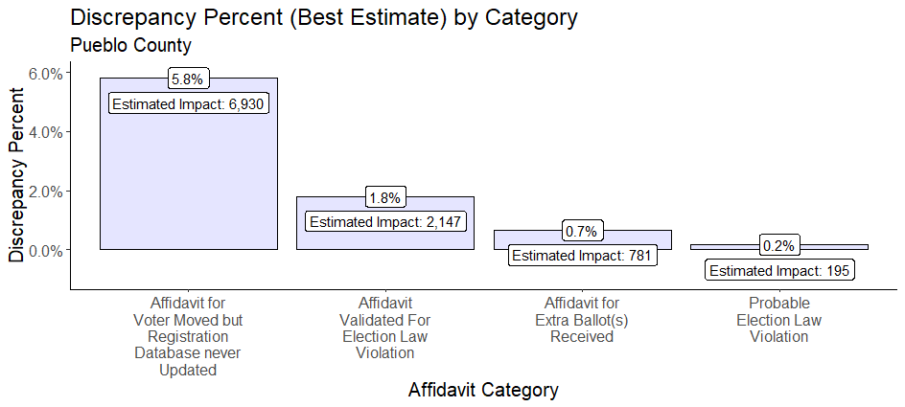

Below is the breakdown of Pueblo County's election law violation affidavits category:
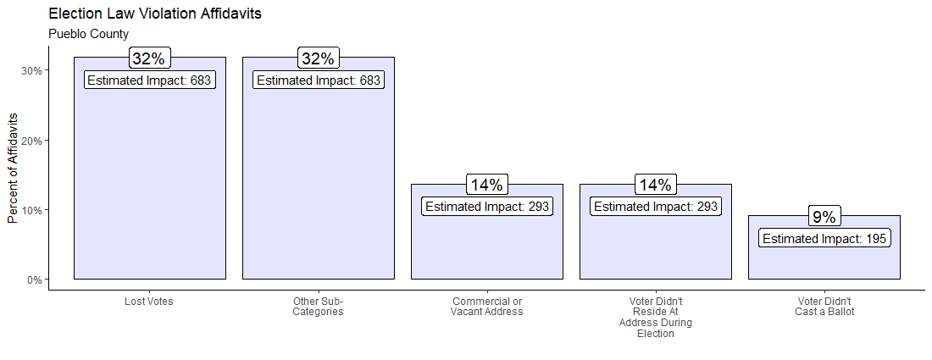
Given the results discussed above, any race won or ballot measure that passed/failed with a margin less than or equal to 8.4% in Pueblo County should be questioned and audited.

Douglas County
Douglas County suffered from the same primary issue as Pueblo, where the registration database was not updated to reflect voters' corrected residential addresses. This means that many precinct-level issues that were voted on may have been influenced by those who did not reside in those precincts. Additionally, Douglas County had the largest percentage of voters in the four canvassed counties who voted from a vacant or commercial lot.

Below is a breakdown of Douglas County's discrepancy percentages by category:
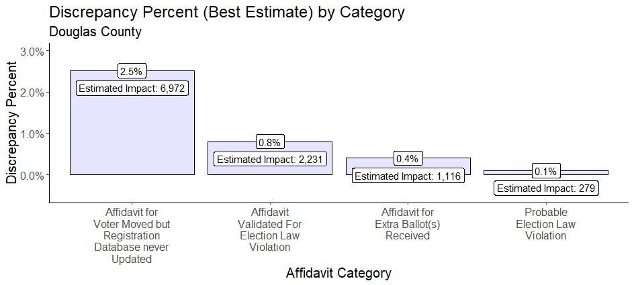
Below is the breakdown of Douglas County's election law violation affidavits category:
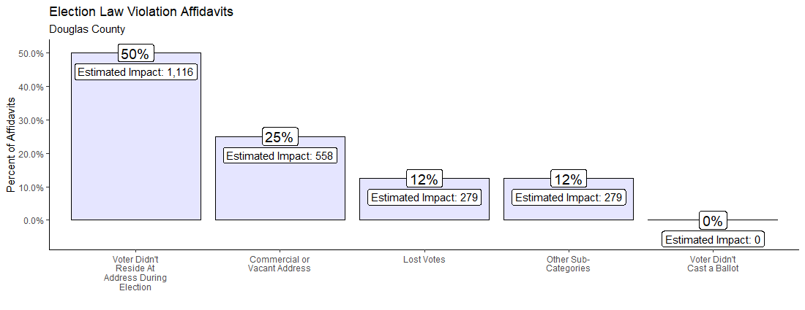
Given the results discussed above, any race won or ballot measure that passed/failed with a margin less than or equal to 3.8% in Douglas County should be questioned and audited.

Conclusions
The results of voter canvassing in four Colorado counties (Douglas, El Paso, Pueblo, and Weld) showed significant discrepancies and irregularities in the Colorado election records, indicating failure of safeguards to achieve the Colorado Constitution’s mandate that the general assembly secure the purity of elections and guard against abuses of the elective franchise. A "best estimate" statistical analysis indicated, conservatively, that approximately 8% of voters (123,852 out of 1.1M) in those four Colorado counties were affected by election canvassing-detected irregularities, alone. Mail-in ballots were sent to individuals who were either deceased, had moved, or were non-citizens. Additionally, 3% of the voter registration reflected irregularities in the residential addresses, highlighting that the current Colorado registration system (SCORE) data is inaccurate. The counting of Illegitimate ballots not only deprives the rights of Colorado citizens and dilutes their sacred vote, but it also is in violation of state law. These irregularities and issues directly impact (and call into question) statewide, county, and local elections. A statewide independent investigation (encompassing canvassing and a full forensic audit of the entire election system) must be performed to understand the magnitude and impact of the known and unknown issues. To reiterate a statewide independent investigation must be accomplished to ensure integrity, security, and transparency in every aspect of Colorado’s elections. Demanding that independent investigation is unequivocally within the Constitutional rights of Colorado citizens.

Appendix

Reviewers' Credentials
They/Their/Theirs #1
- Ph.D. in Economics; M.S. in Mathematics; M.A. in International Economics; M.A. in Education; Retired USAF, LtCol (served 25yrs); Assistant Professor in Mathematics (USAFA) and Assistant Professor in Economics (USAFA); Financial & Economic advisor to Deputy Assistant Secretary of the Air Force (Pentagon); Additional Experience includes Flight Test Analyst, Chief of Defense Satellite Test Branch, and Laser Lab Intern
They/Their/Theirs #2
- Master's and Ph.D. in Mathematical Statistics; 30+ years as a Professional Statistician
They/Their/Theirs #3
- Master's in Business Analytics; Certified Analytics Professional; 10+ Years of Analytical and Financial Experience
They/Their/Theirs #4
- Certified Public Accountant; 10+ Years of Accounting Experience
They/Their/Theirs #5
- Exemplary prior US military service; Bachelor and Master's Degrees in Arts, Sciences, and Information Technologies; 40 Years of Combined Experience: Programming, Systems Engineering, Product Development, Curriculum Planning, Operations Analysis, and Systems Architecture; Additional Experience: Fortune 500 Companies, Corporate & Commercial education, Higher Education, Communications, Video Game/Simulations, and defense industries.
They/Their/Theirs #6
- 27+ years of software development and engineering expertise; Experience in Healthcare, Jail Systems, and Marketing development
They/Their/Theirs #7
- 40+ years of software development and engineering expertise; Experience in Marketing, Real Estate, and Voter Data Acquisition and Development
They/Their/Theirs #8
- 25+ years Active-Duty military, including command of military installations and operational forces, staff assignments, including Office of the Secretary of Defense, and formal research for Department of Defense; BA, Political Science/MAS, Aeronautical Science/MA, National Security Affairs; operational test manager, director, analyst; trained in Scientific Test and Analysis Techniques (STAT), statistical research.

Statistical Methodology
- All code and raw data are available upon request to see how the statistical methodology was implemented.
- A stratified sampling methodology utilizing voter opportunity score was used to target precincts. Stratified sampling was chosen because it provides more precision than simple random sampling
- It was noted that each county's Voter Opportunity Scores reflected a Weibull distribution, therefore, a box-cox transformation was used to normalize the distribution to derive a standard deviation for sample size calculations
  - Exhibit 1 below shows an example of the distribution type of the voter opportunity score in each county canvassed as well as how the lambda was chosen to transform the distribution to a normal distribution for calculation of the standard deviation.
- For canvassing purposes, a 99% confidence level (z-score) with a 3% margin of error was used
  - $Samplesize={((z_{score}}^{2}×standard deviation×(1-standard deviation))÷{margin of error}^{2})÷(1+((\left({z_{score}}^{2}×standard deviation×\left(1-standard deviation\right)\right)÷\left({margin of error}^{2}×county voter population\right))))$

Exhibit 1
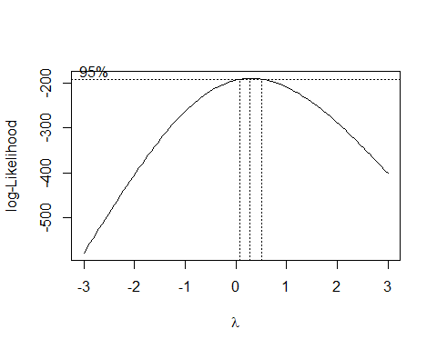
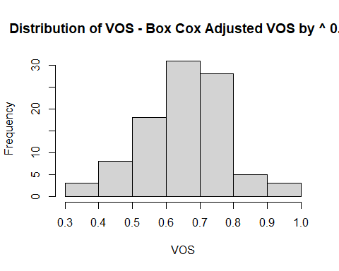
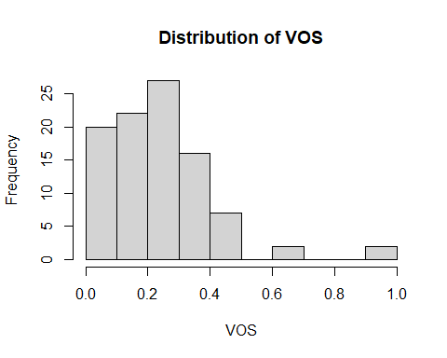

- Once sample size was known for each county, the sample size was split in half with one half going towards the lowest voter opportunity score precincts and the other half going towards the highest voter opportunity score precincts
  - This methodology created a linear regression model which allowed for better canvassing while still holding to a random sample methodology
- A t-test was performed where the voter opportunity scores were compared between voters who responded, and those who did not to see if a statistically significant difference was apparent. If the difference between these groups' voter opportunity score distributions was significant, then there would have been a potential issue with applying the discrepancies found in canvassing to the entire county population. The difference was shown to not be statistically significant. Additionally, visual inspection of the probability of voter opportunity score distributions by county confirmed that the distributions were very similar.
  - Welch Two Sample t-test
    - data: non_responder_vos_vector and responder_vos_vector
      - t = -0.61021, df = 8621.3, p-value = 0.5417
      - alternative hypothesis: true difference in means is not equal to 0
      - 95 percent confidence interval:
        - -0.008521271 0.004475490
      - sample estimates:
        - mean of x mean of y
          - 0.2291709 0.2311937
- Logistic regression confirmed that the precinct and voter opportunity score interaction is statistically significant, but potentially not practically significant. Next steps will include refining the sampling process to look at spatially balanced cluster sampling.

I helped prepare and am responsible for the foregoing Colorado Canvassing Report content.

This 10th day of March 2022


I contributed to and stand by this report.
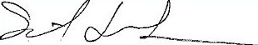

________________________________
Shawn Smith

In El Paso County (EPC) alone, 14,485 mail ballots sent to names on the Colorado Secretary of State’s Statewide Colorado Voter Registration and Election (SCORE) system list of Active Registered voters for the Nov 2020 General Election were returned as “undeliverable” by the USPS. The CO SecState’s VoterCountsbyStatus for Nov 01, 2020 shows 452,715 Active voters in EPC, representing 12% of CO’s Active Voters two days prior to the General Election. Unless inaccuracies in EPC’s voter registration data are anomalous in comparison to other CO counties, this implies a likely statewide total of more than 120,000 mailed ballots addressed according to SCORE records but reported as undeliverable by USPS." (https://www.sos.state.co.us/pubs/elections/VoterRegNumbers/2020/October/VoterCountsByStatus.pdf)
This is based on all ballot measures and races where only a single candidate could win. The races and measures in question are those with margins of failure or pass that were less than the estimated ballot irregularity rates. Calculations of these numbers available upon request. Data retrieved from: https://results.enr.clarityelections.com//CO//105975/276916/reports/summary.zip
§ 1-1-107(5) CRS, from https://codes.findlaw.com/co/title-1-elections/co-rev-st-sect-1-1-107.html
8 CCR 1505-1, from https://www.sos.state.co.us/CCR/NumericalCCRDocList.do?deptID=20&deptName=1505%20Department%20of%20State&agencyID=104&agencyName=1505%20Secretary%20of%20State
https://codes.findlaw.com/co/title-1-elections/co-rev-st-sect-1-1-5-101.html
https://denver.cbslocal.com/2021/07/13/colorado-secretary-state-jena-griswold-elections-all-star-game-georgia/
https://web.archive.org/web/20220225161500/https://www.heritage.org/press/heritage-foundation-launches-election-integrity-scorecard-ranking-states-election-laws
https://www.sos.state.co.us/pubs/newsRoom/pressReleases/2021/PR20210617Rules.html
https://www.coloradosos.gov/pubs/rule_making/hearings/2021/ElectionsRulesHearing20210803.html
https://www.rasmussenreports.com/public_content/politics/general_politics/october_2021/vote_by_mail_most_voters_think_it_will_cause_more_cheating
https://www.sos.state.co.us/pubs/newsRoom/pressReleases/2021/PR20210909Canvassing.html
https://forensus.com/statistical-sampling-case-law/
Age was chosen as the variable to determine opportunities due to issues with the registration date (e.g., there are many voters who have a voting history that predates their registration date).
For more detailed statistical information, please refer to the appendix.
https://codes.findlaw.com/co/title-1-elections/co-rev-st-sect-1-13-705.html
https://codes.findlaw.com/co/title-1-elections/co-rev-st-sect-1-13-723.html
https://codes.findlaw.com/co/title-1-elections/co-rev-st-sect-1-2-228.html
https://codes.findlaw.com/co/title-1-elections/co-rev-st-sect-1-2-218-5.html
https://en.wikipedia.org/wiki/Sampling_error#:~:text=The%20sampling%20error%20is%20the,unknown%20value%20of%20the%20parameter
More information on this strategy can be found here: https://en.wikipedia.org/wiki/Stratified_sampling. Another resource is the book Complex Surveys by Thomas Lumley.
Information on Weibull Distributions: https://en.wikipedia.org/wiki/Weibull_distribution
Information on Box-Cox Transformation: https://en.wikipedia.org/wiki/Power_transform#Box%E2%80%93Cox_transformation
Sample Size Formula - retrieved from https://www.qualtrics.com/experience-management/research/determine-sample-size/. Additionally, Sample size with finite population correction factor calculation retrieved from https://byjus.com/sample-size-formula/. For more information on standard deviation, you can check out this source: https://en.wikipedia.org/wiki/Standard_deviation
Visual inspection of the distributions can be found under the section title Probability density of VOS by canvass response here: https://ln5.sync.com/dl/e817b9880/hwtchqqx-7tag86gk-r6x8yngc-sg5zimwp
https://www.sciencedirect.com/topics/computer-science/logistic-regression
Information on this can be found under the section titled Logistic regression for response rate found here: https://ln5.sync.com/dl/e817b9880/hwtchqqx-7tag86gk-r6x8yngc-sg5zimwp
https://en.wikipedia.org/wiki/Cluster_sampling

