Dear INSERT NAME of election manager or auditor:
I was informed that the random hand count audit has added only one additional candidate, while Minnesota Statutes 206.89 allows for all races to be audited.

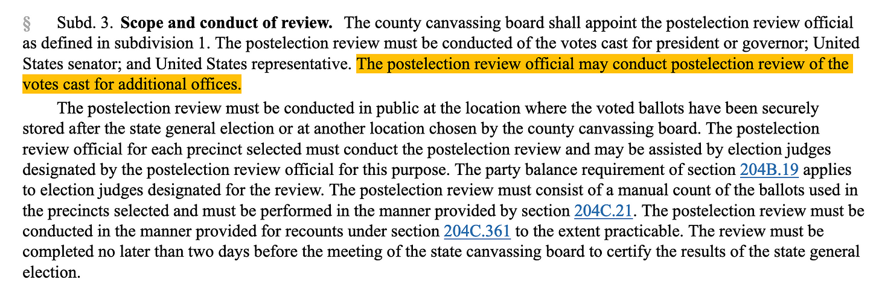

Why have you chosen to avoid doing ALL candidates in the 4-6 precincts selected at random after the county canvassing board certified the election? Avoiding the rest of the candidate races can only bring suspicion to your process.
Please let all COUNTYNAME County residences know that you are making every effort to make our elections secure, not by words and lawyer speak, but by legal actions, namely counting ALL of the candidates' votes.
I await your confirming notice.
INSERT YOUR NAME

