- Ray Scott shared our opening prayer
- Roger Mueller led us in the Pledge of Allegiance
- Treasury Report: Roger
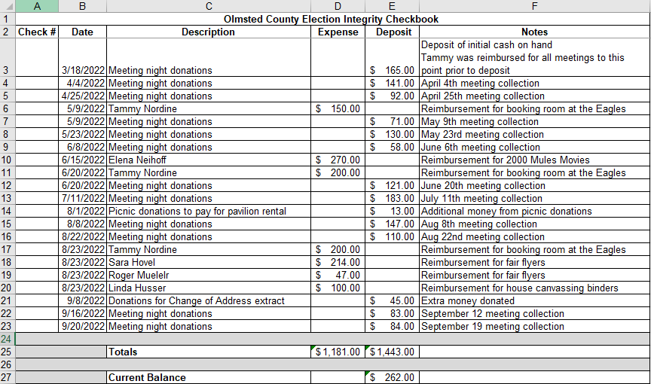
Motion was moved, seconded and passed to accept the treasury report
- Commissioner Meetings Update
  - Roger gave a summary of the three public comment sessions we attended
  - Roger gave a summary of the meeting held with commissioner Thein, Heidi Welsch, Mary Blair-Hoeft, and another gentlemen who works for the county
  - From the meeting mentioned in 4.b, there is a response that needs to be written and sent back to that team
- Black Community meeting Recap
  - Roger shared that he met with a group of black community leaders. He shared the election judge information. He also shared what a learning experience it was to work with them
- Post Election Review Volunteers
  - Roger shared there is work going on across MN to have volunteers work during the post-election review along with the county canvassing
  - There are 6 volunteers:
    - Roger Mueller
    - John Howie
    - Peg Sherman
    - Gale McEvoy
    - Jim Kachmarzinski
    - Debra Patzner
  - Roger is checking on the dates
- Olmsted Precincts we want covered in November
  - Roger got a list of Olmsted County precincts that Lukas Severson would like to have covered for the election
  - Roger collected names
  - Roger will send out the list to all election judges from the MN GOP list
  - More information to come
  - There was a couple of questions:
    - How were these precincts identified?
      - The number of voters who showed up on Aug 9
      - The total number of potential voters, they want to focus on the larger ones
    - Is there anything specific we need to watch out for?
      - School splits within a precinct
      - Please, please, please go to this site Voter Information Portal (state.mn.us) to view your sample ballot for Nov 8th so you are prepared before you vote!!
      - Looking at your precinct tabulator to see if it contains an internal modem
https://www.multitech.com/documents/publications/data-sheets/86002156.pdf
Just a note. The link shows the modem card that is used in the DS200 tabulator. If this is installed there should be a tag on the rear panel of the tabulator:
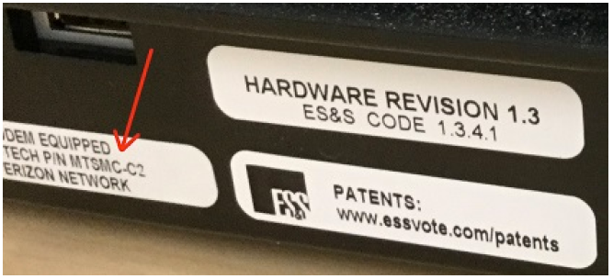
The hardware revision code is also there. This is up where the power cord goes into the machine.

- Next meeting and for the rest of the year
  - There will be one more meeting in November on the 21st and then we will take the rest of the year off
- Other Topics
  - Some topics were discussion but unfortunately, I cannot remember the details

