((Match/modify according to refusal reasons))
Dear Clerk XX,
Thank you for your expedient response to my Cast Vote Record (CVR) request. Your reason for the denial to provide the requested CVR misconstrues the law and overlooks the significant precedent already in place.
For the purpose of this request: results from each tabulator are downloaded into the electronic management system (EMS). The data from each tabulator is aggregated into a report called the CVR. The CVR is an electronic record in the EMS that records the vote selections of all the votes made on each ballot. The exported report is provided as a file in csv or json format. The CVR records the tabulator the ballot was cast on, the type of vote it was (early, absentee or Election Day), the precinct the ballot came from, and other information.
Having this data available in a single file allows comprehensive review of the election without requesting multiple records from the county clerks – saving both citizens and election officials time and expense.
Please refer to the NM IPRA Compliance Guide (Inspection of Public Records) for the correct interpretation of the statute 14-2-8.B you quoted (page 33).
https://www.nmag.gov/wp-content/uploads/2021/11/Inspection-of-Public-Records-Compliance-Guide-2015.pdf
Chapter VII. Section 14-2-8 Part B: Creation of Public Records has the following provision that governs my request: "The right to inspect applies to any nonexempt public record that exists at the time of the request. A records custodian or public body is not required to compile information from the public body’s records or otherwise create a new public record in response to a request.”
Example 47 is provided which states: A person asks a county personnel officer for a list of all employees with college degrees. The office does not keep lists of employees with college degrees, although college degree information may be included in an employee’s personnel file. The records custodian is not required to go through each file to find and list employees with college degrees. It may, however, make the nonexempt portions of all personnel files available to the requester so she can peruse them in search of employees with college degrees."
Clearly, the interpretation refers to a citizen in the example requesting a public official to create a customized (ie create or provide a new one) document from a large number of other documents. The public official is not required to spend time creating a customized document, but they are still required to provide the underlying information to the citizen.
Therefore, similar to the example 47 provided above, I am not requesting a customized document. I am requesting a standard report of the data that exists on your EMS. If you are unable to follow simple steps to export the data on your EMS, then please provide a copy of the entire 2020 Election database. The requested data can then be extracted from the entire database by someone else besides the records custodian.
Please also refer to the Election Assistance Commission - Voluntary Voting Systems Guidelines (EAC VVSG) for further information regarding CVR, standards, provision for privacy protection in the voting system and extractions of report.
Since 2005, the CVR has been a part of the EAC VVSG. Voluntary Voting System Guidelines Overview (eac.gov)
The most current version describes CVRs in details and how privacy of voter information is protected. Voluntary Voting System Guidelines Version 2.0 (eac.gov)
2.1-D – Records last at least 22 months: All systems must maintain the integrity of election management, voting, and audit data, including cast vote records (CVRs), during an election and for a period of at least 22 months afterward, in temperatures ranging from 5 C to 40 C (41 F to 104 F) and relative humidity from 5% to 85%, non-condensing (page 69)
4.1-C – Exchange of cast vote records (CVRs): The voting system’s audit, casting, tabulation, and vote-capture functions dealing with CVRs must have the capability of importing or exporting CVRs according to CDF specification(s). (page 116)
9.1.5-F- Unique identifier: A paper-based voting system must be capable of adding a unique identifier after a voter casts their ballot. (page 185)
9.1.6-K Privacy preserving, universally verifiable ballot tabulation states: A cryptographic E2E verifiable voting system tabulation process must preserve the privacy of every voter and provide a method for public verification. (page 190)
9.4-C – Unique ballot identifiers: The voting system must enable election auditors to uniquely address individual ballots. (page 194)
Principle 10 Ballot Secrecy further discusses how the voting system protects the secrecy of voters’ ballot selections. (page 196)
11.1-B- Voter information in log files: The voting system must not log any voter identifying information. (page 207)
It is significant to note that New Mexico has made compliance with the VVSGs statutory: “A voting system that does not comply with all requirements in the Election Code and the most recent voluntary voting system guidelines adopted by the United States election assistance commission shall be decertified for use in this state.” NMSA 1-9-7.4(B). (Erin’s version)
It is significant to note that NM Law has provision that requires compliance with VVSG standards (federal) under NMSA 1-9-7.4(B). (Cynthia’s version)
https://nmonesource.com/nmos/nmsa/en/4351/1/document.do
It states: If at any time the secretary of state becomes aware that a voting system certified for use in this state does not comply with all requirements in the Election Code [Chapter 1 NMSA 1978] or meet federal election standards, the secretary of state shall undertake an investigation to determine if the voting system should continue to be certified for use in the state. Tests and inspections conducted pursuant to this section shall commence upon the order of the secretary of state and shall follow the procedures in Section 1-9-14 NMSA 1978. A voting system that does not comply with all requirements in the Election Code and the most recent voluntary voting system guidelines adopted by the United States election assistance commission shall be decertified for use in this state.
Lastly, the creation of this standardized record is mandated by the National Institute Standards and Technology. The purpose “is to provide an interoperable, non-proprietary data exchange format in JavaScript Object Notation (JSON) and eXtensible Markup Language (XML) for CVRs so as to promote greater transparency to voting records produced by vote-capture devices, and to facilitate the exchange of CVRs with other devices that operate upon CVRs regardless of device manufacturer.” According to NIST, the intended audience of the CVR is the “general public.” It is clear that it is the intent of the federal entities in place for oversight of elections, that CVRs are intended to be shared with the public and increase transparency of elections. Cast Vote Records Common Data Format Specification Version 1.0 (nist.gov)
Note: Many counties in NM have already provided their CVR in response to citizen's public records requests. McKinley even has it readily available on their county website.
ELECTION DOC. CVR FILE REPORT | McKinley County, NM.
The public is entitled to the greatest possible information regarding the affairs of government and the official acts of public officers and employees. Such information is an essential function of a representative government and an integral part of the routine duties of public officers and employees. Information Public Request Act affords members of the public to keep a watchful eye on government and an opportunity to determine whether the affairs of government are honest, faithful and competent.
Voter confidence is important. If there is no transparency, one may question tyranny.
Sincerely,

- New Mexico must comply with the VVSGs by statute.
- NM Statutes Annotated (1978) § 1-4-5.5 Voter Information
Voter information Certain information from voter databases may be released only with authorization by the county clerk and cannot be used for unlawful purposes. Voter registration lists maintained by the secretary of state and voter registration certificates filed with the county clerks are not covered by this statutory provision and are public records that must be disclosed as provided by law. Comment: this statute refers to the voter registration database – not election records. There is nothing in the statutes preventing the CVR from being released.

MORE denial reasons:
- Rio Arriba Specific report requested is exclusively run on RTR (Dominon’s) System. Not on SERVIS (the Secretary of State’s System) which is used for canvass reports, described 2 different computer system. NMSA 1-12-70 (no other person, then SOS makes public record - covered). Offered canvass reports, (see envelopes for each polling location, roster, tapes to verify results and view election ballots). Michele L Jordan, Bureau Chief of Elections. (Sounds like Servis is the voter roll management system? Request Rio Arriba to provide source for the information they are providing regarding RTS (Dominion’s) System and Servis System for reference and better understanding.) See screenshot of email: on the page 6 (may change with editing) of this document. Comment: the record we’re asking for is contained on the individual county election management systems. This record request has nothing to do with data maintained by the SOS.
- Potential Denial Reason (not brought forth): IPRA § 1-4-5.5 (page 16) Voter information. Certain information from voter databases may be released only with authorization by the county clerk and cannot be used for unlawful purposes (because of privacy laws?). Voter registration lists maintained by the secretary of state and voter registration certificates filed with the county clerks are not covered by this statutory provision and are public records that must be disclosed as provided by law (ie police, investigation, etc?). Comment: we’re not asking for voter registration lists. The CVR has no identifiable information in it that would tie anything in it to a specific voter.

- No Responsive Records or Documents or file format available, No report exist: Union, Socorro “Cast Records Report” Cibola, Harding (covered – use IPRA ex 47, EAC VVSG 2.1-D and 4.1-C, HAVA requirements, NIST, McKinley example online & other counties provided)
Comment: all counties have the same system. All counties have the ability to export the report we’re asking for.
- IPRA Section 14-2-8 Procedure for Requesting B: Nothing in the Inspection of Public Records Act shall be construed to require a public body to create a public record. Otero, Cibola, Harding, Mora, Curry (covered – use IPRA Example 47, EAC VVSG 2.1-D and 4.1-C, & HAVA requirements) Comment: Fine. Don’t take the 10 minutes to export the report. Instead, provide the entire election project file as IPRA guidance requires.
- IPRA Section 14-2-9 Procedure for Inspection B: A custodian shall provide a copy of a public record in electronic format if the public record is available in electronic format and an electronic copy is specifically requested. However, a custodian is only required to provide the electronic record in the file format in which it exists at the time of the request. Mora, Curry (covered – use VVSG 4.1-C, please provide in the file format that exists with export of data from the election management system / tabulator) Comment: That’s ok. It will exist in csv or json format. We can use either.
- SIERRA: 22 mos retention surpassed (covered, primary was only 154 days ago as of 11/12/22 & VVSG 2.1-D)
- IPRA 14-2-8 (e) : (NEW ANGLE) REDIRECTING INSPECTION REQUESTS (Page 34) Sometimes, a person may send a request for records to the wrong entity. Should this occur, the Act places an affirmative responsibility on the person who receives such a request in writing to forward the request to the proper custodian, if known, and to notify the requester. (See Appendix) II, Form III.) The notification to the requester must state the reason for the absence of the records from that person’s custody, the location of the records and the name and address of the proper custodian. If, after reasonable inquiry, the initial recipient of the request is unable to determine where the records might be located or who the proper custodian is, it would be permissible for the recipient to inform the requester that he or she does not have custody and to explain the efforts made to find their location and the result of those efforts. NOTE: Guadalupe, Serrano DELETED (NEEDS TO BE ON THE RECORD – a violation?), thus referred me to NM SOS to get the records. Then denied in 2nd email dt 1-12-70 (B) and to no other person. (covered) See Screen shot #2 & #3 on page 6 & 7 Comment: Violation of the election code is a 4th degree felony. Deleting election records with federal candidates on the ballot is also a federal crime. The SOS does not have these records.
- NMSA 1-12-70 (B) (Otero, Mora, Guadalupe-alone) (Covered under Lea) The county clerk shall maintain voting data by precinct that includes the number of voters who voted early in-person, absentee by mail and on election day and the number of voters who voted using each type of voting system. The county clerk shall report this data to the secretary of state within sixty days following the election, and to no other person. The secretary of state shall then combine the data within a precinct to the extent necessary to protect the secrecy of each voter's ballot in accordance with rules issued by the secretary of state before the data as processed becomes a public record.
Paper ballots marked by voters, their digitized equivalents and records related to voting are exempt from the Inspection of Public Records Act [Chapter 14, Article 2 NMSA 1978] until forty-five days following any recount, contest or other judicial inquiry or until forty-five days after adjournment of the state or county canvassing board, whichever is later. Any inspection of paper ballots marked by voters, their digitized equivalents or records related to voting shall be conducted in such a manner as to secure the secrecy of the ballot.
Define detail
ADD 1-12-69 REBUTTALS
1-12-69: G. Paper ballots marked by voters, their digitized equivalents and records related to voting are exempt from the Inspection of Public Records Act [Chapter 14, Article 2 NMSA 1978] until forty-five days following any recount, contest or other judicial inquiry or until forty-five days after adjournment of the state or county canvassing board, whichever is later. Any inspection of paper ballots marked by voters, their digitized equivalents or records related to voting shall be conducted in such a manner as to secure the secrecy of the ballot.
exemption is 45 DAYS. Secrecy.
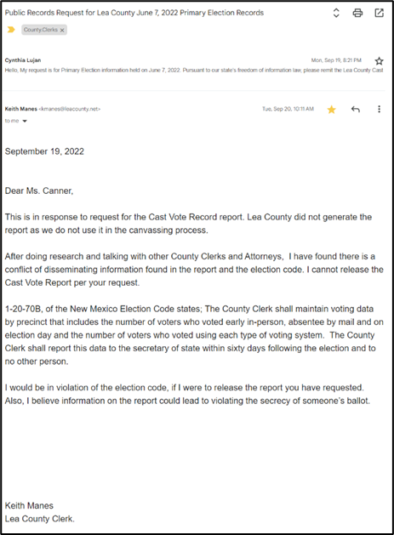
Lea County (NEW ISSUES/ADD RESPONSE)
- Not generated bk not used in the canvassing process
- Denied bk 1-20-70B NM Election Code: 1-20-70B, of the New Mexico Election Code states: the County Clerk shall maintain voting data by precinct that includes the number of voters who voted early in-person, absentee by mail and on election day and the number of voters who voted using each type of voting system. The County Clerk shall report this data to the secretary of state within sixty days following the election and to no other person. Rebuttal: The SOS herself publishes an official canvass with this information after the election, she also publishes lists of everyone who has voted or requested a ballot MULTIPLE TIMES PER DAY during early voting, this information is also available in the voter history column of the registration database. Is the SOS committing a crime?
- I would be in violation of the election code, if I were to release the report you have requested. Also, I believe information on the report could lead to violating the secrecy of someone’s ballot.
LEA Response:
- Because a county does not use the CVR for their canvassing process does not give a reason to not provide public information that is still available.
- There are no Election Code 1-20-70B. However there is an election code 1-12-70.B which FULLY states:
- The county clerk shall maintain voting data by precinct that includes the number of voters who voted early in-person, absentee by mail and on election day and the number of voters who voted using each type of voting system. The county clerk shall report this data to the secretary of state within sixty days following the election, and to no other person. The secretary of state shall then combine the data within a precinct to the extent necessary to protect the secrecy of each voter's ballot in accordance with rules issued by the secretary of state before the data as processed becomes a public record.
https://nmonesource.com/nmos/nmsa/en/4351/1/document.do
Regarding the concern of violating the secrecy of someone’s ballot: refer again to EAC VVSG reference mentioned above. (my language)

Screenshot # 1 Rio Arriba County
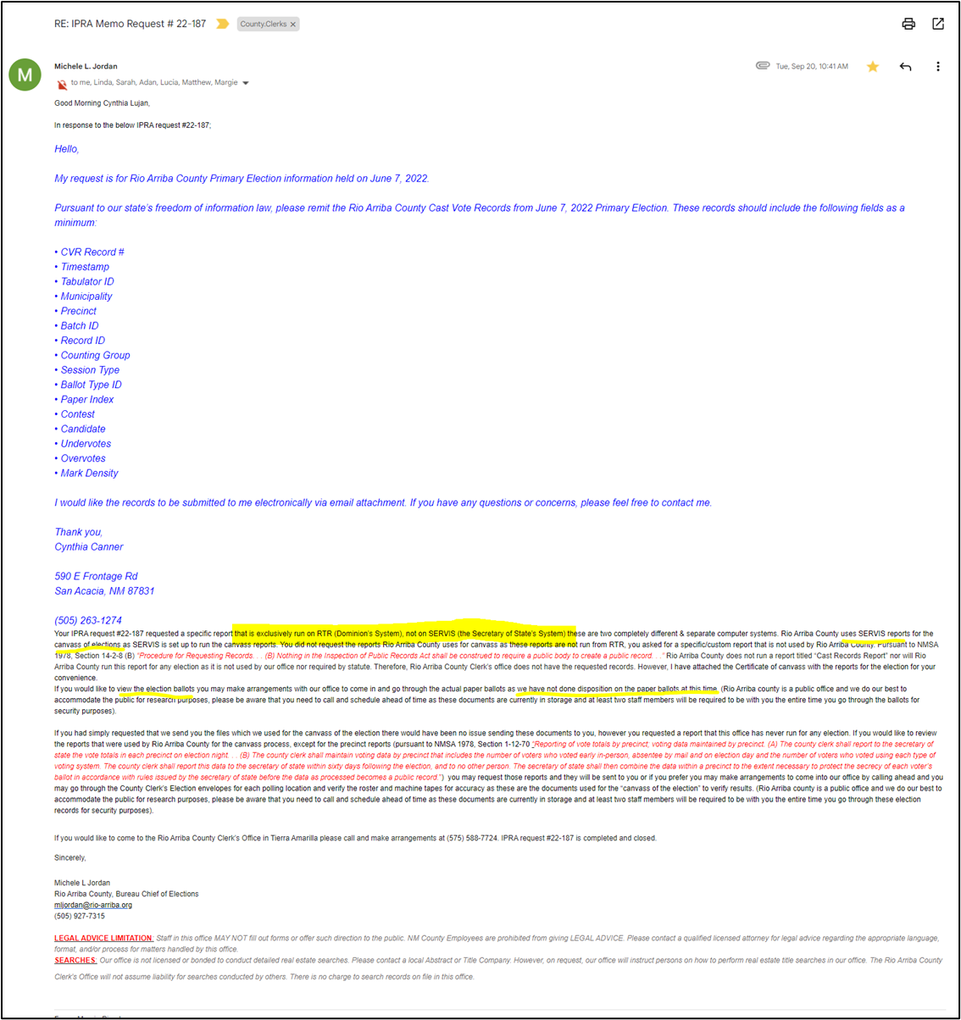

Screenshot # 2&3 Guadalupe
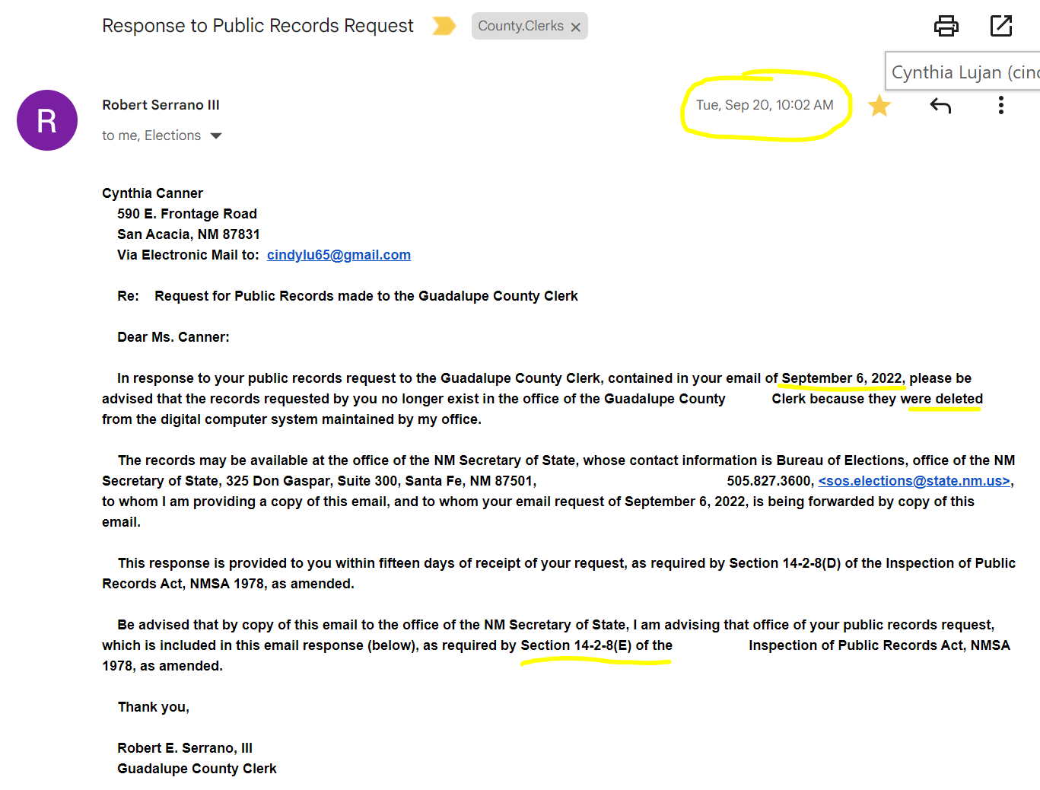
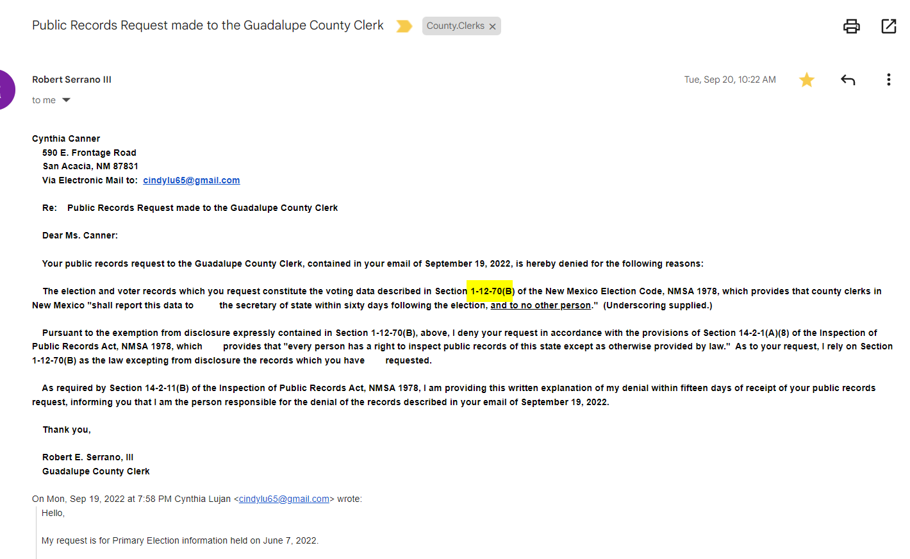
- 11/23 Colfax Co / / 2nd Rebuttal Clerk Rayetta Trujillo. As I mentioned in an earlier IPRA, I do not prepare the CVR Report, so that is not available from this office. Per State Statute 1-13-21 A – the media devices have been cleared for the 2022 Primary Election.
  - NMSA 1-13-21-A Clearing voting systems; transferring ballots. 45 days.
- 11/21 Lea Co / 2nd Rebuttal Keith Manes: did not produce or use report. Come/make appt to view election dox. 6 days ago.
- 11/22 Guadalupe/ / 2nd Rebuttal Bob.Serrano.iii.
  - Material cleared prior. 1-13.21 (2019) Alternatively, see paper ballot by appt.
  - 1-12-69(G) (2019) inspection of paper in manner to secure secrecy.
  - 1-12-69(G) 2022 GE CVR will provided once legal to do so (45 days after state canvassing recesses). Submit IPRA then.
- 11/27 Rio Arriba Michele Jordan Bureau Chief of Elections (same w/14-2-8 (B) and referenced 3 IPRAs: 22-170, 22-187, 22-216)
NMSA 8-4-5. Bureau of elections created; organization; duties.
There is created within the office of the secretary of state a "bureau of elections." The bureau of elections shall be headed by a director who shall be appointed by the secretary of state and who shall be knowledgeable in the election laws of the state. The bureau of elections shall perform those duties pertaining to the state administration of elections as are assigned by the secretary of state and which are pursuant to the election laws of the state. Such duties shall include the conduct of schools, instruction and training pertaining to election administration and the preparation of instruction materials and manuals to promote uniformity of the administration of election laws in the state. There is created in the bureau of elections the position of state voting machine supervisor. The state voting machine supervisor shall be knowledgeable in the mechanical operation, repair and maintenance of voting machines used in this state. The state voting machine supervisor shall provide assistance to counties in the repair, maintenance, care and proper use of voting machines owned by the counties.

History: 1953 Comp., § 4-2-7, enacted by Laws 1969, ch. 191, § 1.

Annotations
Prima facie election official violation creates favor for contestant. — Laws 1935, ch. 147, § 42 (now repealed) created a prima facie case in favor of contestant running on ticket of minority political party upon prima facie showing of violation of Election Code by election officials; when such showing was made it became contestee's duty, as member of dominant political party having majority representation on board of election officials, to prove that no fraud or coercion was exerted and that secrecy of ballot was preserved; prima facie showing required of contestant consisted of alleging and proving specific facts entitling him to favored position; facts constituting noncompliance charged against election officials were to be specifically set out.
Trujillo v. Trujillo, 1948-NMSC-040, 52 N.M. 258, 197 P.2d 421 (decided under former law).

Is it true that you were elected and took an oath to certify that the elections under your oversight were conducted fairly, honestly and securely? Many questions persist about the recent elections. Among those questions are that electronic counting machines are allowed to be used to count the vote in New Mexico if, and only if, they are certified properly.

The printing and tabulation machines in New Mexico and Bernalillo county are not properly certified. Did you know the election system and its machines have not been certified since 2017? For example, the software being used is not the correct version. Therefore, the election in Bernalillo county is fraudulent and MUST NOT be certified.

Second, we the people are promised the right to petition our government for redress of grievances. The Bernalillo County Commission is who we depend on to keep our elections fair, honest and secure. Serious questions about the integrity of the recent election remain and MUST BE addressed BEFORE you can in good conscience certify the election. Did you know that 18 states are controlled by winning the election in a single county and New Mexico is one of those states? Bernalillo County is the controlling county.

Lastly, would you have the integrity and courage to do the right thing for your constituents and withhold certification until a full audit of the election is conducted, overseen by observers from all parties? We're hoping and praying for a blessing for you and your family as you continue to serve us and Bernalillo County. Happy Thanksgiving to you and your family! I thank God for you and for serving our Bernalillo County and its constituents.

Health and Peace to you,
Geraldo "DrC" Cionelo
6725 Lamar Ave NW 87120

Sin

Best regards,
Cynthia Canner

The records MUST exist according to law with substantial precedent in place.

Before I provide the reference to the laws that mandates maintenance of the specific records I am requesting - I want to further describe what is being requested to ensure clearer understanding.

The results from each tabulator are downloaded into the electronic management system (EMS). The data from each tabulator is aggregated into a report called the cast vote records (CVR). The CVR is an electronic record in the EMS that records the vote selections of all the votes made on each ballot. The exported report is provided as a file in csv or json format. The CVR records the tabulator the ballot was cast on, the type of vote it was (early, absentee or Election Day), the precinct the ballot came from, and other information.

CVR is a federal standard requirement under Election Assistance Commission (EAC) to be: maintained for 22 months, be exchangeable, provide unique information per ballot (not a summary) and of course provide voter secrecy. Voluntary Voting System Guidelines Version 2.0 (eac.gov) (see 2.1-D, 4.1-C, 9.1.5-F, 9.1.6-K, 9.4-C 11.1-B)

It is significant to note that NM Law has provisions that require compliance with EAC under NMSA 1-9-7.4(B).
It states: If at any time the secretary of state becomes aware that a voting system certified for use in this state does not comply with all requirements in the Election Code [Chapter 1 NMSA 1978] or meet federal election standards, the secretary of state shall undertake an investigation to determine if the voting system should continue to be certified for use in the state. Tests and inspections conducted pursuant to this section shall commence upon the order of the secretary of state and shall follow the procedures in Section 1-9-14 NMSA 1978. A voting system that does not comply with all requirements in the Election Code and the most recent voluntary voting system guidelines adopted by the United States election assistance commission shall be decertified for use in this state.
I pray that you will take this request seriously. The public is entitled to the greatest possible information regarding the affairs of government and the official acts of public officers and employees. Such information is an essential function of a representative government and an integral part of the routine duties of public officers and employees. The Information Public Request Act affords members of the public to keep a watchful eye on government and an opportunity to determine whether the affairs of government are honest, faithful and competent.
I believe you will agree that voter confidence is important and that if there is no transparency, one may question tyranny. With all due respect, my IPRA request must not be closed.

Pushback, denial, refusal, misconstrue, compliance, guide, example, CVR, custom, VVSG, EAC, Election Assistance Commission, NIST, National Institute Standards and Technology,

