Attachment D – Mandatory Questions

File 0-3 Proposed SVS

3 State Level and EPoll Dataset-Building and Reporting

Supplier must propose a SVS solution that includes:
- State level ballot building (EMS)
- EPoll data set building and reporting (EPDMS),
- Electronic Poll Books (EPoll),
- Ballot Marking Devices (BMD),
- Polling Place Scanners (PPS),
- Central Scanning Devices (CSD),
- Consumables,
- and Peripherals

Provide the name and configuration of the product(s), product descriptions, and quantity proposed to be provided in the SVS (do not include cost).

Yes. The proposed solution from Dominion and KNOWiNK includes all of the noted solution requirements. Below we provide a high-level response detailing the name and configuration of the products as well as the proposed quantity when available:

- State level ballot building (EMS)
Ballot building is conducted using the Election Event Designer module of Democracy Suite, version 5.5A. Dominion is proposing 175 licensed copies of the Democracy Suite set of Products including 183 licenses of Adjudication, 175 licenses of Automated Test Decks, and 175 licenses of UOCAVA modules. The increased number of Adjudication Modules is due to select counties having more than one of each due to volume of absentee ballots printed and cast in major elections.


At the heart of our complete voting system solution is Democracy Suite, a robust and tested Election Management System that drives all voting channels out of a single comprehensive database; mail-in ballots, in person voting, accessible voting, and Uniformed Overseas Citizens Absentee Voting Act (UOCAVA)/Remote Accessible Vote by Mail(RAVBM). All pre-election and post-election tasks utilize the same database. From ballot layout to results reporting on Election Night, Democracy Suite is a complete, end-to-end elections solution that provides a single, powerful and versatile platform for election management.

Existing functionality and ongoing development of Democracy Suite centers around providing free and fair elections while considering the needs of our customers for easy to use and intuitive products, efficient processes, and accurate and transparent results for all ballots cast.

Democracy Suite is comprised of two modules: Election Event Designer and Results, Tally and Reporting.

- EPoll data set building and reporting (EPDMS)

ePulse is a secure web-based back-end election management system for use at the state and county level.
ePulse Capabilities
- Customizable real-time and
- election night reporting
- Ballot tracking
- Inventory tracking
- Election Day issue tracking
- Poll worker time-tracking
- Video communications from
- Poll Pads to ePulse
- Run concurrent elections
- Update voter rolls minutes before an election

ePulse is an all-inclusive election management suite designed to give administrators real-time access to monitor their election as a whole. All Poll Pads can connect to this central hub where voter check-in data is securely transferred via WiFi or cellular networks in near real time. This tool allows for administrators to oversee the operation of individual precincts and Poll Pads including battery life of the device, average check-in times, number of ballots issued or spoiled and more; all the while ensuring the election authority can directly contact poll workers via video or text message for speedy trouble resolution.

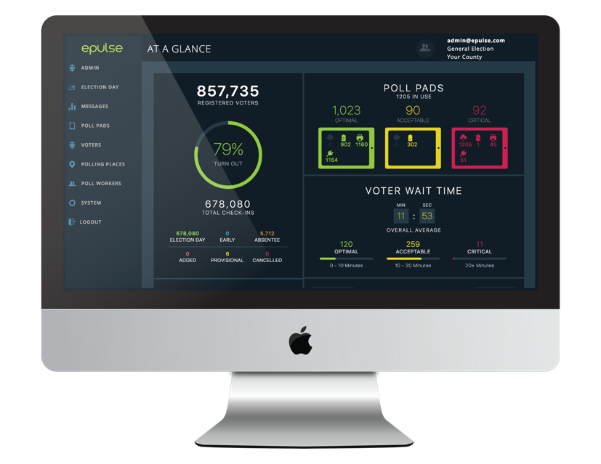
ePulse election monitoring dashboard. ePulse aims to be as intuitive and user-friendly as the Poll Pads themselves. These simple-to view dashboards give the user an overview of election data essentials which can be easily digested and exported into customizable reports.

Data Set Building with ePulse
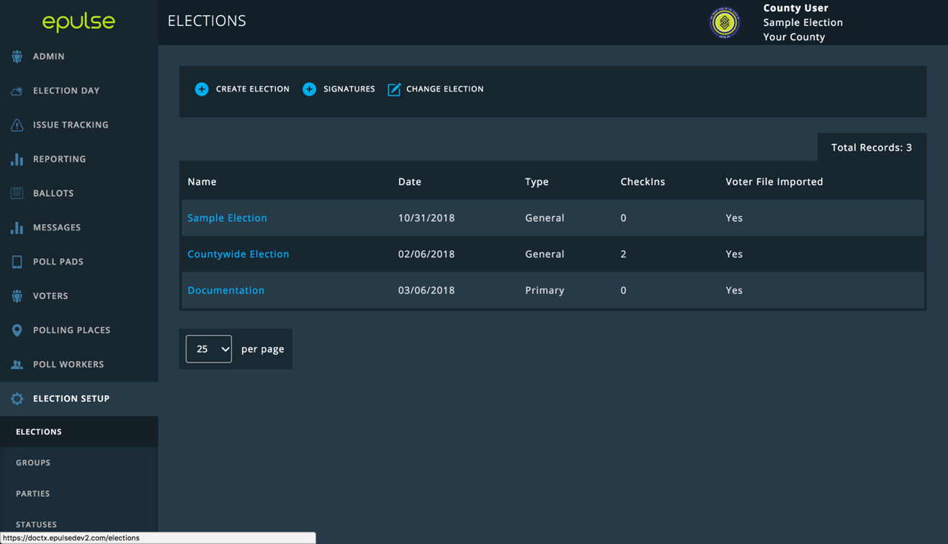
The Poll Pad and ePulse are designed to require minimal development to easily integrate with Georgia’s select voting system. Once integration is established, the voter data is imported into ePulse, our election management software, and distributed to the Poll Pads. The following images show the steps to build an election.
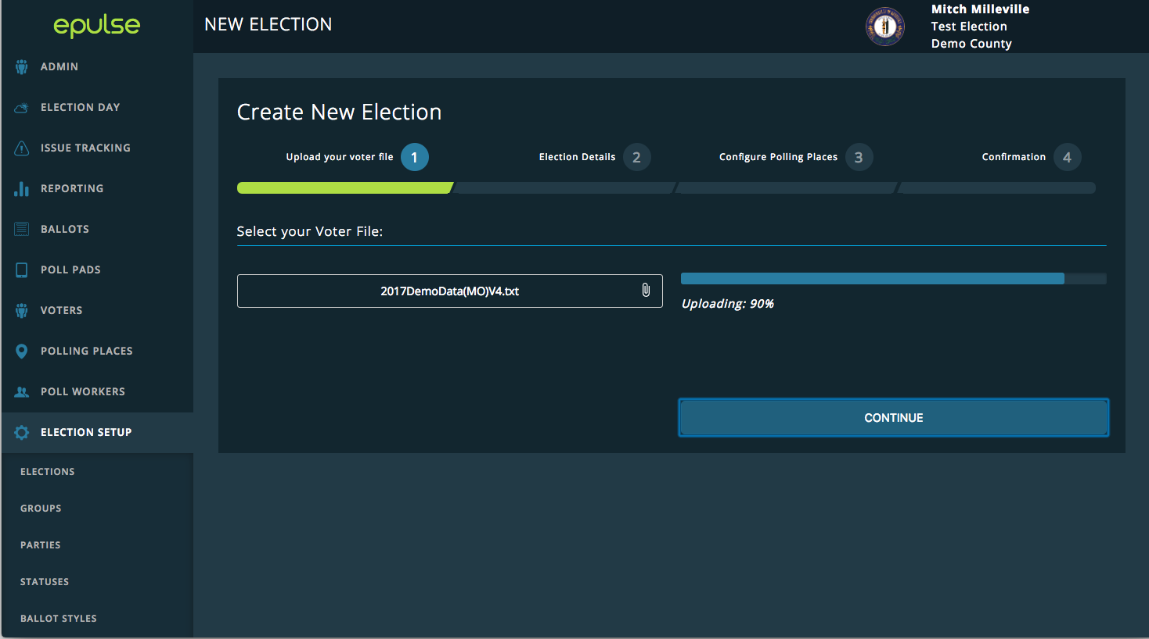

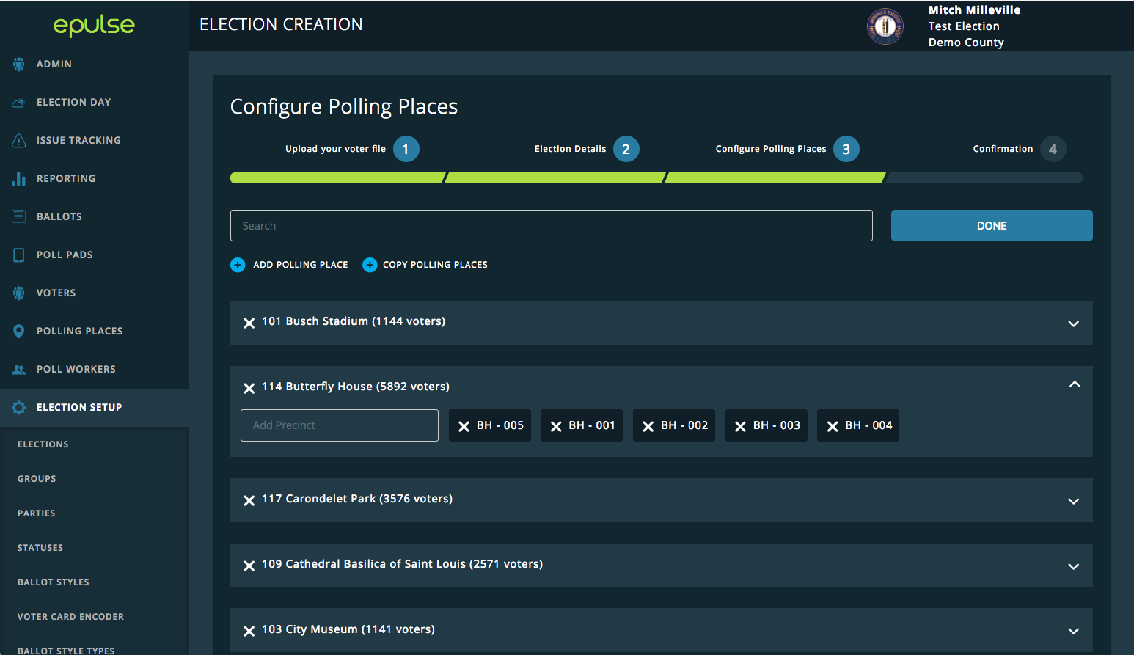
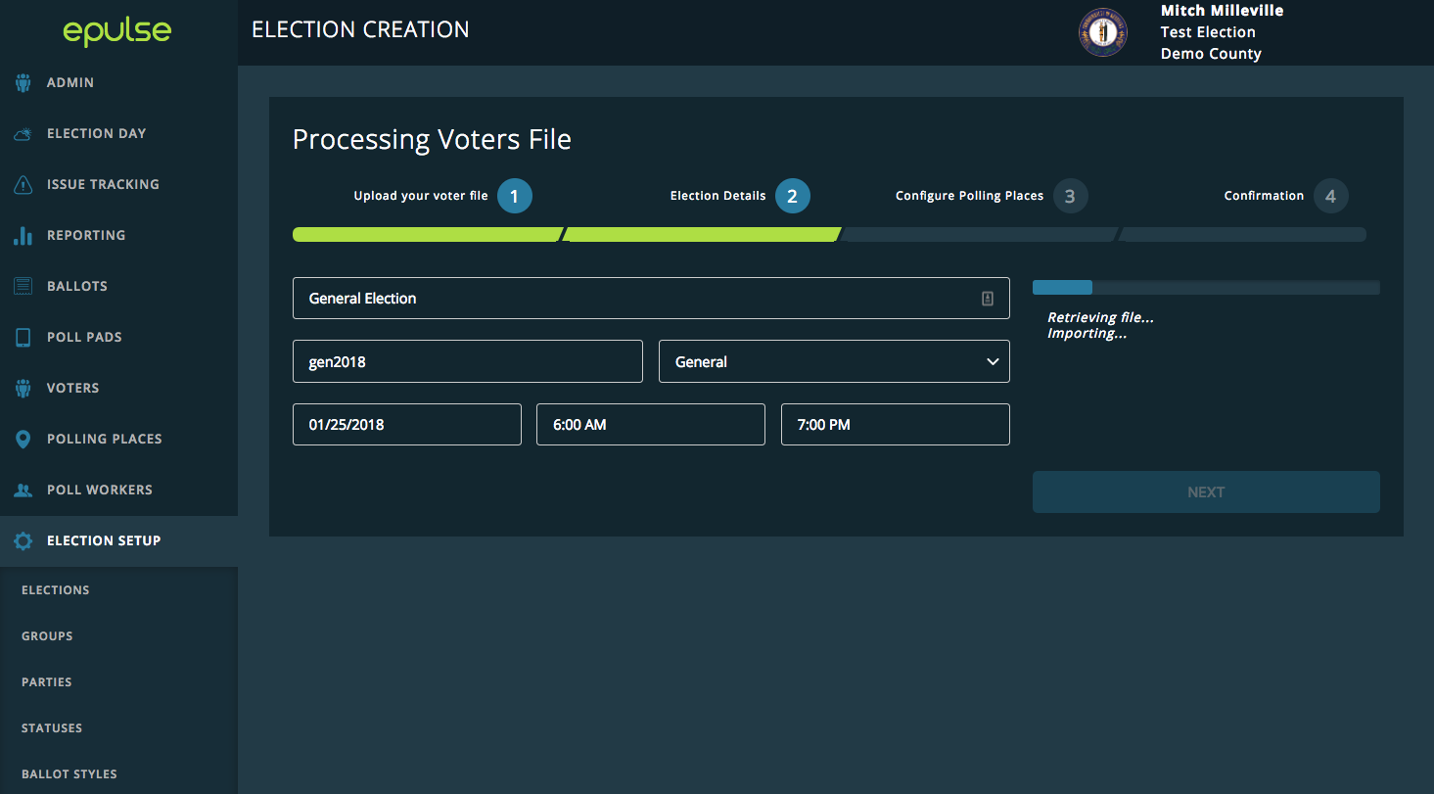
Election Details. The ePulse user enters in the election details, including election type, date, and poll open and closing times. Supplemental changes can be applied in mass via a batch update shortly before Election Day in ePulse. Individual records can be updated in ePulse. If connectivity is available, the application will automatically pull in any relevant supplemental changes once connected to the network. Absent the availability of network connectivity, jurisdictions can deploy an iSync drive or use Poll Pad's barcode scanner to update the appropriate voter status.

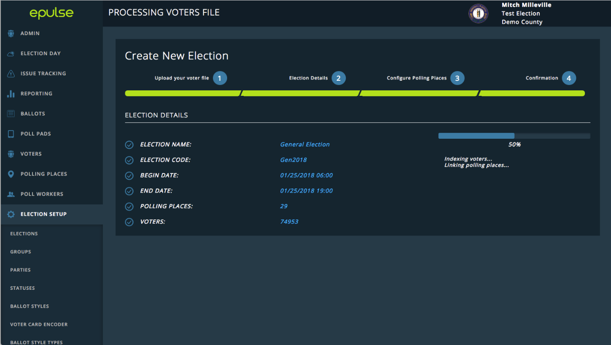
Final Configuration. ePulse begins indexing the voters and links voter records to the correct polling places. ePulse allows the upload of supplemental data and rosters from the State Voter Registration in accordance with Georgia law. Once loaded, the changes enacted by the supplemental file are then disseminated to the Poll Pad application via wireless hotspot connectivity, or barcode scanning, for near real-time updating of voter records.
The third step is reviewing the imported list of polling places. The user can customize the configuration for each Polling Place and precinct. Various combinations of polling locations can be manually added or imported in bulk into ePulse for use during an election. Vote centers, early absentee locations, or precinct specific locations are the most common types, but we are also able to work with the State to set up a unique offering at your request.

Figures D-31 and D-32. Setting up an election in ePulse.

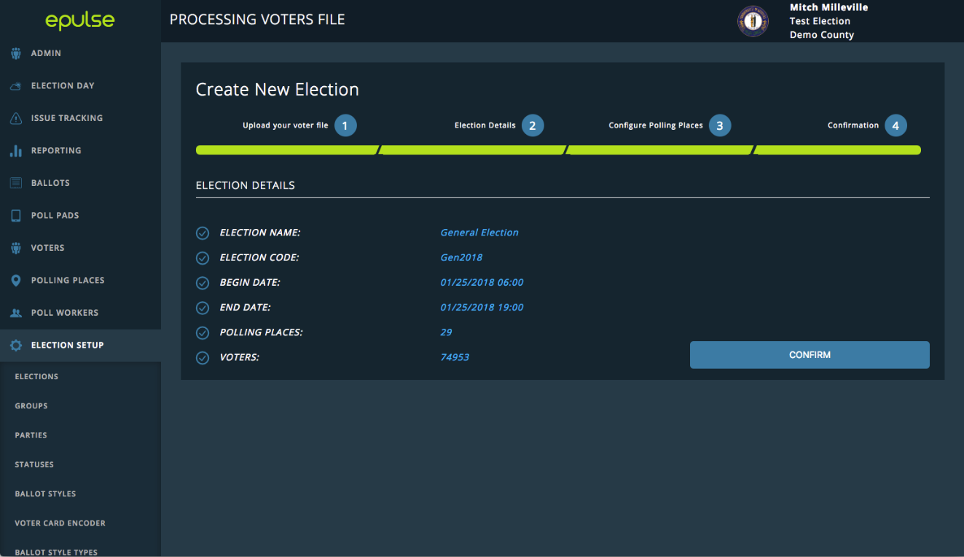
Election Setup Confirmation. The Confirmation page provides a summary report of the new election details. The user reviews; then clicks Confirm.

Reporting with ePulse
ePulse has numerous modules that give each County a complete view to manage elections. The following pages highlight the major Poll Pad features and ePulse modules that come with the Poll Pad solution.

ePulse Module: Reporting
Reports can be run in ePulse at any point during and after the election. Our standard reports are listed below. The State and its jurisdictions can apply filters to customize the standard reports and they may be exported and printed.

- Voter Check-in Details with Signatures
- Suspense/Inactive Voters who Voted
- Voter Turnout by Precinct
- Poll Worker Sign Ins
- Voter Turnout
- Provisional Voter Report
- Canceled Voter Check Ins
- Voter Rolls by Polling Place
- Ballot Styles
- Voter Turnout by Polling Place

ePulse can sort, filter, and search through check-in data in the post-election discovery process, making it easy to hone in on the exact information that is needed at any time.

The Poll Pad system can report on any data collected by the auditing system, including but not limited to: transaction types; transaction times; transactions by poll official; and number of searches per transaction. Transaction types and transaction times are easily viewable on the Election Day dashboard and updated in real time throughout the day with the use of an internet connection.

Sample ePulse reports are provided on the following pages and include both the web browser screenshots and exported reports.

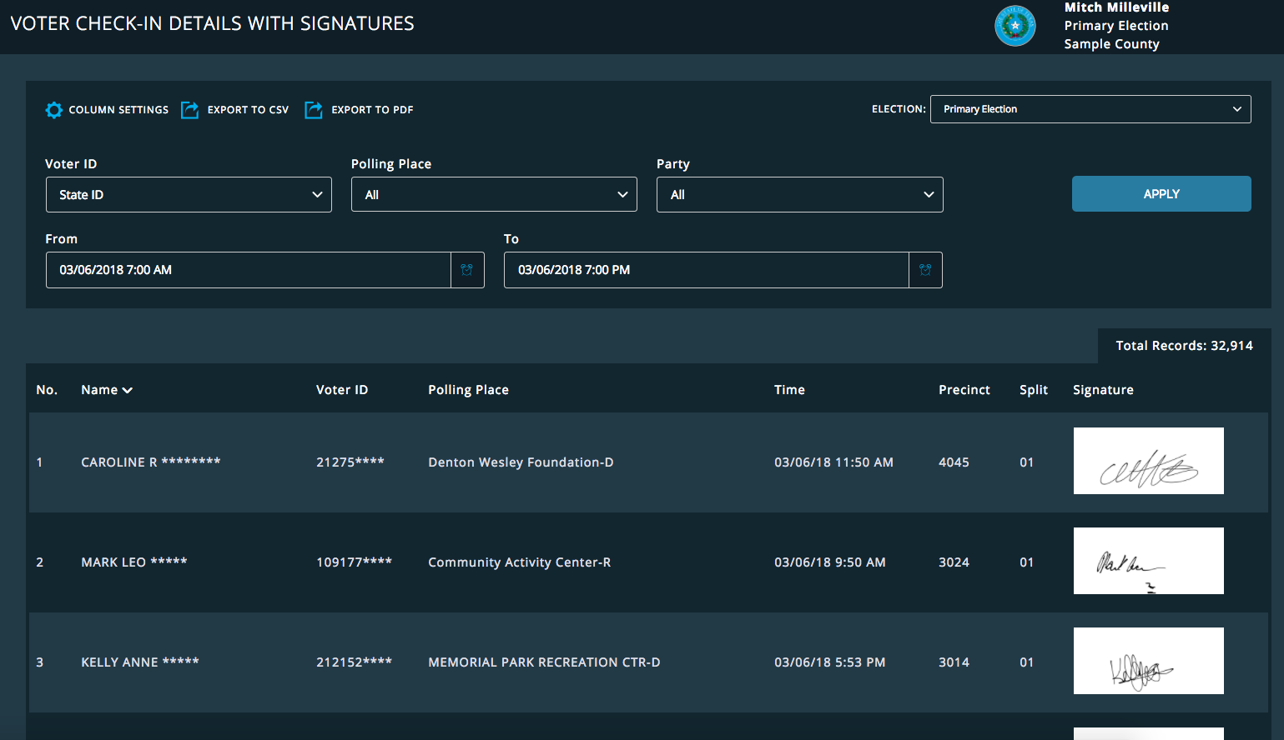
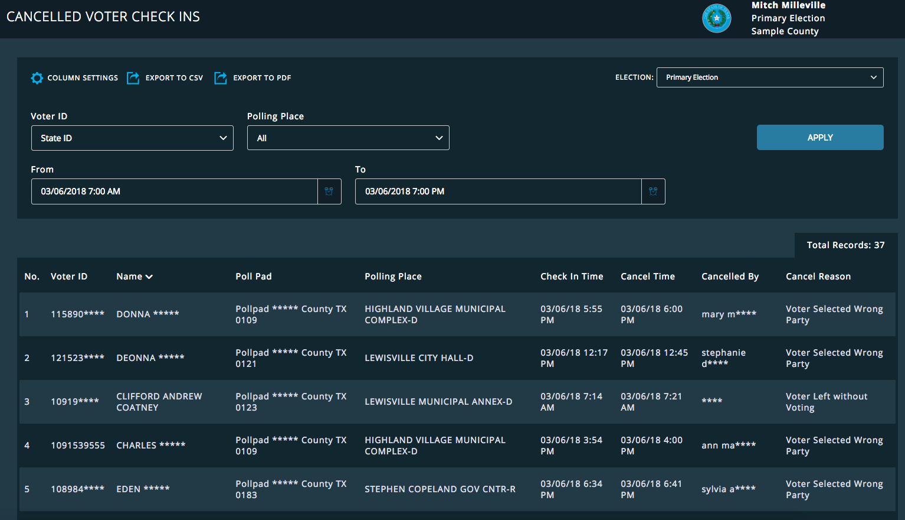
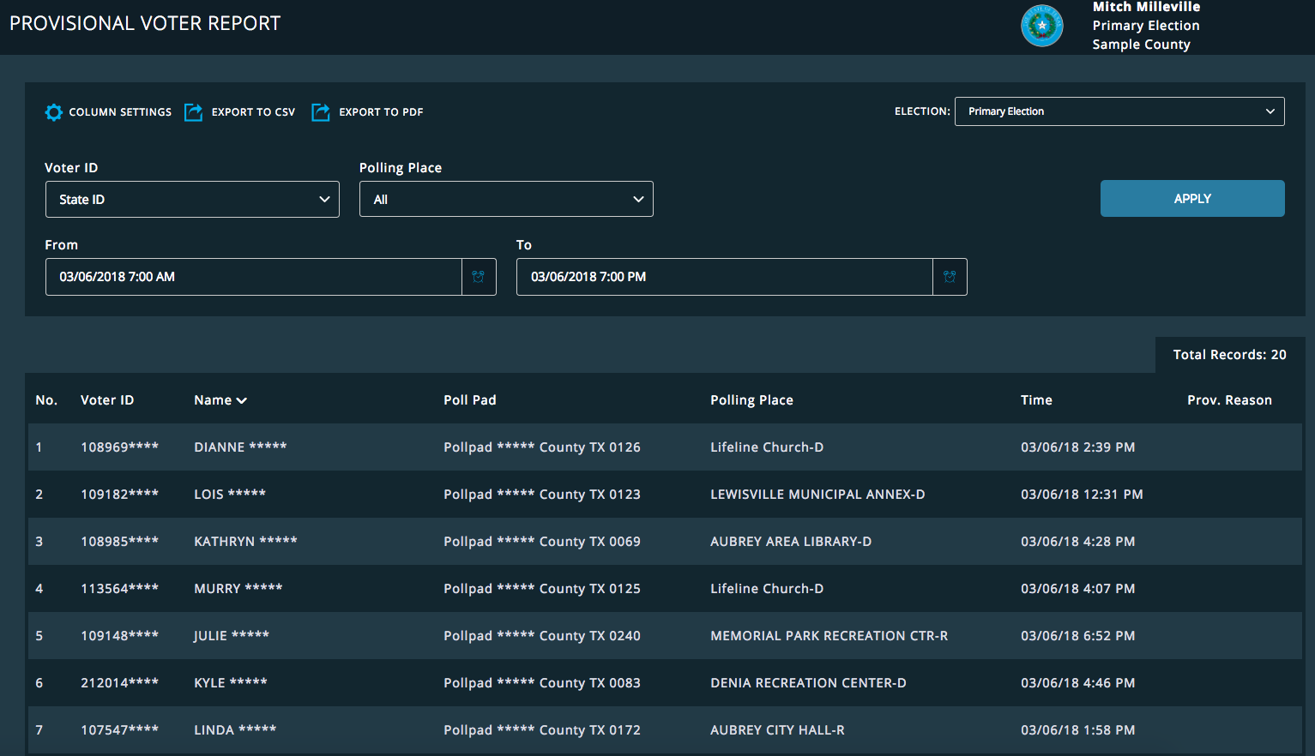

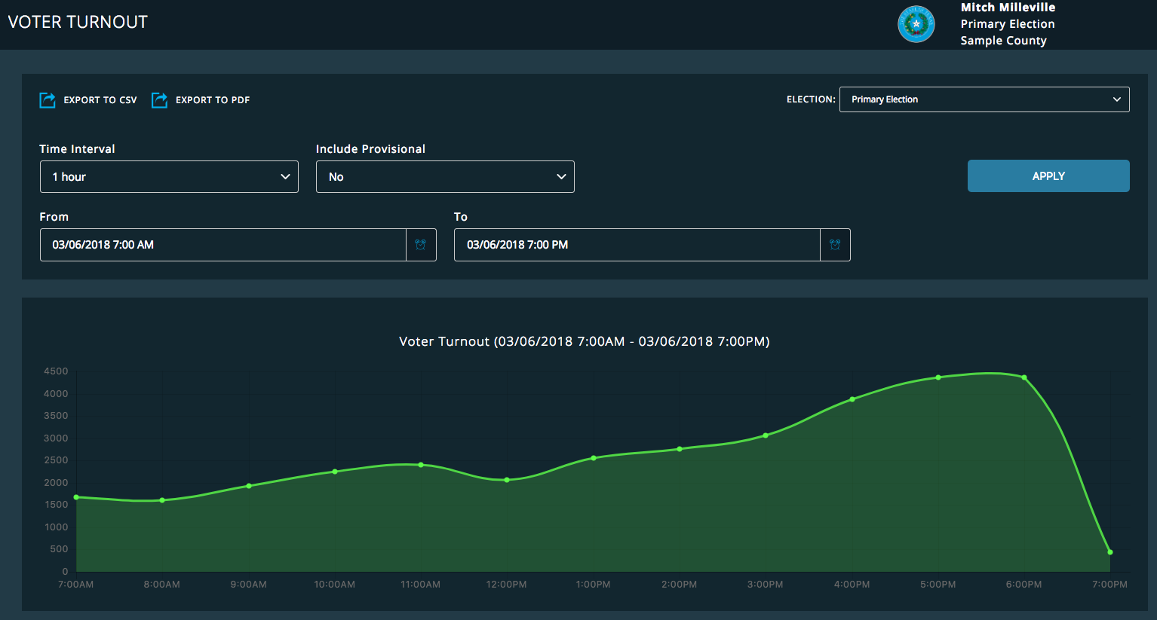

Sample PDF Report Downloaded from ePulse

If deployed with connectivity, ePulse and Poll Pad can communicate in near real-time during elections. These communications can be usedfor the following modules:

ePulse Module and Mobile Application: iTrack Issue Tracking
ePulse provides a method to assign election incident reports to help desk technicians and track their resolution. iTrack is a module built into ePulse and is divided into incident tracking and incident viewing/reporting. Reporting an incident allows the user to assign incidents to specific technicians, as well as detail what devices were affected by the incident, in which polling location or vote center, and whether the incident is open, pending, or closed. Issue creation, updates, and close are all timestamped, and the user that performed each event is logged in the system. iTrack allows for a method to track technicians and their GPS coordinates via a smartphone application that runs on iOS and Android operating systems.

KNOWiNK provides in-depth training and troubleshooting guides for in-office tech support and on-site personnel. Tech support personnel in the election office access the iTrack Issue Tracking system to log issues, assign them to devices and poll workers, and deploy techs out to the field to resolve incidents on-site. Using iTrack, Tech Support can communicate with poll workers via text messaging and video chat to get a first-hand understanding of what the poll worker is encountering. iTrack is available in ePulse on a web browser and as a mobile application.
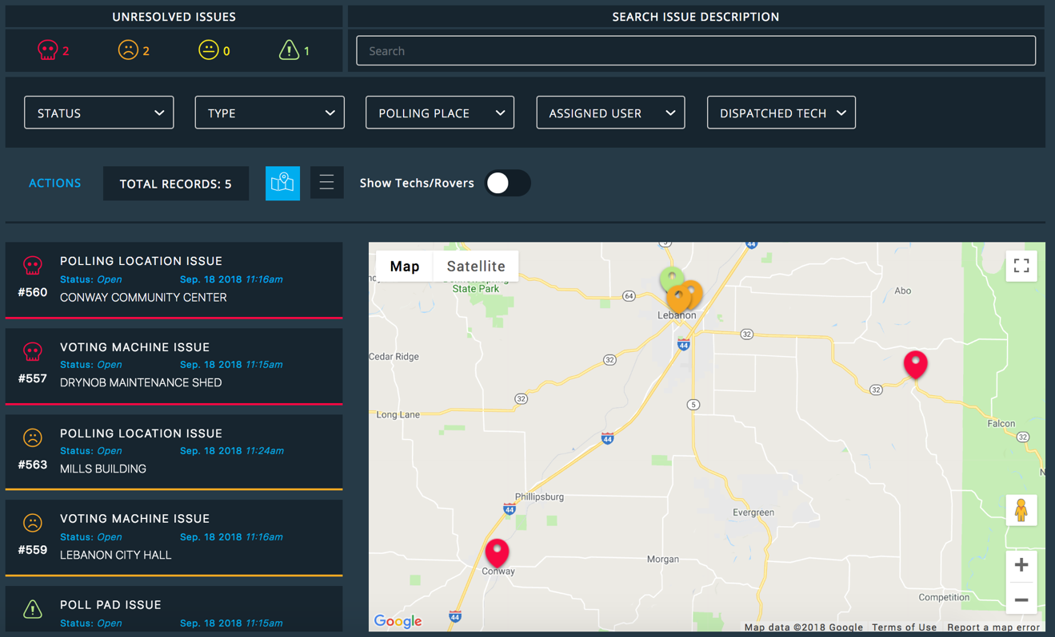
iTrack module in ePulse.

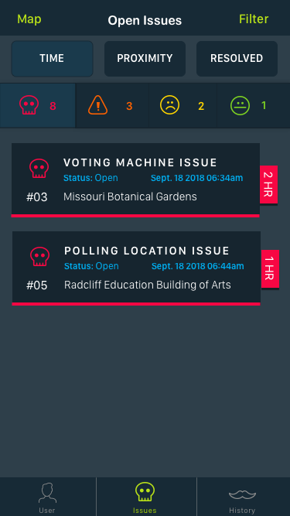
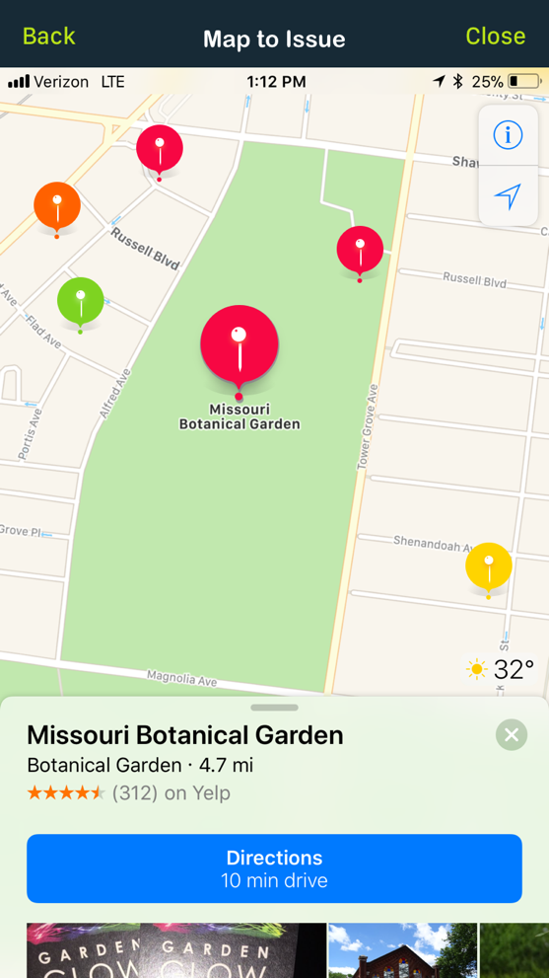
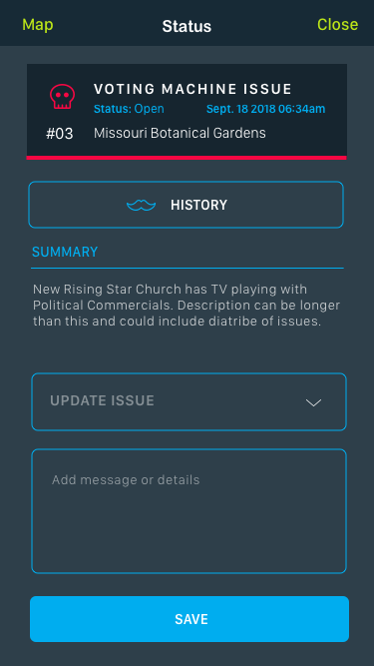
iTrack Mobile Application Screenshots.

“The Poll Pad solution and KNOWiNK customer service consistently meet Denton County’s unique needs. ePulse allows us to change a voter from one ballot style to another, a feature we could not do with our previous system. We highly recommend KNOWiNK’s Poll Pad solution.”

– Frank Phillips, Election Administrator, Denton County, Texas

ePulse Module & Mobile Application: iTrack Assets
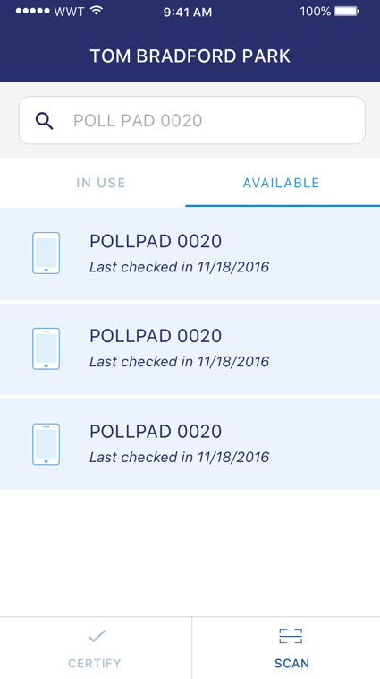
This tool allows the user to create a comprehensive inventory database of their election-related equipment for assigning and tracking. Users can set up item names, serial numbers, and other pertinent data. Users can assign inventory items to individual polling location destinations.

iTrack Assets is also a mobile application that can be used on any iOS device. Using iTrack, tech support can communicate with poll workers via text messaging and video chat to get a first-hand look at what the poll worker is encountering. It uses data from the client’s ePulse database. Users can select a polling place from the ePulse database and scan the barcode to check devices into or out of the polling place inventory. This information is communicated in real time, which allows viewers the ability to check on the status of inventory items at each polling place through ePulse. Election officials can set alerts for missing or low inventory, and log device incidents in the iTrack application and ePulse module for expedited issue tracking and resolution.

With iTrack Assets users can
- Scan any barcode
- Track inventory
- Set alerts
- Print labels
- Log incidents

ePulse Module: Video and Text Messaging
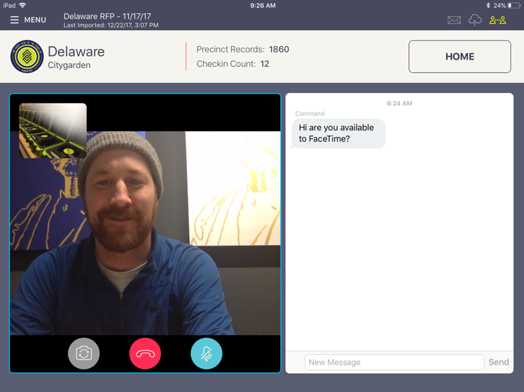
ePulse provides election authorities with a powerful and complete communications tool between polling places and the elections office. Customizable and pre-written messages can be sent between the Poll Pads and ePulse to communicate questions and answers. KNOWiNK’s innovative video chat is embedded directly into the Poll Pad application and is an election industry first. It revolutionizes how poll workers communicate issues to the election authority by giving them a first-hand look at the polling place.

ePulse Module: Poll Worker Time Tracking
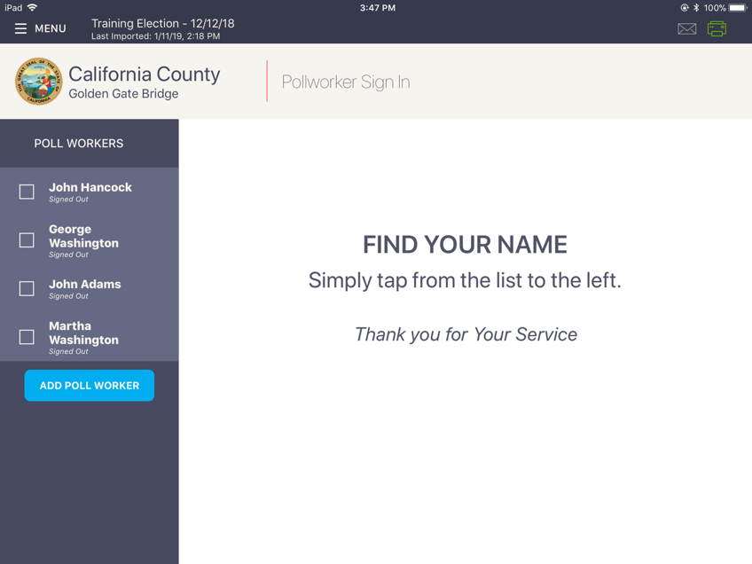
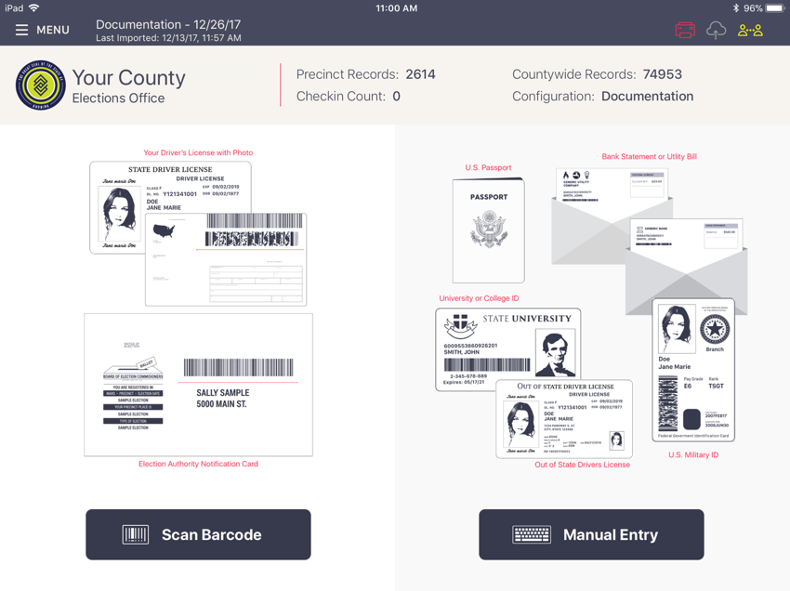
Poll Pad checks in poll workers, logging the timestamp and signature for each event. ePulse allows election officials to assign roles and pay rates to poll workers and provides reports on payroll, attendance and election day performance. Poll worker attendance is automatically managed on the Poll Pad. Using ePulse, election authorities may export a report of poll worker attendance and time for easy reporting and payment.

- Electronic Poll Books (EPoll)

The Poll Pad® – KNOWiNK’s Electronic Poll Book

Poll Pad is a secure electronic voter check-in tool used by election authorities across North America.
The Poll Pad solution provides a seamless electronic voter check-in and verification process for election authorities across North America. Poll Pad is a secure Apple iPad application requiring no appendages for operation.
“Poll workers and voters
especially appreciated
how easy the Poll Pads
are to use…itʼs really
a wow factor.”
- Nellie Gorbea
Rhode Island Secretary of State
- Process voters in approximately 30 to 45 seconds; mitigate long lines with fast and secure voter look-up.
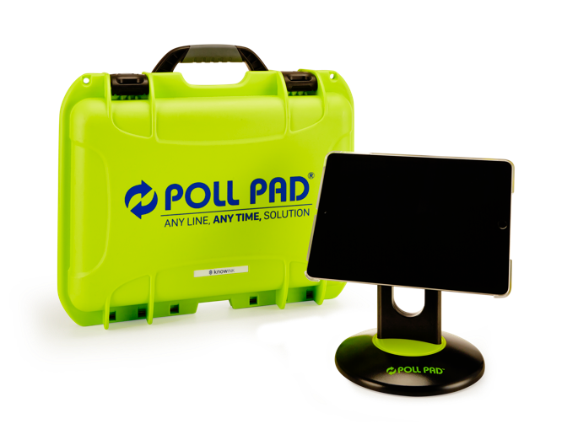
- Built-in election management and reporting tools; elections can be finalized and submitted within hours of election close.
- Efficiencies translate into reduced polling place staffing; jurisdictions can realize Election Day staffing reductions up to 50%.
- Customizable workflow presents required steps according to each
- jurisdiction’s requirements and preferences.
- Improved accuracy and reduced preparation time and storage requirements with the elimination of paper logs.
- Poll workers or voters cannot leave the application without a password, preventing user error, a line slow-down, or creating a
- potential security issue.

“Poll Pad was a big improvement over the legacy system it replaced in 2016, both in the Primary and General Elections. The District aggressively rolled out new voting
equipment and pollbook system concurrently in June. Poll Pad’s intuitive setup and
operation, safeguards against error, top tier customer support and user-friendliness
for the poll workers were all big contributors to the successful 2016 rollout.“
–District of Columbia Board of Elections

Integration with Voting Systems and Voter Registration Systems
The Poll Pad integrates with voting systems and voter registration systems (VRS), including Dominion’s Image Cast. Our development team continuously incorporates customer feedback to add new features and process improvements.

- Ballot Marking Devices (BMD)

The proposed Ballot Marking Device is the ImageCast X Prime as certified under Democracy Suite 5.5A.

ImageCast Prime X – Ballot Marking Device

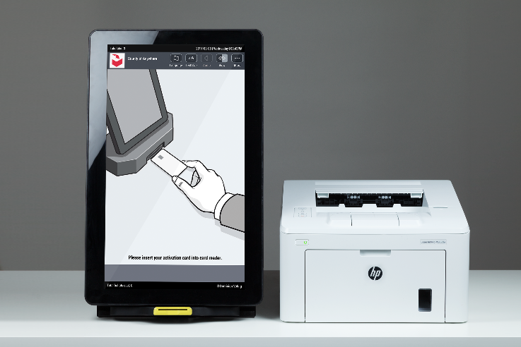
ImageCast X Prime 21” Tablet Specifications | Ballot Marking Device  Printer Unit Specs
Manufacturer: Avalue  Model: HID-21V  OS: Android 5.1.1.  Processor: Intel Celeron J1900  Power: DC 19V input  Weight: 19.5 lbs (including battery)  Dimensions: H 22” x W 13.5” x D 2.9”  Battery Backup Life: 2 hour minimum | Model: M402dn  Power: DC 19V input  Weight: 19 lbs  Dimensions: 8.5” H x 15” W x 14” D

Quantity - ImageCast X Prime BMD’s is 30,050 as per Attachment O. Dominion is proposing 30,050 Standard ICX Voting Booths.

- Polling Place Scanners (PPS)

The proposed Polling Place Scanner is the ImageCast Precinct as certified under Democracy Suite 5.5A.

ImageCast Precinct
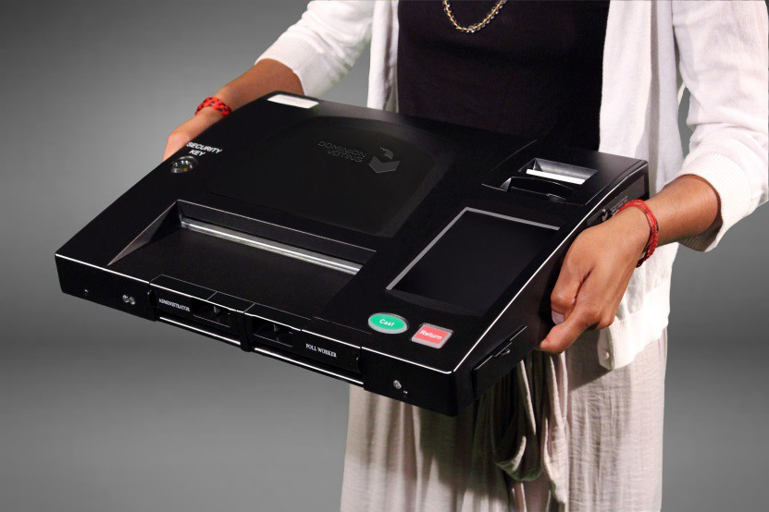
Model number: PCOS-330A 16V AC
OS: Linux
Processor: NXP ARM Cortex-A9 Dual Core 1GHz
Memory: 2GB
Modem: External Multi-Tech HSPA USB Modem
Weight: 14 lbs.
Dimensions: 17” x 13” x 3.5”

ImageCast Precinct Ballot Box
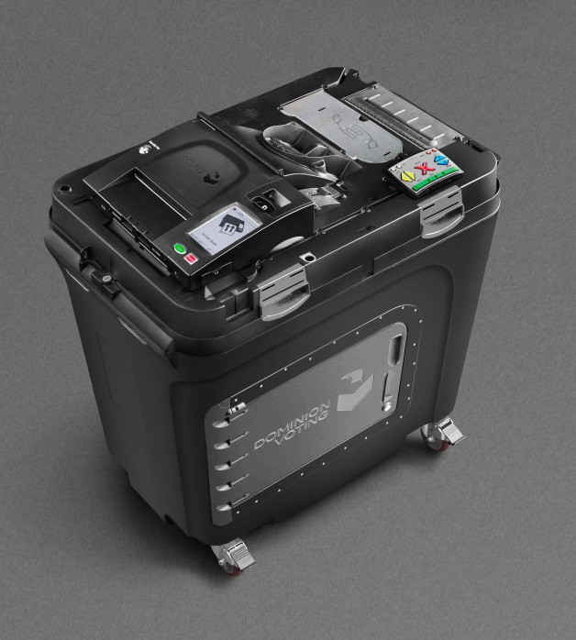
The ImageCast Precinct includes a plastic ballot box to receive cast ballots directly from the ImageCast precinct tabulator. The ballot box contains several key elements such as multiple storage compartments (main, diverted, auxiliary), multiple locks and doors, and access control monitoring. The ImageCast Precinct and attached ballot box are integrated components of the voting system, and it includes security arrangements to prevent unauthorized access to the tabulation component and a locking access door for all ballot locations.

The capacity of the ballot box exceeded 1,500 sheets for 11-inch, 14-inch, 17-inch, and 22-inch ballots with 65lb, 80lb, and 100lb paper weights.
The overall size of the ballot box with the lid on is 25” (W) by 38” (D) by 44” (H) and the weight is 85 pounds.

Quantity – Dominion is proposing 3,500 ICP Precinct Scanners in accordance to Attachment O. Each scanner comes with a Ballot Box, 3,500 Ballot Boxes.

- Central Scanning Devices (CSD)

The proposed central scanning device is the ImageCast Central as certified under Democracy Suite 5.5A. The ImageCast Central can be paired with two scanners including the high Speed Canon G1130 and, for smaller counties with limited scanning needs, the Canon M160ii.

ImageCast Central
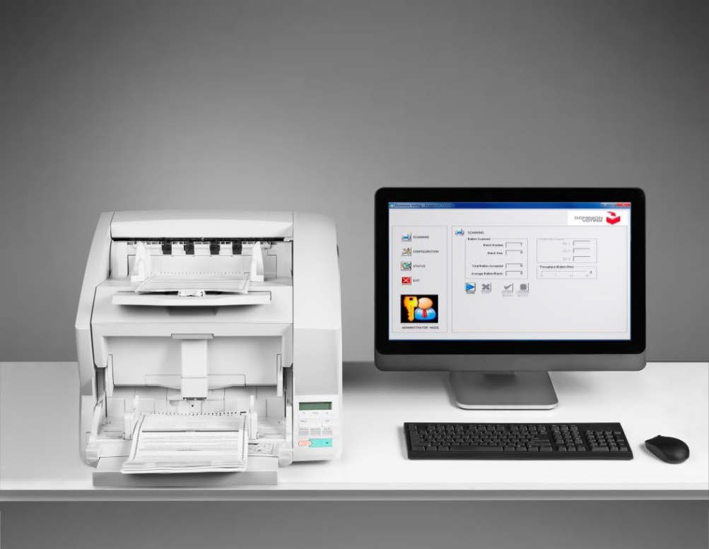

Includes Canon DR-G1130 scanner, Dell OptiPlex 7440 AIO computer, one 8GB flash memory card, one i-Button (black), one i-Button Programmer with USB Adapter, patch cable 25', Lexar LRW400CRBNA reader.

Dell OptiPlex 7440 AIO Computer Specs:
Processor: Intel® Core™ i3-6100 Processor (Dual Core, 3MB, 4T, 3.7GHz, 65W) ...
Operating System: (Dell recommends Windows 10 Pro.)
Monitor: 23.8" WLED Full-HD AIO Non-Touch Display.
Memory: 1 4GB2 DDR4 at 2133MHz. ...
Hard Drive: 2.5 inch 500GB 7200rpm Hard Disk Drive
Approximate weight: 15.9 lbs
Approximate Dimensions: 15.5”x22.6”x2.5”

Scanner: Canon Model DR-G1130 Specs
Feeder Capacity: 48 mm stack or 500 sheets of 80 g/m² (20 lb bond)
Scanning Resolution: 150 x 150 dpi, 200 x 200 dpi, 240 x 240 dpi, 300 x 300 dpi, 400 x 400 dpi, 600 x 600 dpi
Scanning Speed: B&W 100 ppm Portrait/130 ppm Landscape
Power: AC 100V (50/60Hz), AC 120V (60Hz), AC220-240V (50/60Hz)
Approximate weight: 50.3 lbs
Approximate dimensions: 18.9”x21.1”x12.4”

Scanner: Canon M160ii
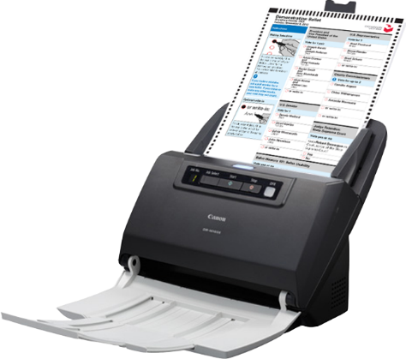
Feeder Capacity: 60 sheets 21 lbs. bond
Scanning Resolution: 150 x 150 dpi, 200 x 200 dpi, 240 x 240 dpi, 300 x 300 dpi, 400 x 400 dpi, 600 x 600 dpi
Scanning Speed: B&W 60 ppm
Power: DC24V 1.0A
Approximate weight: 7 lbs
Approximate dimensions: 11”x 10” x 9”

Quantity – Dominion is proposing 165 ICC Central Scanners. 20 model G1130 and 145 Model M160ii.

- Consumables

Consumable Item | Dominion Part Number | Model/Specifications | Timeline for Replacement | Quantities - Barry
ICP Cleaning Sheet | 141-000008 | Cleaning sheets | Dispose of sheets after each use and cleaning. | Each County to receive 5 sheets per Device.
ICP Lithium Battery | 117-000512 | Backup batteries | Four months before recharge. Capacity diminishes after 500 charge cycles. | Batteries have a 5-year life. Year 6 should replace all IC batteries.
ICX Lithium Battery | 117-000531 | Backup batteries | Four months before recharge. Capacity diminishes after 500 charge cycles. | Batteries have a 5-year life. Year 6 should replace all batteries.
ICP Paper Roll (96 foot) | 123-000229 | Archival thermal paper roll. | 7 year retention with proper storage. | 14,000 rolls have been proposed
Ballot Marking Device Printer toner | 123-000340 | Replacement toner | ~Every 3,100 pages | Toner will last for 3,100 images per BMD. Toner should last for 15 to 20 elections.
Ballot Marking Device Paper | 144-000018 | 3rd party paper stock  11”, 14”, 17”, 19”, 22” as applicable | As needed on a per election basis | Based on per election needs
Ballot Box Storage Boxes | 125-000074 | Cardboard ballot boxes for ballot transportation and storage. | As needed on a per election basis | 25 boxes per carton

It is Dominion’s policy to keep replacement parts and consumables on hand to meet the needs of our customers.

- Peripherals

The proposed system includes various peripheral items including:

Product | Description | Quantity
Server Kit | Includes PowerEdge R630 rack server, 24 port switch, 24" monitor, keyboard/mouse, patch cable, Cepstral, Avast.  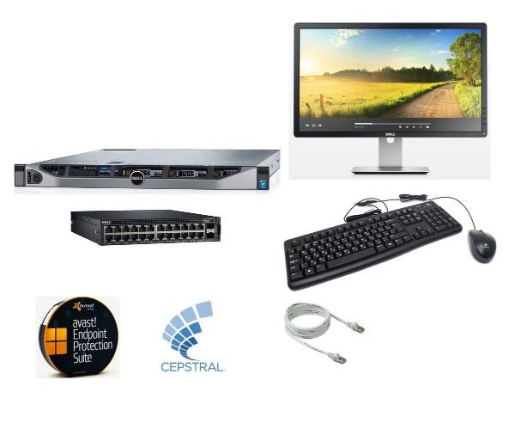 | 4
EMS Workstation | Includes Dell T3420, 24" monitor, iButton programmer, high speed media reader, patch cable, smart card reader/writer.  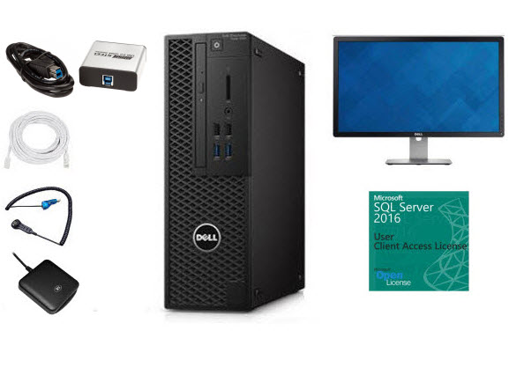 | 171
Adjudication Workstation | Includes Dell T3420, 24" monitor, SQL Server 2016 CAL, cables, Windows 10 Pro.  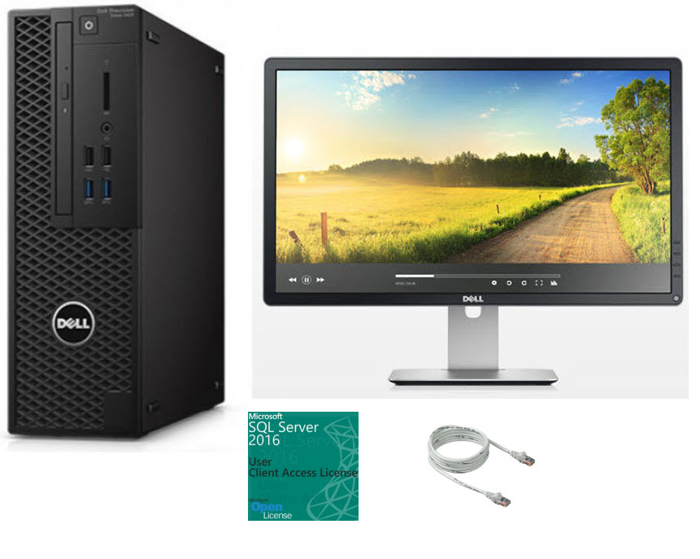 | 183
Voter Activation Cards | Smart Card to activate voting session on the ImageCast X Prime.  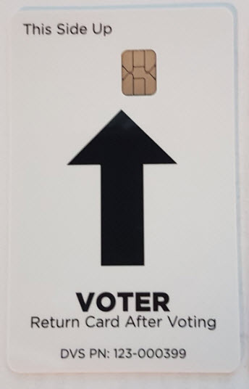 | 3 per unit
Uninterruptible Power Supply | Backup power supply for precinct locations.  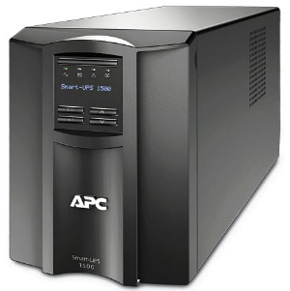 | 2,913

Audio Tactile Interface | Accessibility units for ImageCast X includes ATI unit, headphones and connection cord.  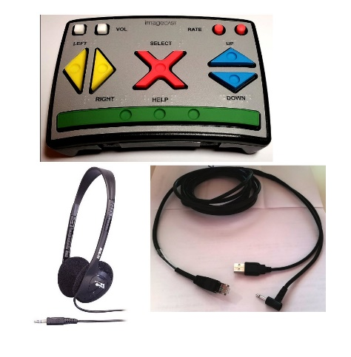 | 2,754
Hardware and peripherals for electronic poll books
iPad tablet | The iPad has a touchscreen/keyboard and a shockproof clear case. The iPad has a battery life of approx. 10 hours. Make: Apple | Model: MP2FLL/A | 8,000
Encoder/iOS Reader | The Mfi certified lightning port contact card reader connects securely to the iPad lightning port and include a micro USB cable. Make: FEITAN Technologies | Model: iR301 | 8,000
iSync Drive | KNOWiNK’s secure proprietary removable memory device, the iSync flash drives. Make: KNOWINK | Model: iSD-110 | 2,800*
Stand for iPad | The iPad stand is durable and user friendly. Make: AI Data | Model: i360 | 8,000
Scanning tray | KNOWINK’S patented scanning trade scans barcodes on voter ID cards or state identification cards. Make: KNOWiNK | Model: ISP103b-KN2-1 | 8,000
Styluses | Poll workers and voters may use the styluses or their finger for the iPad’s capacitive touch screen. Make: AI Daata | Model: ISP-1010-KNO | 16,000
Carrying case | Shockproof weatherproof foam-fitted case. Make: Nanuk | Model: 910 | 8,000
Thermal printer (optional) | The Star Micronics printer is the original printer used with KNOWiNK’s system. This printer requires AC power. Make: Star Micronics | Model: TSP650ii | (Optional. The printer pairs with one Poll Pad.)

