Physical Layout
Start with an 8’ table close to yet separate from the scanning area.
Designate an area: “Arrival from Storage”
Designate a second area: “Ready for Scanning”
Print Target Cards and Labels by Voter Group: AB, EV, ED, OT
Place groups in Target/Label bin under Ballot Preparation Table
 | 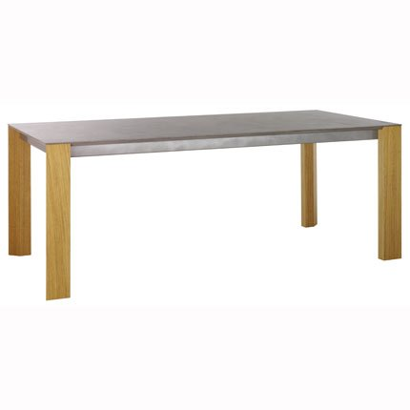    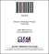  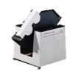  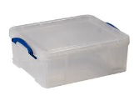  Box prepped and ready to scan  Arrival from Storage  Ballot  Jogger  Target Cards & Label storage  Ready for Scanning  Ballot Box Showing Target Card and Matching Box Label  Ballot Prep Table | 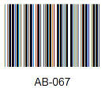  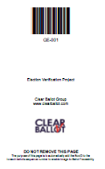  Target  Card  Barcode  Label  Matching  Barcodes
Examine Ballot Boxes in Arrival from Storage Area
Ballots should ALL be from one Voter Group (AB, EV, ED, OT, etc)
Start with Absentees first, then Early Voting (these are the comingled ballots)
Follow with Precinct ballots, finally with Provisionals, other, etc.
Prepare Ballot Box
Open the box and examine the contents
Unfold any folded ballots, straighten bent corners
Remove any rubber bands, post-it notes or non-ballot paper
Use the Ballot Jogger if necessary to align the ballots, orientation is not important
Add Target Card and Box Label
Choose the next sequential Target Card and matching label
Place the label on the box
So that it is very visible when the boxes are stacked
So that it does NOT obscure any jurisdiction specific labels
Place the matching target card FACE UP on top of the ballots
Close the box and move it to the Ready For Scanning Area

Voter Groups  A Voter Group, sometimes called a “counter group” or “tally group”, is a code that identifies a group of voters so that their votes can be reported separately. The number and names of Voter Groups can vary by jurisdiction. | Voter Group Examples:  ED – Voters casting ballots at their precinct on Election Day  AB – Absentee voters who cast their ballots by mail  EV – Early voters  OT – Other voters (e.g. Provisional)
Target Card  The purpose of a Target Card is to inform the scanner that a new box is being scanned and to assign the value of the barcode as the BoxID prefix for all subsequent ballots.  See also: Checklist: Printing Targets and Labels | 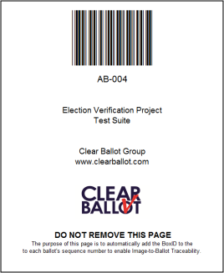
Box Label  The purpose of a Box Label is to help locate the box that contains a ballot needed for inspection. Ballots in the box will be in sequential order starting with the Target Card at the bottom of the box. | 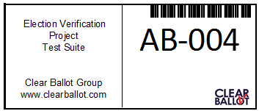
Ballot Image Naming Convention  The purpose of this naming convention is to provide reliable image-to-ballot traceability.  - Ballot images are named with a BoxID, a Ballot Sequence Number and a File Type  - The BoxID is formed as a Voter Group and a Box Sequence Number  - The BoxID is supplied by a Target Card  - The Ballot Sequence Number is supplied by the scanner software. | How a Ballot Image is Named
  AB - 004 + 10001.jpg
  BoxID |  | Ballot Seq # | File  Type
  Voter  Group | Box Sequence Number | Ballot Sequence Number | File Type
  Source of Data
  Target  Card |  | Scanner
Examples of Ballot Naming  - The first side of the Target Card is always named by the value of its barcode and Ballot Sequence Number 10001; the back side is # 10002.  - Ballots are named with an odd Ballot Seq. # for the front side and an even Ballot Seq. # for the back.
  Front of AB Target | AB-004+10001.jpg
  Back of AB Target | AB-004+10002.jpg
  Front of 1st AB Ballot | AB-004+10003.jpg
  Back of 1st AB Ballot | AB-004+10004.jpg
  Front of 2nd ED Ballot | ED-001+10005.jpg
NB: The orientation of the ballot is not important. Front and back sides refer to how the ballot is presented to the scanner.

Pre-printed Target Cards and Box Labels may be found on the P drive of the ScanStation Laptop, which maps to files shown below on the ScanServer:
Network File Location on the ScanStation laptop | Printing Instructions | Estimated number of cards and labels to print
“P:\InstallKits\Targets” | Print target cards on letter or legal size paper stock  NOTE: For best results print targets on a laser printer to ensure that the bar code can be accurately read by the scanner | Polling (ED): 1 card per precinct + 10% (for precincts that fill more than one box)  Absentee (AB) and Early (EV):  1 card for every 700 Absentee or Early Voting ballots expected.  Other (OT) and Provisionals (PR):  1 card each
  Voter  Group | # Pre-Printed Cards
  ED  (Polling) | 1,000
  AB | 500
  EV | 500
  OT | 50
  PR | 50
  NEC  (spares) | 50
“P:\InstallKits\Labels” | Print labels on Avery 5163 (2”x4”) – 10 labels / sheet | Each sheet has 10 labels. Use the above guidelines and divide by 10.
  Voter  Group | # Pre-Printed Sheets of 10
  ED  (Polling) | 100
  AB | 50
  EV | 50
  OT | 5
  PR | 5
  NEC  (spares) | 5

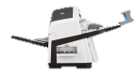
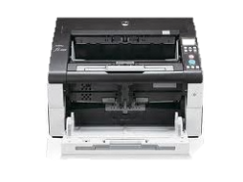
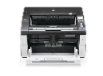


Un-Scanned
Ballot Stack
Scanned Ballot Box
(Using Original
Ballot Box)

6’x3’ ScanStation Table
Input
Tray
Output
Tray
fi-6670
fi-6800
Input Tray
Output Tray
Completed
Area
Laptop
Scanner
Arrival Area
Target Cards & Label storage
- Preparing the ScanStation for Scanning
- Power on Scanner; then Laptop
- Double click “Update6800” (or whichever model scanner) shortcut to load the most current scanner profiles
- Start Tabulator – to enable the laptop to tabulate ballot images
- Preparing Ballots for Scanning
- Move ONE ballot box from the Arrival Area to the left side of the ScanStation table.
- Open this ballot box and confirm a Target Card is on top of the ballot stack
- Place this target card in the input tray of the scanner
  - Face up if fi-6800,
  - Face down if fi-6670, fi-7180 or fi-6140
- Place all the ballots in the Un-Scanned Ballot Stack area.
- Move the now empty ballot box to the Scanned Ballot Box area.
- Scanning Ballots
- Push the Start Scan button on the scanner. The target card will be scanned and move to the output tray.
- Assure that the Tabulator Screen, Target card and Box label all MATCH
- Place the Target Card face down in the Scanned Ballot Box.
- Place approx. 1.5” ballots from the un-scanned ballot hopper in the Scanner input tray. Click YES on the computer screen. These ballots will move to the Scanner Output Tray.
- Transfer these ballots from the Scanner Output Tray to Scanned Ballot Box WITHOUT changing the order or orientation. Ballots scanned first are on the bottom.
- Repeat steps 4 & 5 until there are no more ballots in the Un-scanned Ballot Stack.
- Click NO on the Laptop scanner to terminate this box
- Close the original ballot box and place it in the Completed Area
- Repeat steps B & C until there are no more boxes in the Arrival Area

Item | Symptom | Remedy
Ballot Mis-feed | - Scanner reports a mis-feed | Review any screen messages before proceeding. If given choices such as “re-scan” or “continue” check the status of the ballots in question, then respond to the screen message. Remove the offending ballots from the scanner and re-insert them into the hopper to be re-scanned if indicated.  If ballots are crumpled, folded or torn, attempt to smooth them to aid in the scanning process.
Target Card not read | - Tabulator reports a fatal error | Delete the box, re-start Tabulator, and re-scan the box
Box requires re-scanning | - Ballots became out of order  - Operator inadvertently terminated a box before all ballots were scanned. | Run the “Delete Box” script, Re-initiate the standard procedures for scanning a box.  If ballots are crumpled, folded or torn, attempt to smooth them to aid in the scanning process.
No response to Start Scan button or scanner incorrectly reports no paper on input tray | - If the paper is curled upward, the paper sensor may not be depressed. | With your fingers, press down at the center of the leading edge of the paper and press the Start Scan button.

NOTE: Wireless router shown only for illustration purposes. Do not use a wireless router on the scanner network.

